CONSENT ITEM H
January 22, 2024
OLDHAM COUNTY BOARD OF EDUCATION
CONCERN
Consider approval of OCS Family Resource and Youth Services Center District Assurances for 2024-2026.
DISCUSSION
OCS Family Resource and Youth Services Centers are established for students and families. Before they can submit a grant application for funding, the schools must have certain assurances approved by the Board of Education. Attached are the FRYSC assurances for your review and approval.
RECOMMENDATION
Approve the Family Resource and Youth Services Centers School District Assurance Certification for fiscal year 2024-2026.

On a motion by _______________, seconded by _______________,, the Board approved Family Resource and Youth Services Centers School District Assurance Certification for fiscal year 2024-2026. ( , )
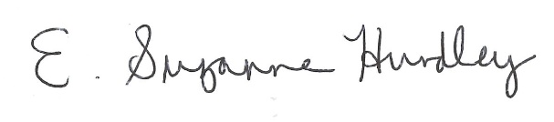
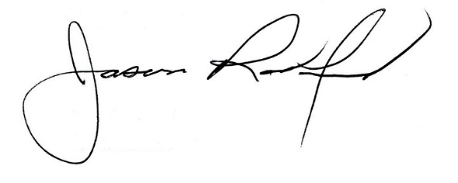

___________________________________ ______________________________
Suzanne Hundley, Board Chair Jason Radford, Superintendent/Secretary

