CONSENT ITEM L
January 22, 2024
OLDHAM COUNTY BOARD OF EDUCATION
CONCERN
Consider rejection of School Facilities Construction Commission (SFCC) Offer of Assistance for the FY2022-24 Biennium.
DISCUSSION
Pursuant to KRS 157.622, the School Facilities Construction Commission (SFCC) is hereby making an official Offer of Assistance to the OLDHAM CO. Board of Education. Acceptance of this Offer of Assistance commits the school district to adhere to the statutes and regulations governing this program. This Offer of Assistance is in the annual debt service amount of $2,544.05 to be used towards proposed construction or major renovation of facilities outlined in your most current approved facility plan.
In order for Oldham County to be eligible to accept this offer, it would require a restriction and transfer to the SFCC Escrow – Current Offer the fund balances remaining in both the Building Fund and Capital Outlay Fund as of June 30, 2023, plus interest accumulated on these funds.
RECOMMENDATION
Reject the SFCC Offer of Assistance because of its minimal amount, fund escrow requirements, and corresponding restrictions to capital planning, funding, and future bond issuance.

On a motion by _______________, seconded by _______________, the Board rejected the SFCC Offer of Assistance because of its minimal amount, fund escrow requirements, and corresponding restrictions to capital planning, funding, and future bond issuance. ( - )

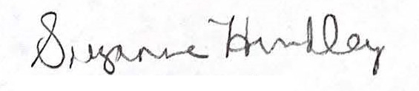
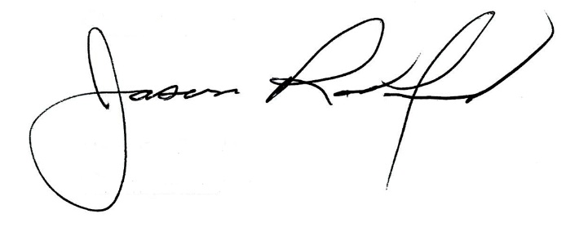

Suzanne Hundley, Board Chair Jason Radford, Superintendent/Secretary

