CONSENT ITEM H
October 14, 2024
OLDHAM COUNTY BOARD OF EDUCATION
CONCERN
Consider Approval of Additional 504 Chair for FY25.
DISCUSSION
The following 504 Chair require approval by the Board.
- Emily Amstutz - NOMS
RECOMMENDATION
Approve additional 504 Chair for FY25.

On a motion by _______________, seconded by _______________, the Board approved the additional FY25 504 Chair.

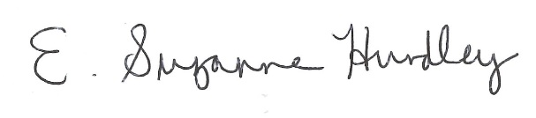
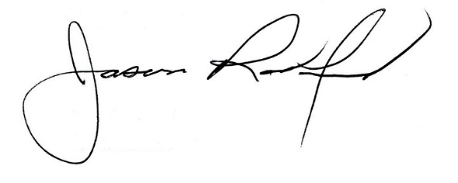

Suzanne Hundley, Board Chair Jason Radford, Superintendent/Secretary

