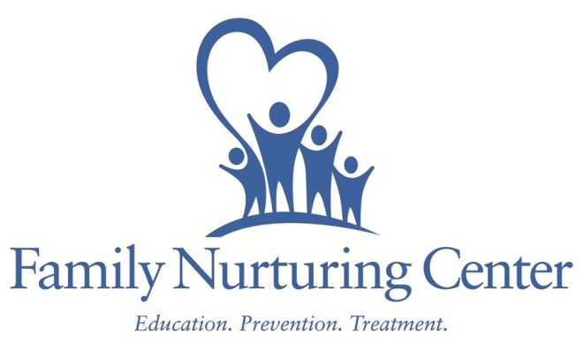
Memorandum of Understanding
Parties: Family Nurturing Center
Boone County Schools

The purpose of this memorandum of understanding is to outline the roles and responsibilities of each party in the provision of on-site child abuse treatment services. Through the generosity of funders including Boone County Fiscal Court, United Way of Greater Cincinnati, KY Justice Cabinet/Victims of Crime Acts and local foundations and donors, this program is offered at no cost to the school or the students.
Family Nurturing Center agrees to:
-Provide qualified staff to lead groups on site at designated Boone County Schools.
-Deliver 10 – 12 weeks of programming based on agreed upon schedule to address the impact of child abuse & neglect.
-Provide paperwork and program information for relevant parties.
-Collaborate with school personnel to ensure effective service provision.
Boone County Schools agree to:
-Refer appropriate children to Family Nurturing Center to determine eligibility.
-Provide space on site at designated school during school time, and allow referred students to participate.
-Share appropriate information on students with signed release of information forms.
-Assist in distributing and collecting necessary paperwork, permission forms and confidentiality statements.
-Collaborate with Family Nurturing Center to ensure effective service provision.

This agreement is effective on date of signature and ongoing, but may be cancelled with 15 days written notice by either party.

Family Nurturing Center Authorized Representative Boone County Schools Authorized Representative

Date Date

