# THIS IS A DECISION PAPER

**TO: HARDIN COUNTY BOARD OF EDUCATION**

**FROM: Teresa Morgan, Superintendent**

**DATE: SEPTEMBER 5, 2024**

**SUBJECT: APPROVAL BG 4s Site and Surface for the NHHS Turf Project**

**ISSUE:**

KDE requires BG 4s to begin closing out a project. All the work is complete and the fields look great.

# FACTS:

**BG 4’s**

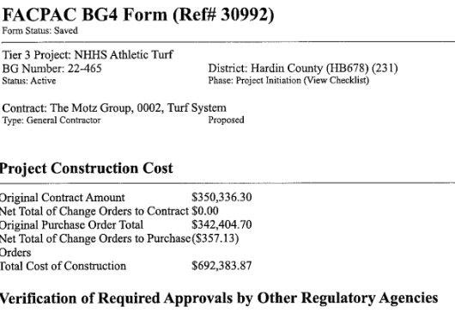

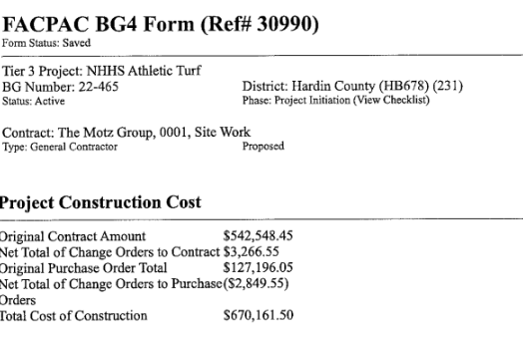

# RECOMMENDATION

**I RECOMMEND THE BOARD APPROVE the BG 4s for the NHHS turf project.**

# 

**RECOMMENDED MOTION**

**I MOVE THE BOARD APPROVE BG 4s for the NHHS Turf project.**