CONSENT ITEM D
January 22, 2024
OLDHAM COUNTY BOARD OF EDUCATION
CONCERN
Consider Approval of Contracts in excess of $20,000 and Post-Approval of Contracts less that $20,000.
DISCUSSION
Pursuant to Board Policy 3055, the Superintendent can approve contracts for transactions of less than $20,000 in value, subject to post approval by the Board of Education. Below are listed the name of the contract vendor, the subject of the contract, and the amount of the contract for contracts of less than $20,000 that were approved by the superintendent, and contracts in excess of $20,000 that must be approved by the Board.
School/Dept | Vendor | Subject | Amount
NOMS | Rachels Challenge | Professional Development | $3,600.00
NOHS | Seelbach Hotel | Prom Rental Venue | $2,500.00
NOHS | Concord | Play rights Contract | $2,307.20
NOHS | Swank | Streaming services | $1,400.00
OCMS | Institute at Tremont | School Trip-Nature Club | $1,430.00
OCMS | Miller Transportation | Transportation to Tenn | $5,400.00
OCMS | YMCA | Rental Indoor Soccer | $400.00
OCHS | Solution Tree | Professional Development-Onsite | $13,000.00
OCHS | Concord | Play rights Contract | $2,702.13
OCHS | BSN Sports | Promotional Products/Teamwear | Rebates per $$
SOMS | Rachels Challenge | Professional Development | $4,600.00
OCAC | MTI-Seuss | Play rights contract | $ 1,835.00
SOHS | TMA | Band Competition | $0
SOHS | All Occasions | Table Rental | $1,545.00
SOHS | TRW License Agreement | Play rights Contract | $2,350.00
SOHS | Comfort Inn | Speech Team Hotel | $99.00 per room
DISTRICT | BHS TYTO | TYTO Contract | -

RECOMMENDATION
Approved the attached contracts and authorized the Superintendent and Secretary of the Board, or his designee, to execute all the above contracts, and ratified any contracts of these contract signed prior to formal approval.

On motion by _______________, seconded by _______________, the Board approved the attached contracts and authorized the Superintendent and Secretary of the Board, or his designee, to execute all of the above contracts, and ratified any contracts of these contract signed prior to formal approval. ( - )

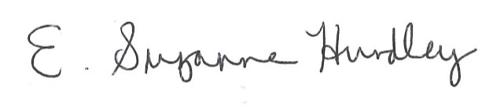
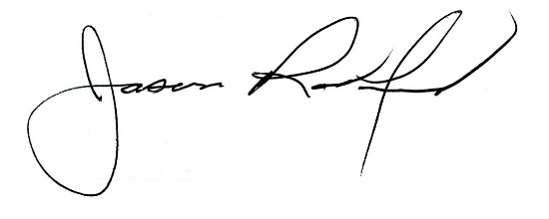

Suzanne Hundley, Board Chair Jason Radford, Ed.D, Superintendent

