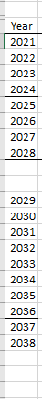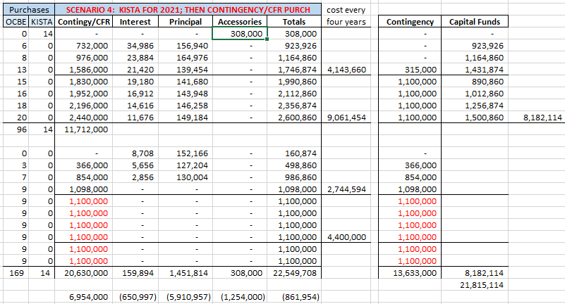

Notes:
FY21 we also received a bus via VW Settlement for a reduced price. Can reduce the FY22 budget by 1.

