**SUPERINTENDENT REPORT C**

**August 26, 2024**

**OLDHAM COUNTY BOARD OF EDUCATION**

**CONCERN**

Consider a report on OCS summer Professional Development.

**DISCUSSION**

**TEACHER ONBOARDING PROGRAM (TOP)**

**What is a highlight from today's sessions?**

Quote: "Meeting other first year teachers and learning together about teaching strategies and engagement techniques. All the presenters were very enthusiastic and engaging. Hearing from veteran teachers and listening to their advice. Getting specific strategies on how to facilitate discourse as well as how to cultivate a safe environment."

**Themes in teacher feedback:**

Engaging and Practical Learning Experiences

* Teachers found our sessions on instructional strategies, engagement techniques, and classroom tools to be very helpful. They found that these could be applied in their classrooms immediately. They also appreciated learning from experienced educators and engaging presenters.

Social Emotional Learning (SEL) and Classroom Environment

* SEL sessions were highlighted as valuable. Teachers shared their excitement about implementing SEL practices, improving classroom management, and creating a supportive learning environment for all students. Their feedback on this topic underscored the importance of addressing both the academic and emotional aspects of teaching.

Networking and Collaboration

* Many teachers shared how much they enjoyed meeting other teachers, especially new educators. They shared how much they appreciated the opportunity to build relationships and share their personal experiences as they begin their teaching journey in Oldham County.

Time Management and Session Structure

* While the content shared during the teacher onboarding program was generally well received, some teachers indicated that they would like the pacing of our sessions to change in the future. A few teachers suggested shorter, more focused sessions. A few teachers suggested adding additional breaks and opportunities to move. We will take these suggestions into account when planning the teacher onboarding program next year.

**CONTENT PD DAYS**

**What is a highlight from today's sessions?**

Quote: "The morning session was great! Lots of hands-on experience with how the different elements (3D) of the standards should/can be utilized in a classroom. Strategies that I can immediately apply to my class. Learning strategies to engage readers and writers. Being able to discuss content and strategies with other people in the district teaching the same class."

**Themes in teacher feedback:**

Collaboration and Peer Interaction

* Many teachers shared how much they appreciated working with colleagues, collaborating with peers, and having time to work in their professional learning communities (PLC). They also appreciated the opportunity to share ideas and plan together.

Practical Strategies and Resources

* We received significant positive feedback about learning new, practical teaching strategies that could be immediately applied in the classroom. Teachers valued receiving resources, tools, and activities that they could use with students this fall.

Content-Specific Learning

* Many teachers expressed appreciation for content specific sessions, and the opportunity to work with colleagues in a particular subject area. This included positive feedback around our current pilot of OpenSciEd in secondary science classrooms and other content specific teaching strategies in social studies, ELA, and mathematics.

Engaging Presenters and Sessions

* Several teachers shared their appreciation for the quality of presenters or sessions. They found the content shared to be valuable, engaging, and informative. The quality of the presentations and the presenter's expertise were frequently highlighted.

Time for Application and Planning

* Many teachers valued having dedicated work time with their colleagues. This allowed them to learn, plan lessons, and develop projects together based on the information and instructional strategies presented.

**ELEVATE CONFERENCE & IGNITE CONFERENCE**

**What is a highlight from today's sessions?**

Quote: "We had such useful topics addressed and incredibly professional and knowledgeable presenters! Well done!"

**Themes in teacher feedback:**

Artificial Intelligence (AI) in Education:

* Many teachers highlighted AI related sessions as being particularly valuable. They appreciated learning about AI tools, their potential applications in the classroom, and how to integrate AI responsibly into a learning environment with students.

Engagement and Instructional Strategies

* There was a great deal of positive feedback on sessions covering student engagement techniques, instructional strategies, and differentiation. Teachers found these sessions practical and applicable to their classrooms.

Teacher Choice and Variety

* Teacher choice was highlighted by many participants. Teachers greatly appreciated the ability to choose sessions that were relevant to their needs and interests. The variety of topics and the conference style format with multiple sessions was highlighted.

Collaboration and Peer Learning

* Many teachers valued the opportunity to learn from colleagues across the district. They appreciated hearing different perspectives and learning about strategies that their peers were using in the classroom.

Mental Health and Well-being:

* Sessions on topics like anxiety, burnout prevention, and creating a positive classroom environment were mentioned as valuable. Teachers felt that this was positive because it addressed both student and teacher well-being.

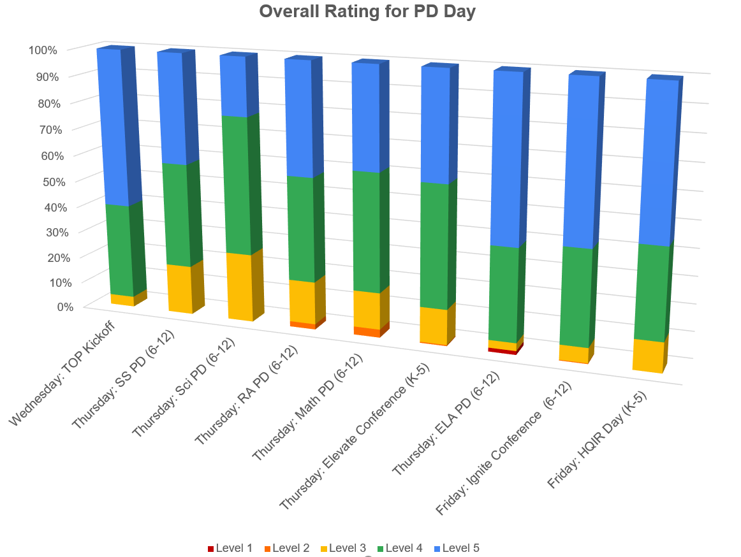

**RECOMMENDATION**

Take the report under advisement