CONSENT ITEM J
August 26, 2024
OLDHAM COUNTY BOARD OF EDUCATION
CONCERN
Consider Approval of District Federal Assurances for FY25.
DISCUSSION
As part of both state and federal programs, the Board of Education must approve the submission of Federal Assurances annually so that federal funds may be awarded to the District.
In the Assurances, the Superintendent is declaring that all schools and the district are in compliance with all of the assurances described in our completed Assurances Report.
Additionally, all principals and relevant district personnel have been sent a copy of the assurances to review and confirm. A copy of these confirmations is on file in the board office. The Board must approve the submission of these assurances before any federal funds can be awarded to the district for the 2024-2025 school year.
RECOMMENDATION
Approve FY25 District Federal Assurances as submitted.

On a motion by _______________, seconded by _______________, the Board approved the Oldham County Schools District Assurances for FY25. ( - )

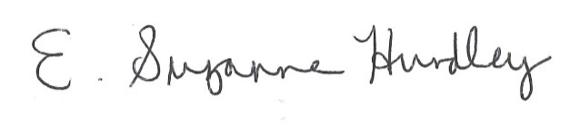
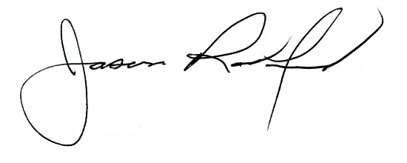

Suzanne Hundley, Board Chair Jason Radford, Superintendent/Secretary

