MINUTES
October 14, 2024
OLDHAM COUNTY BOARD OF EDUCATION
CONCERN
Consider Approval of Meeting Minutes.
DISCUSSION
The draft minutes of the September 23, 2024, Regular Board Meeting, October 3, 2024-Special Called SBDM Meeting, and the October 8, 2024, Special Called Expulsion Hearing are available for review and approval.
RECOMMENDATION
Approve the minutes of the following meetings as presented.
September 23, 2024 – Regular Board Meeting
(1) Suzanne Hundley, Chairperson, (2) Larry Dodson, Board Vice Chair; and (3) Joe Dennis, Board Member, (4) Carly Clem, Board Member (5) Allison Sheffer, Board Member, and Dr. Jason Radford, Superintendent and Secretary to the Board were present.
October 3, 2024 – Special Called SBDM Board Meeting
(1) Suzanne Hundley, Chairperson, (2) Larry Dodson, Board Vice Chair; and (3) Joe Dennis, Board Member, (4) Carly Clem, Board Member (5) Allison Sheffer, Board Member, and Dr. Jason Radford, Superintendent and Secretary to the Board were present.
October 8, 2024 – Special Called Expulsion
(1) Suzanne Hundley, Chairperson, (2) Larry Dodson, Board Vice Chair; and (3) Joe Dennis, Board Member, (4) Carly Clem, Board Member (5) Allison Sheffer, Board Member, and Dr. Jason Radford, Superintendent and Secretary to the Board were present.

On a motion by _______________, seconded by _______________, the Board approved the minutes of the September 23, 2024, Regular Board Meeting. ( , )
On a motion by _______________, seconded by _______________, the Board approved the minutes of the October 3, 2024-Special Called Meeting. ( , )
On a motion by _______________, seconded by _______________, the Board approved the minutes of the October 8, 2024-Special Called Expulsion Hearing. ( , )
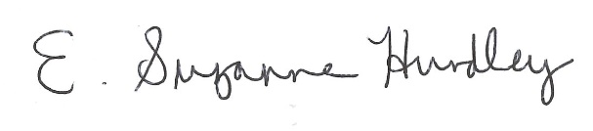
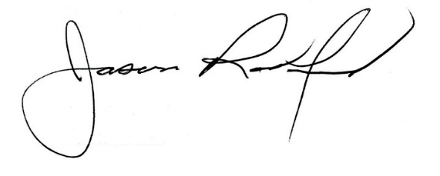

___________________________________ ______________________________
Suzanne Hundley, Board Chair Jason Radford, Superintendent/Secretary

