ACTION ITEM A
October 14,2024
OLDHAM COUNTY BOARD OF EDUCATION
CONCERN
Consider Bus Purchase Authorization.
DISCUSSION
As per our Anticipated Bus Purchase schedule, we are scheduled to purchase fifteen buses this year. Because of the reduction of drivers and routes we are recommending twelve buses. Our current transportation fleet is in need of additional large-capacity buses, conventional C2 buses and special needs buses. Included with this enclosure is the Annual Anticipated Bus Budget and the KDE Bus Purchase Authorizations that must be completed to procure new buses for the 2024 -2025 school year.
RECOMMENDATION
Approve the Bus Purchase:
- Five large-capacity (78 passenger) buses in the amount of $956,795.00
- Three conventional C2 (66 passenger) buses in the amount of $445,515.00
- Two conventional C2 special needs (34 passenger) buses in the amount of $350,436.00
- Two conventional C2 special needs (20 passenger) buses in the amount of $331,298.00

Total purchase cost for twelve buses: $2,084,044.00

On a motion by _______________, seconded by _______________, the Board approved the Bus Purchase:
- Five large-capacity (78 passenger) buses in the amount of $956,795.00
- Three conventional C2 (66 passenger) buses in the amount of $445,515.00
- Two conventional C2 special needs (34 passenger) buses in the amount of $350,436.00
- Two conventional C2 special needs (20 passenger) buses in the amount of $331,298.00

Total purchase cost for twelve buses: $2,084,044.00

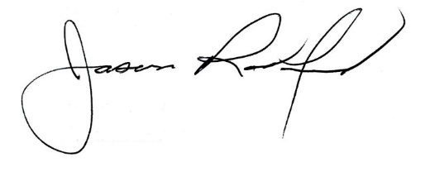
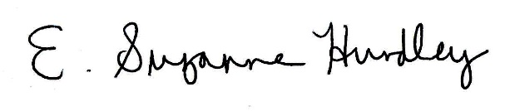

Suzanne Hundley, Board Chair Jason Radford, Superintendent/Secretary

