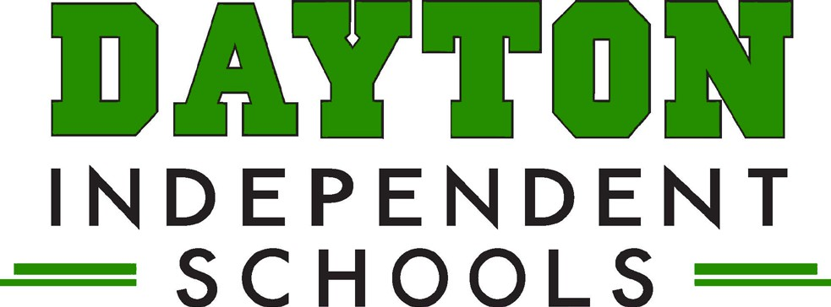

Grants Report

**October 23, 2024**

**Grants in Progress:**

* McKinney Vento Grant -
* Positive Action Grant
* Northern Kentucky Institute for Arts Integration
* Trauma Informed School Services
* School Based Mental Health Grant
* Prichard Community Schools Grant
* 21st Century Community Learning Grant

**Grants Submitted and Pending:**

* James and Martha Brown Foundation Grant

**Grants Available:**