Academic Services
April 2024 Board Report
Submitted by Alison Teegarden

Curriculum & Instruction
- Summer Learning
  - Now accepting student applications for GES
    - Open to all current K-5 students
  - A narrowed focus at BM/HS
    - Middle school and grade 12 students
  - Both schools will partner with YMCA/ 21st Century for enrichment opportunities
- Search for new ELA Resources at GES
  - Process underway for stakeholder input
  - Final three contenders:
    - Amplify’s CKLA
    - HMH’s Into Reading
    - McGraw Hill’s Wonders
      - if a password is needed: Wonders2023

Continuous Improvement
- Submission of Phase Four of Continuous Improvement by May 1 for District and School:
  - 23.24 GES PD plan
  - 23.24 BHS PD plan
  - 23.24 District Lau Plan
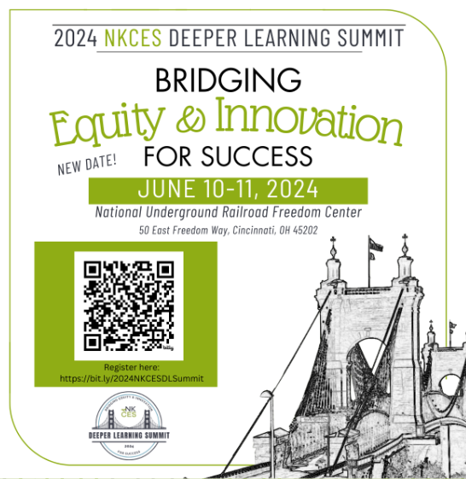
  - 23.24 District Continuation of Learning Plan
Professional Learning
- Regional Deeper Learning Summit June 10-11
  - 9 staff members to attend from GES
  - 6 staff members to attend from BMHS

