CONSENT ITEM I
January 22, 2024
OLDHAM COUNTY BOARD OF EDUCATION
CONCERN
Consider the selection of Trace 3 for the Fiscal Year 2025 Universal Power Supply (UPS) refresh in the amount of $122,267.93 for the following locations:

- Arvin Education Center
- Buckner Alternative
- Buckner Elementary
- Camden Station
- Centerfield
- East Middle
- North High
- North Middle
- South Middle
- Crestwood
- Goshen

DISCUSSION
After our first UPS refresh in calendar year 2018, we collected industry data to develop a refresh plan for our network infrastructure. That plan sets a wired network refresh every 5 years. Fiscal Year 2025 will be the first of a two-year refresh for the district.
On November 28th, 2023, an FCC 470 and bid were released for this first refresh and was on the street until December 27, 2023. The advertisement was subject to USAC program rules and KETS contracts. Two vendors responded to the bid. A committee reviewed and scored the proposals based upon price, compliance with the specifications, level of service provided without additional cost, technical solution and references.
The lowest bid and the recommended vendor was Trace 3 in the amount of $122,267.93. It is the intent to fund this entire project from prior USAC reimbursements and no additional funding is being requested.
All procedures have been followed and paperwork will be filed with USAC to receive 50% reimbursement on the cost of this project, estimated to be $61,133.96.
RECOMMENDATION
Select Trace 3 for the Fiscal Year 2025 UPS refresh in the amount of $122,267.93 pending USAC’s approval and Funding Commitment Decision Letter.

On a motion by _______________, seconded by _______________, the Board approved the Select Trace 3 for the Fiscal Year 2025 UPS refresh in the amount of $122,267.93 pending USAC’s approval and Funding Commitment Decision Letter.

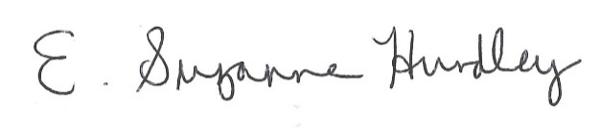
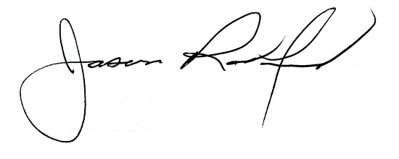

Suzanne Hundley, Board Chair Jason Radford, Superintendent/Secretary

