ACTION ITEM C
January 22, 2024
OLDHAM COUNTY BOARD OF EDUCATION
CONCERN
Consider Bus Purchase Authorization.
DISCUSSION
As reviewed during our New Board Member Orientation last spring with the Board, our transportation fleet is in need of additional large-capacity buses, conventional C2 buses and special needs buses. Included with this enclosure is the Annual Anticipated Bus Budget and the KDE Bus Purchase Authorizations that must be completed to procure new buses for the 2023 -2024 school year.
RECOMMENDATION
Approve the purchase of three large-capacity (78 passenger) buses in the amount of $545,910.00
Approve the purchase of six conventional C2 (66 passenger) buses in the amount of $849,540.00
Approve the purchase of four conventional C2 special needs (52 passenger) buses in the amount of $670,976.00
Total purchase cost for thirteen buses, $2,066,426.00

On a motion by _______________, seconded by _______________, the Board the purchase of:
Approve the purchase Three large-capacity (78 passenger) buses in the amount of $545,910.00
Approve the purchase of six conventional C2 (66 passenger) buses in the amount of $849,540.00
Approve the purchase of four conventional C2 special needs (52 passenger) buses in the amount of $670,976.00.
Total purchase cost for thirteen buses, $2,066,426.00. ( - )

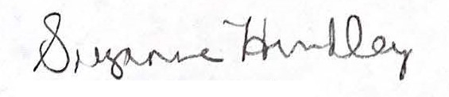
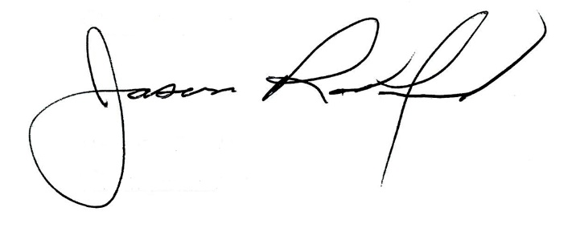

Suzanne Hundley, Board Chair Jason Radford, Superintendent/Secretary

