CONSENT ITEM A
October 3, 2024
OLDHAM COUNTY BOARD OF EDUCATION
CONCERN
Consider Approval of Field Trips Requesting Overnight Stay & Field Trips Requesting Use of Common Carrier.
DISCUSSION
The following are field trips requesting overnight stay and trips requesting use of a common carrier:
SCHOOL | GROUP | LOCATION/DATE | JUSTIFICATION | INSTR. DAYS LOST
NOMS | Club Atlas | Washington, DC  April, 30-May 2, 2025 | Overnight: learning trip  Air | 3
SOMS | Club Atlas | Washington, DC  April 27-April 29, 2025 | Overnight: learning trip  Air | 2
Approve the field trips as attached and described above, pursuant to the condition that students not traveling on school buses, with their parents, or with a Board employee whose insurance carrier has named OCBE as an additional named insured, will be transported to and from their destination on an approved charter bus(es) and school(s) shall obtain written evidence of liability.

On a motion by _______________, seconded by _______________, the Board approved the field trips as attached and described above, pursuant to the condition that students not traveling on school buses, with their parents, or with a Board employee whose insurance carrier has named OCBE as an additional named insured, will be transported to and from their destination on an approved charter bus(es) and school(s) shall obtain written evidence of liability. ( , )
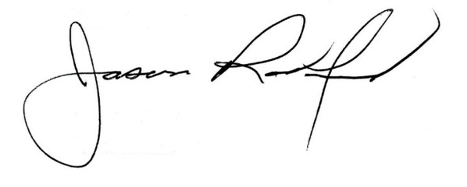
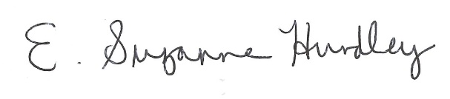

Suzanne Hundley, Board Chair Jason Radford, Superintendent/Secretary

