CONSENT ITEM J
January 22, 2024
OLDHAM COUNTY BOARD OF EDUCATION
CONCERN
Consider the selection of Step CG for the Fiscal Year 2025 wired network refresh in the amount of $611,208.38 for the following locations:

- Arvin Education Center
- Buckner Alternative
- Buckner Elementary
- Camden Station
- Centerfield
- East Middle
- North High
- North Middle
- South Middle
- Crestwood
- Goshen
DISCUSSION
After our first network refresh in calendar year 2018, we collected industry data to develop a refresh plan for our network infrastructure. That plan sets a wired network refresh every 5 years. Fiscal Year 2025 will be the first of a two-year refresh for the district.
On November 28th, 2023, a mini-bid was released for this first refresh and was on the street until December 27, 2023. The mini-bid advertisement was subject to USAC program rules and KETS contracts. Several KETS contract holders responded to the bid. A committee reviewed and scored the proposals based upon price, compliance with the specifications, district personnel’s capability for management, prior experience with vendors and technical solution.
The lowest bid was from Encore in the amount of $505,106.41, however the committee recommends Step CG’s bid, based upon the attached evaluation matrix in the amount of $611,208.38. It is the intent to file a capital outlay request for this project next fiscal year (FY2025). This project will be included in next year’s budgeting cycle and no additional funding is being requested.
All procedures have been followed and paperwork will be filed with USAC to receive 50% reimbursement on the cost of this project, estimated to be $305,604.19.
RECOMMENDATION
Select Step CG for the Fiscal Year 2025 wireless refresh in the amount of $611,208.38 pending USAC’s approval and Funding Commitment Decision Letter.

On a motion by _______________, seconded by _______________, the Board approved the Select Step CG for the Fiscal Year 2025 wireless refresh in the amount of $611,208.38 pending USAC’s approval and Funding Commitment Decision Letter.

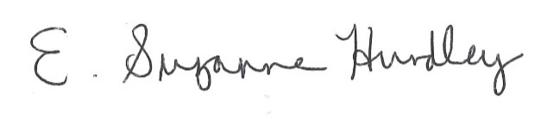
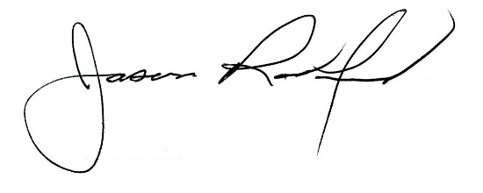

Suzanne Hundley, Board Chair Jason Radford, Superintendent/Secretary

