ACTION ITEM A
August 7, 2024
OLDHAM COUNTY BOARD OF EDUCATION
CONCERN
Consider Emergency Approval of Policy Revisions
DISCUSSION
Consider Emergency approval of policies that require approval with an emergency provision due to the start of the 2024-2025 school year.
NUMBER | NAME OF POLICY | REASON FOR AMENDMENT/ADDITION
M02.31 | School Resource Officers (SROs) | Adoption of the correct SRO policy.
BA03.1233 | Parental Leave  Certified | Revision of Parental Leave for Certified Staff
AX03.2233 | Parental Leave  Classified | Revision of Parental Leave for Classified Staff

RECOMMENDATION
Approve the aforementioned policies as presented.

On a motion by _______________, seconded by _______________, the Board approved the policies that require approval with an emergency provision due to the start of the 2024-2025 school year. ( , )

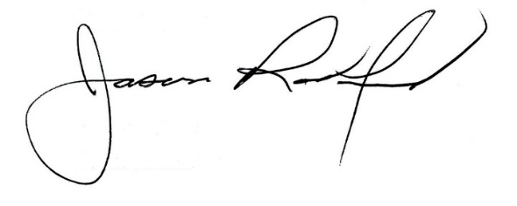
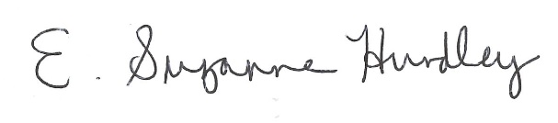

Suzanne Hundley, Board Chair Jason Radford, Superintendent/Secretary

