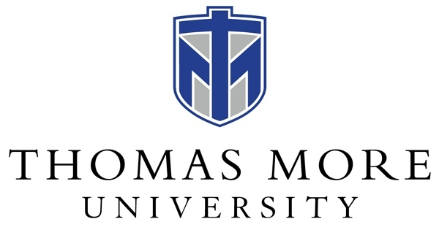

Memorandum of Agreement

Programs and Services Available to School Systems

This agreement is entered into by the Board of Education of the Beechwood Independent School District and Thomas More University, Education Department, Crestview Hills, KY

This memorandum describes the programs and services available to the below noted education agency through the Education Department at Thomas More University. These programs and services are available at no cost to the education agencies in the indicated service area of the University and are available upon request.

The Following Services are available to the Beechwood Independent School District:

- Practicum Supervision:

Undergraduate Teacher Education Program: The practicum experience component at Thomas More University involves at least two 30-75-hour placements in classrooms depending on teacher certification levels. The Director of Field Placements and the course instructors shall collaborate carefully with school personnel to assign cooperating teachers with teacher candidates.

- Clinical Field Experience/Student Teacher Supervision:

Undergraduate Teacher Education Program: The clinical field experience component at Thomas More University involves a 15-week field experience (70 days) for all teacher candidates. Elementary and Middle School teacher candidates require one 8-week placement and one 7-week placement in two different schools, in different grade levels. Teacher candidates in P-12 content areas (Art, Theatre, Spanish) and grades 5-12 (Business and Marketing) will be assigned to two placements depending on the program. The Director of Field Placements carefully collaborates with school personnel to assign cooperating teachers with teacher candidates.

Under 16 KAR 5:040, cooperating teachers will complete co-teaching training at an Institution of Higher Education in order to supervise a student teaching candidate.

Cooperating teachers are also asked to attend the Thomas More University Student Teaching Orientation meeting held in the spring or fall prior to the supervision of the teacher candidate.

- Joint Professional Growth Opportunities: Thomas More University faculty will offer joint professional growth opportunities and school-based research opportunities between the education agency and the university faculty that contribute to the profession.

Additional Provisions:

Thomas More University teacher candidates are required to obtain the following prior to entering the field for practicum placement:

- Criminal History Record by the Administrative Office of the Courts (KY)*
- VIRTUS background check via Selection.com: All teacher candidates are required to complete VIRTUS training in Education 101 and maintain an “active status” throughout the entire education program. VIRTUS Training is a requirement of the Diocese of Covington and indicates that our teacher candidates are trained in sexual abuse and sexual misconduct with minors.
- Physical Restraint and Seclusion Training: Thomas More University teacher candidates are required to participate in the Physical Restraint and Seclusion Training. Certificates of Completion are maintained in student files in the Education Department and available upon request.

Thomas More University teacher candidates are required to obtain the following prior to clinical field experience:

- Criminal Records Check*, which includes:
- Criminal History Search
- Sex Offender Registry Search
- FBI Fingerprint Check
- TB Test
- Child Abuse or Neglect Check (CAN)/Central Registry Check Form

*Background checks on record at Thomas More University will be applicable to all
education agencies that candidates visit during the course of study at Thomas
More University. Thomas More University will provide copies of background checks
to education agencies upon request.

Expenses for all background checks are incurred by the teacher candidates.

Thomas More University agrees to inform its teacher candidates that they shall be responsible for following the rules and regulations of the education agency, including recognition of the confidential nature of information regarding pupils and their records.

Thomas More University will keep all records and reports on teacher candidate experiences in accordance with the policy and regulatory requirements.

Provisions Applicable to the Education Agency:

- The education agency will allow teacher candidates to collaborate with his/her supervising teacher using any combination of face-to-face and virtual learning, following district provisions.

- The education agency, upon request by the teacher candidate or the Institution, will provide policies and procedures and other relevant materials to allow the teacher candidate to function appropriately within the education agencies.

- The education agency, upon request by Thomas More University and the Education Professional Standards Board, will provide feedback regarding teacher candidates and the Teacher Education Program via (but not limited to) Employer Surveys, Graduate Surveys, and New Teacher Surveys.

- Teacher candidates observing in the education agency shall follow the education agency’s protocols for health and safety.

- Teacher candidates shall not remove materials from any of the education agency’s property without appropriate approval.

Entered into this day, the 14th of June, 2023.

