CONSENT ITEM A
October 14, 2024
OLDHAM COUNTY BOARD OF EDUCATION
CONCERN
Consider Approval of Field Trips Requesting Overnight Stay & Field Trips Requesting Use of Common Carrier.
DISCUSSION
The following are field trips requesting overnight stay and trips requesting use of a common carrier:
SCHOOL | GROUP | LOCATION/DATE | JUSTIFICATION | INSTR. DAYS LOST
NOMS | KYA | Crowne Plaza  Nov 7-9, 2024 | Overnight: KYA  Parents | 2
SOHS | Boys Basketball | Bowling Green  December 21-22, 2024 | Overnight: Tournament  Parents | 0
SOHS | Boys Basketball | Campbellsville, KY  December 26-28, 2024 | Overnight: Tournament  Parents | 0
OCMS | Honor Choir | Lexington, KY  November 1-2, 2024 | Overnight: Competition  Parents | .5
EOMS | KYA | Crowne Plaza  Nov 7-9. 2024 | Overnight: KYA  Parents | 2
OCHS | Choir | Gatlinburg, TN  May 1-4, 2025 | Overnight: Performance  Charter Bus | 1
OCHS | Baseball | Panama City  March 30-April 4, 2025 | Overnight: Spring Break Trip  Parents | 0
NOHS | Girls Cross Country | Gatlinburg, TN  July 26-32, 2025 | Overnight: Training Camp  Parents | 0
OCMS | KYA | Crowne Plaza  Nov 7-9, 2024 | Overnight: KYA  Parents | 2
SOMS | KYA | Crowne Plaza  Nov 7-9, 2024 | Overnight: KYA  Parents | 2
Approve the field trips as attached and described above, pursuant to the condition that students not traveling on school buses, with their parents, or with a Board employee whose insurance carrier has named OCBE as an additional named insured, will be transported to and from their destination on an approved charter bus(es) and school(s) shall obtain written evidence of liability.

On a motion by _______________, seconded by _______________, the Board approved the field trips as attached and described above, pursuant to the condition that students not traveling on school buses, with their parents, or with a Board employee whose insurance carrier has named OCBE as an additional named insured, will be transported to and from their destination on an approved charter bus(es) and school(s) shall obtain written evidence of liability. ( , )
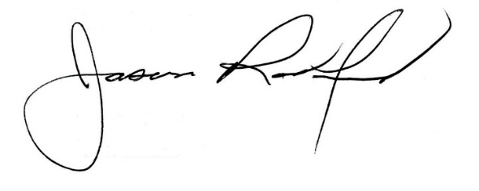
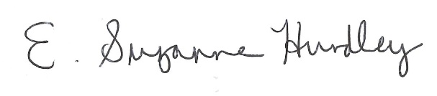

Suzanne Hundley, Board Chair Jason Radford, Superintendent/Secretary

