CONSENT ITEM F
August 26, 2024
OLDHAM COUNTY BOARD OF EDUCATION
CONCERN
Consider Approval of FY25 ARC Chairs
DISCUSSION
The following ARC Chairs require approval by the Board for FY25
SCHOOL | ARC CHAIR
Oldham County Preschool | Seanna Bezehertny
Buckner | Amanda Taylor
Camden | Tricia Judy
Centerfield | Tricia Judy
Crestwood | Brigid Taylor
Goshen | Kristen Eichler
Harmony | Kristi Kremer
Kenwood | Kristi Kremer
LaGrange | Kristen Eichler
Locust Grove | Amanda Taylor
EOMS | Michelle Schoengart
NOMS | Bonnie Koontz
OCMS | Michelle Schoengart
SOMS | Bonnie Koontz
BAHS | Jamie Brown
NOHS | Gabriel Cesarz  Jacki Hunsaker
OCHS | Natalie Dorris  Jacki Hunsaker
SOHS | Kayla Peege
YATP-Arvin | Jennifer Hallas
Central Office Personnel | Niki Brown  Jennifer Hallas  Bethony Keil  Tammy Redecker  Braxton Hall  Angela Lange  Sarah Heitzman  Julie Sackella  Kendra Smith-Wehr
RECOMMENDATION
Approve the FY25 ARC Chairs.

On a motion by _______________, seconded by _______________, the Board approved the FY25 ARC Chairs.

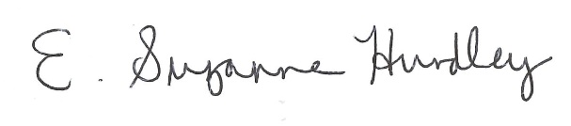
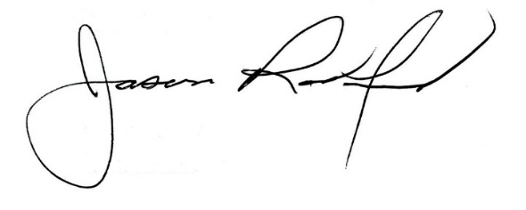

Suzanne Hundley, Board Chair Jason Radford, Superintendent/Secretary

