Strategic Prevention Framework
I³: Inspired, Individualized, Inclusive
September 2024 - October 2024
Goal: To reduce the onset & progression of substance misuse & its related problems in Bellevue, KY, by supporting the development & delivery of community substance misuse prevention & mental health promotion services.
Objective 1: | By 9/29/2027, reduce the 30-day use of alcohol among tenth-grade students by 2% each year as measured by annual KIP survey data.
Objective 2: | By 9/29/2027, reduce regular (30-day) vaping use among tenth-grade students by 2% each year as measured by annual KIP survey data.
Objective 3: | By 9/29/2027, reduce regular (30-day) cigarette smoking among tenth-grade students by 2% each year as measured by annual KIP data.
Objective 4: | By 9/29/2027, tenth-grade students reporting serious psychological distress, according to the K6 KIP data, will decrease by 4% each year.
Objective 5: | By 9/29/2027, expand collaboration with community prevention partners, demonstrated by support from community prevention partners at least 2x each year in the project’s family prevention education opportunities, documented by photographic evidence & meeting notes.

ASSESSMENT
Accomplishments | Description | Align
Assessing schools’ assets & resources: | I³ staff reviewed & updated the Resource Map | 1-5
Assessment of schools’ capacity: | I³ staff, in collaboration with GES & BMHS school leadership, are assessing capacity for SEB Tier 2 & Tier 3. | 1-5
Specification of baseline data: | SEB screener was given to all K-5 students (196)  The data will be used within the MTSS framework to proactively detect students who need support beyond Tier 1 instruction & support. | 1-4
Monitoring schools needs assessment activities: | The KIP Survey will be administered in the fall of 2024. | 1-4
Monitoring schools needs assessment activities: | Internal Referrals for mental health & prevention services.  13 internal referrals for services  7 internal referral assessments completed for services | 1-4
Monitoring schools needs assessment activities: | External Referrals for mental health & prevention services.  0 student/family external referral  0 student/family Care Solace referrals  0 staff member's Care Solace referrals | 1-4
Monitoring schools needs assessment activities: | Grant staff are collecting & monitoring data on all grant lead initiatives. This includes, but is not limited to:  - Outreach & Engagement Data  - Participation Data  - Outcome Data  - Financial Data  - Progress Monitoring | 1-5
Use of needs assessment data | Grant staff is redirecting efforts to target the community with infrastructure development initiatives. | 5
CAPACITY
Accomplishments | Description | Align
Professional Development: | SPF Grant Staff:  - UK Trauma Center on Trauma & Children through the Secondary Traumatic Stress Innovations & Solutions Center. Using the Window of Tolerance framework to discuss regulation, dysregulation, & coping strategies in the face of secondary traumatic stress.  - Secondary Traumatic Stress Core Competencies in Trauma-Informed Supervision.  - Staying Inside the Window of Tolerance: An Advanced Training on STS & Resilience  - MHLC Community of Practice - Crisis Text Line  - Strategic Planning to Strengthen Youth Programming to Reach Coalition Outcomes  - Making Sense of Health Privacy Laws: HIPAA & FERPA for School-Based Health Professionals  - Emerging High-Risk Underage Drinking Products & Advocacy Against Their Spread  - Dangers of Youth Vaping: What Parents Need to Know in 2024  - SOS Training  - Vape-Free Schools Initiative Training (Tier 1)  - INDEPTH® (Intervention for Nicotine Dependence: Education, Prevention, Tobacco, & Health) (Tier 2)  - N-O-T (Not on Tobacco®) Youth Cessation (Tier 3)  - Effective Strategies for Balancing Family Screen Time  - QPR Gatekeeper Training  GES Mental Health Professional:  - Play Therapy training continued  - Character Strong: Adult Behavior Change First building SEL  - Character Strong: 5 Activities to Reduce Bullying & Problem Behavior  - Making Sense of Health & Privacy Laws | 5
Professional Conferences: | - Annual Kentucky Prevention Network Conference – Sept 29 - Oct. 2 | 5
Building internal coalitions: | Grant staff participated in the following monthly coalition/committee meetings:  - GES PBIS Tier 2/3 Meeting  - GES Student Care Team Meeting  - GES Student Care Team - Ancillary Meeting  - BMHS MTSS Meeting  - BMHS YSC Advisory Council Meeting  - 5K Initiative Planning Committee  - Rae of Sunshine - SMILE Club Meeting  - SPF Grant Advisory Board Meeting 9.24.24 I3 Advisory Meeting | 5
Building external coalitions: | Grant staff participated in the following monthly coalition/committee meetings:  - NKY ASAP  - SBMH Grant Committee Meeting  - TISS Grant Committee Meeting & Advisory Board Work Session  - NKY Youth Summit Planning Committee Meeting  - NKISP Steering Committee Meeting  - Campbell County Drug-Free Alliance General Meeting  - Team Kentucky - Prevention & Promotion Branch | 5
Building external partnerships: | Grant staff meet with the following community partners:  - Starbucks Meeting to explore partnership in “Spill the Tea”  - Kroger – Continued support of the Dinner Table Project  - 1N5 Meeting to discuss partnership  - NKY Health Department – Exploring ways to support BISD through various initiatives such as the REACH Project & Too Good For Drugs. | 5
Other infrastructure development: | - Review & update the webpage with resources weekly. MH&Prevention Webpage  - Resource mapping review & update supports for students, staff, & families. BISD Resource Map | 5
PLANNING
Accomplishments | Description | Align
Articulation of a vision for prevention activities: | Grant staff will work with school leadership to discuss the following:  - Implementation of #iCANendthetrend, tobacco use & vaping prevention program through the UK.  - Implementing a chapter of Rae of Sunshine at BMHS  - MTSS tiered level of support & SEB Screener Capacity & Decision Rules | 1-5
Articulation of a vision for prevention activities: | Grant staff are working toward planning the following:  OCTOBER  - 10/16 - Unity Day  - 10/17 - Bi-Weekly Rae of Sunshine - SMILE Club Meetings  - 10/23 - NKY Youth Summit  - Team will be volunteering  - 10/23 - 10/31 Red Ribbon Week  - Life is a Movie: Film Drug-Free  - Red Ribbon Week Flyer  - 10/26 - National Take-back Day  - Flyers distributed & will be placed on webpage  - Take-Back Day Flyer.pdf  - Lock Box Flyer.pdf  NOVEMBER  - 11/13 - World Kindness Day  - GES - Kindness wheel  - BMHS - Random Acts of Kindness  - 11/11 - Veteran’s Day  - Staff Highlight  - 11 Ways to Show Gratitude  - Mental Health Resources for Veterans  - 11/14 - 10/17 - Bi-Weekly Rae of Sunshine - SMILE Club Meetings  - 11/15 - SPF Newsletter #2  - 11/15 - Spill the Tea  - 11/26 - Support for the Holidays  DECEMBER  - 12/12 - Bi-Weekly Rae of Sunshine - SMILE Club Meetings  - 12/17 - Dinner Table Project #2  - 12/20 - Sober Fun for the Holidays  - Abbreviated SPF Newsletter, including sober fun & support for the holidays  WINTER  - Newsletter  - Dinner Table Project  - Bi-Weekly Rae of Sunshine - SMILE Club Meetings  - Prevention Day (Jan 2025)  - #SELday  SPRING  - Newsletter  - Dinner Table Project  - Bi-Weekly Rae of Sunshine - SMILE Club Meetings  - Mental Health Roundtables  - Mental Health Month  - Mental Health Day of Action  - 5K Initiative | 1-4
Identification of the district-level priorities: | Mental Health & Prevention Services Handbook - I³ team continues to create an evidence-based policy & procedural handbook for BISD’s mental health & prevention services.  - Outlines the screening process  - Details referral process  - Includes information about MTSS | 1-5
Identification/coordination/allocation of resources: | Prevention Specialists will be trained in the following:  - Vape-Free Schools Initiative Training (Tier 1)  - INDEPTH® (Intervention for Nicotine Dependence: Education, Prevention, Tobacco, & Health) (Tier 2)  - N-O-T (Not on Tobacco®) Youth Cessation - Facilitator Training (Tier 3) | 1-3
Identification/coordination/allocation of resources: | Trauma-Informed Grant - The I³ team continues to revise BISD’s trauma-informed plan to create action steps to ensure the implementation of best practices. | 4
Identify/coord/allocate resources: | The I³ team is working with Character Strong to facilitate Tier 2 & Tier 3 SEB training w/ GES SBMH | 4
IMPLEMENTATION
Accomplishments | Description | Align
Specific community-level interventions being implemented: | Grant staff implemented the following:  - 9/01 - Tobacco/Nicotine-free flyer  - Created, distributed to parents, & posted on the website  - 9/10 - Suicide Prevention Day w/ GES SBMH  - Provided educators with resources for classrooms (state policy).  - Updated webpage with Suicide Prevention resources  - Suicide Prevention Awareness board with resources.  - GES - “I Matter” initiative to foster inclusion & positive self-awareness  - GES health class collaboration to promote positive self-talk & affirmations  - BMHS - Suicide Prevention Awareness Campaign during BMHS lunch.  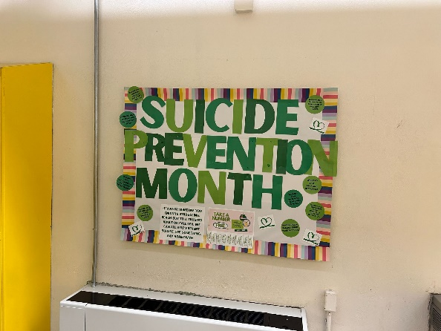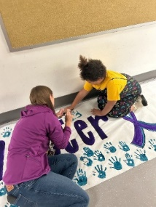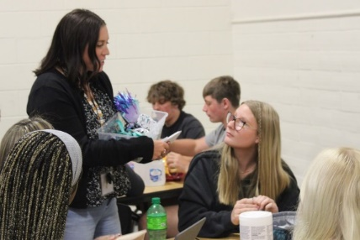  - 9/18 - Staff SEB Screener Training  - 9/26 - GES Respect/SOM celebration  - 9/27 - SPF Newsletter #1  - Prevention Newsletter #1  - 9/30 - National Recovery Day Flyer  - Posted information on the website  OCTOBER  - 10/01 - HOCO - Difficult Convo's For Parents  - Posted on webpage  - 10/03 - Fall Table Talks  - Newsletters & MH&P webpage  - 10/10 - World Mental Health Day  - 10 Ways to Take Care of Your Mental Health on 10/10 10 ways for 10_10  - Team will be at Starbucks handing out resources (Spill the Tea)  - World MH Day "Spill the Tea" w/ Starbucks  - 10/15 - Dinner Table Project #1  - Placemat – Front/Back  - Sample Game Convo Cards  - Meal – White Chicken Chili (donated by Kroger)  - Literacy – TBD  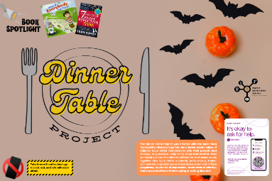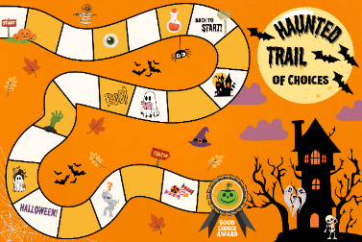  - 10/16 - Unity Day  - Bulletin Board & wear orange  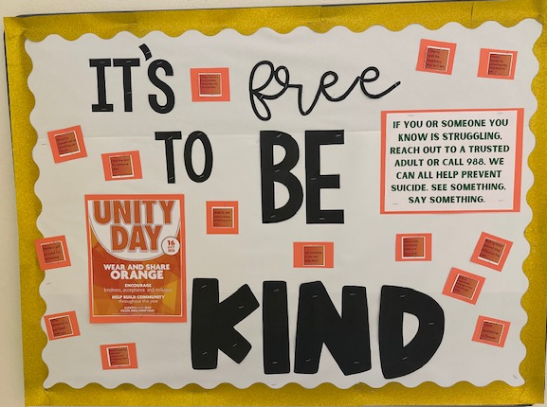 | 1-5
Implemented policies within organizations to facilitate interventions | Grant staff works with the following grants to created procedures for the BISD mental health & prevention team in response to students' & families' mental health & prevention needs. These align with best practices.  - Trauma-Informed Grant  - Grant staff continues to work with TISS Grant to revise BISD’s trauma-informed plan & create action steps to ensure the implementation of best practices.  - School-Based Mental Health Grant  - Grant staff continues to work with SBMH Grant to review & revise BISD’s Mental Health plan & create action steps to ensure the implementation of best practices.  - Prevention  - Grant staff continues to review & revise BISD’s Prevention plan, creating action steps to ensure the implementation of best practices.  - Created district tobacco/nicotine-free procedure in response to HB-142; the procedure was added to the Code of Conduct and middle/high school behavior matrix. | 4
Specific community-level interventions being implemented: | GES SBMH Breakdown of time and/or student reached/seen from 9/12/24 -10/3/24:  - Direct sessions: 440 minutes = 7.3 hours  - Additional sessions: 90 minutes = 1.5 hours  - Groups: 270 minutes = 4.5 hours  - Tier 2 performance: 90 minutes = 1.5 hours  - Continuity of care meetings: 400 minutes = 6.7 hours  GES Caseload Numbers:  - Active cases: 4  - Tier 2 performance: 2  - Referrals: 0 | 4
Developed systems for distributing resources: | 5 lockboxes have been provided to families of students. | 1-3
EVALUATION
Accomplishments | Description | Align
Monitor & evaluate all activities: | Evaluating SEB data to support our developing MTSS. | 4
Grant Reporting: | - SPF SPARS Quarter 3 Report - Accepted  - SPF SPARS Quarter 4 Report - Due Oct. 31  - SPF eRa Commons Annual Performance Review - Due Dec.31

SUSTAINABILITY
Planning for sustaining the infrastructure: | Continue developing & improving the district's MTSS system & mental health support. SEL teams deliver substance abuse prevention curriculum to students.

