CONSENT ITEM F
October 14, 2024
OLDHAM COUNTY BOARD OF EDUCATION
CONCERN
Consider approval of student requests for early graduation due to hardship and waiver of 8 semester requirement.
DISCUSSION
The following students are requesting early graduation due to hardship and waiver of 8 semester requirement:
- Y.T. is an 18-year-old senior at OCHS
- Y.D. is a 17-year-old senior at OCHS
- H.T. is a 17-year -old senior at OCHS
- A.W. is a 17-year-old senior at OCHS
- I.N. is a 17-year-old senior at OCHS
- S.R. is a 17-year-old senior at OCHS
- M.R. is an 18-year-old senior at OCHS
- T.M. is a 17-year-old senior at BAHS
- I.H. is an 18 year old senior at NOHS
Documents to support this request follow this enclosure for your review and consideration.
RECOMMENDATION
Approve the student requests for Early Graduation due to hardship and waiver of 8 semester requirement.

On a motion by _______________, seconded by _______________, the Board approved the Early Graduation Due to Hardship Request and waiver of 8 semester requirement for students as presented. ( - )

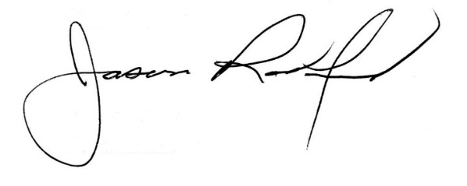
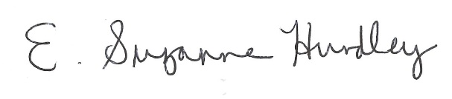

Suzanne Hundley, Board Chair Dr. Jason Radford, Superintendent/Secretary

