CONSENT ITEM H
August 26, 2024
OLDHAM COUNTY BOARD OF EDUCATION
CONCERN
Consider Shortened School Day request for OCS students.
DISCUSSION
The following students have requested a Shortened School Day. Details for each student follow this enclosure for your review.
STUDENT | SCHOOL
A.M. | SOHS
A.L. | NOMS
B.T. | HA
E.M. | CE
I.S. | LA
O.S. | LA
W.D. | SOMS
Z.V. | SOHS
G.D | KW
RECOMMENDATION
Post-approve the shortened school day request for these students.

On a motion by _______________, seconded by _______________, the Board post approved the Shortened School Day requests as submitted. ( - )

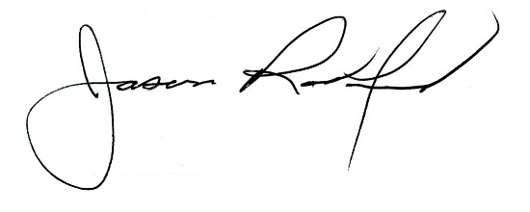
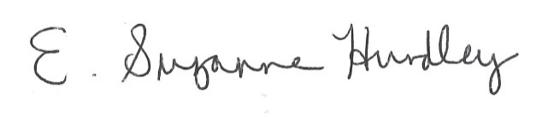

Suzanne Hundley, Board Chair Jason Radford, Superintendent/Secretary

