CONSENT ITEM F
September 23, 2024
OLDHAM COUNTY BOARD OF EDUCATION
CONCERN
Consider approval of student requests for early graduation due to hardship and waiver of 8 semester requirement.
DISCUSSION
The following students are requesting early graduation due to hardship:
- G.A. is a 17-year-old senior at NOHS
- P.A. is a 17-year-old senior at OCHS
- B.B. is a 17-year -old senior at OCHS
- S.B. is a 19-year-old senior at OCHS
- C.T. is an 18-year-old senior at OCHS
- E.S. is a 17-year-old senior at OCHS
- C.M. is a 17-year-old senior at OCHS
- M.C. is a 17-year-old senior at BAHS
- K.D. is a 17-year-old senior at BAHS
- L.C. is a 17-year-old senior at BAHS
Documents to support this request follow this enclosure for your review and consideration.
RECOMMENDATION
Approve the student requests for Early Graduation due to hardship.

On a motion by _______________, seconded by _______________, the Board approved the Early Graduation Due to Hardship Request for these students as presented. ( - )

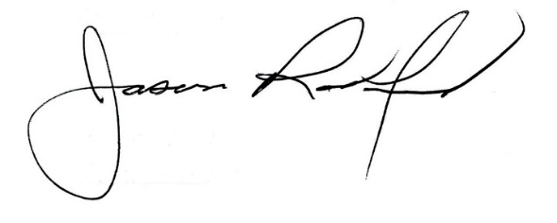
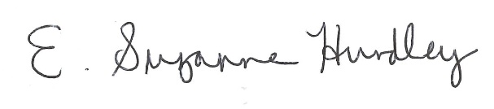

Suzanne Hundley, Board Chair Dr. Jason Radford, Superintendent/Secretary

