CONSENT ITEM D
August 26, 2024
OLDHAM COUNTY BOARD OF EDUCATION
CONCERN
Consider Approval of Contracts in excess of $20,000 and Post-Approval of Contracts less that $20,000.
DISCUSSION
Pursuant to Board Policy 3055, the Superintendent can approve contracts for transactions of less than $20,000 in value, subject to post approval by the Board of Education. Below are listed the name of the contract vendor, the subject of the contract, and the amount of the contract for contracts of less than $20,000 that were approved by the superintendent, and contracts in excess of $20,000 that must be approved by the Board.
School/Dept | Vendor | Subject | Amount
District | OVEC | Tuition Reimbursement | Up to $12,000.00
District | Metro United Way | FRYSC & Camp Literacy Live | $20,000.00
ECS | Teachtown | EnCore Student Subscription | $41,250.00
NOHS | Marriott | Volleyball Hotel | $189.00 per room
SOHS | CityPlace | Baseball Dinner | $891.00
SOHS | Ky Safe Driver | Safe Driver program | Per agreement
SOHS | Super 8 Motel | Cross County Team | $113.40 per room
RECOMMENDATION
Approved the attached contracts and authorized the Superintendent and Secretary of the Board, or his designee, to execute all the above contracts, and ratified any contracts of these contract signed prior to formal approval.

On motion by _______________, seconded by _______________, the Board approved the attached contracts and authorized the Superintendent and Secretary of the Board, or his designee, to execute all of the above contracts, and ratified any contracts of these contract signed prior to formal approval. ( , )

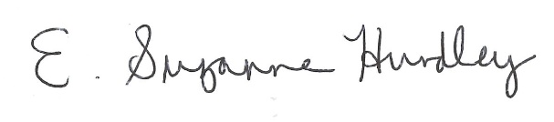
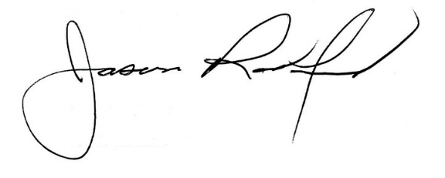

Suzanne Hundley, Board Chair Jason Radford, Ed.D, Superintendent

