MINUTES
August 26, 2024
OLDHAM COUNTY BOARD OF EDUCATION
CONCERN
Consider Approval of Meeting Minutes.
DISCUSSION
The draft minutes of the July 29, 2024, Regular Board Meeting and the August 7, 2024-Special Called Meeting are available for review and approval.
RECOMMENDATION
Approve the minutes of the following meetings as presented.
July 29, 2024 – Regular Board Meeting
(1) Suzanne Hundley, Chairperson, (2) Larry Dodson, Board Vice Chair; and (3) Joe Dennis, Board Member, (4) Carly Clem, Board Member (5) Allison Sheffer, Board Member, and Dr. Jason Radford, Superintendent and Secretary to the Board were present.
August 7, 2024 – Special Called Board Meeting
(1) Suzanne Hundley, Chairperson, (2) Larry Dodson, Board Vice Chair; and (3) Joe Dennis, Board Member, (4) Carly Clem, Board Member (5) Allison Sheffer, Board Member, and Dr. Jason Radford, Superintendent and Secretary to the Board were present.

On a motion by _______________, seconded by _______________, the Board approved the minutes of the June 24, 2024, Regular Board Meeting and the August 7, 2024-Special Called Meeting. ( , )
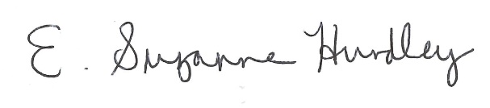
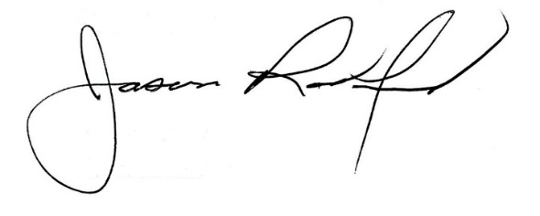

___________________________________ ______________________________
Suzanne Hundley, Board Chair Jason Radford, Superintendent/Secretary

