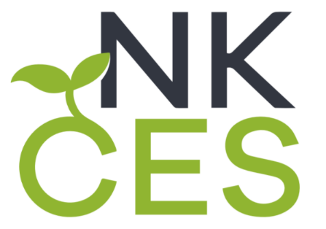
Northern Kentucky Cooperative for Educational Services
5516 East Alexandria Pike
Cold Spring, KY 41076

NKCES Board of Directors Meetings**
2021-2022

Board Meeting Date
August 11, 2021 ** Moved to August 4, 2021
September 8, 2021
October 13, 2021 Moved to October 20, 2021
November 10, 2021
No December Meeting
January 12, 2022
February 9, 2022
March 9, 2022
April 13, 2022 Moved to April 20, 2022
May 11, 2022
June – Louisville, KY

