CONSENT ITEM A
August 26, 2024
OLDHAM COUNTY BOARD OF EDUCATION
CONCERN
Consider Approval of Field Trips Requesting Overnight Stay & Field Trips Requesting Use of Common Carrier.
DISCUSSION
The following are field trips requesting overnight stay and trips requesting use of a common carrier:
SCHOOL | GROUP | LOCATION/DATE | JUSTIFICATION | INSTR. DAYS LOST
OCHS | Volleyball | George Rodgers HS  Nov 8-9, 2024 | Overnight: Competition  Bus or Parents | 0
OCHS | Cross Country | Cedarville, OH  September 27-29, 2024 | Overnight: Competition  Commercial | 0
ARVIN | HOSA | HOSA Washington  Sept 27-30, 2024 | Overnight: Competition  AIR | 2
OCHS | Softball | Ft Walton Beach, FL  March 28-April 4, 2024 | Overnight: Spring Break Tip  Parents | 1
SOHS | Choir | Hyatt Regency, Louisville  Feb 5-7, 2025 | Overnight: KMEA All State  Bus or Parents | 3
SOHS | Choir | KYACDA, Lexington  Nov 1-2, 2024 | Overnight: KYACDA  Parents | 1
NOHS | Boys Golf | Owensboro, KY  Sept 8-9, 2024 | Overnight: State Championship Tournament  Parent | 1
Approve the field trips as attached and described above, pursuant to the condition that students not traveling on school buses, with their parents, or with a Board employee whose insurance carrier has named OCBE as an additional named insured, will be transported to and from their destination on an approved charter bus(es) and school(s) shall obtain written evidence of liability.

On a motion by _______________, seconded by _______________, the Board approved the field trips as attached and described above, pursuant to the condition that students not traveling on school buses, with their parents, or with a Board employee whose insurance carrier has named OCBE as an additional named insured, will be transported to and from their destination on an approved charter bus(es) and school(s) shall obtain written evidence of liability. ( , )
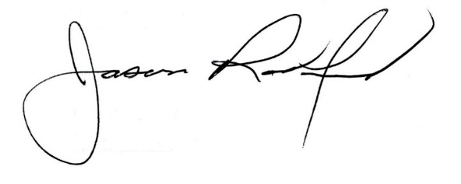
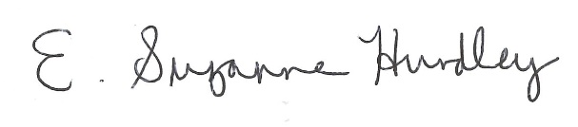

Suzanne Hundley, Board Chair Jason Radford, Superintendent/Secretary

