ACTION ITEM B
September 23, 2024
OLDHAM COUNTY BOARD OF EDUCATION
CONCERN
Consider KSBA Policy Revisions
DISCUSSION
Last month the board was asked to review board policies changes needed to for compliance with new or amended laws, consistency with other board policies or practices, or clarity. Below is listed the number of the policy, its name, the reason for the suggested amendment and the date of the last revision.
At this meeting, you are asked to approve the changes as presented.
NUMBER | NAME OF POLICY | REASON FOR AMENDMENT/ADDITION
01.41 | Election of Board Officers | 1 year terms
01.420 | Public Expression | Addition of new language in the KSBA policy.
01.821 | Travel Expenses | Board members 50 mile requirement.

RECOMMENDATION
Approve the KSBA policy changes as presented.

On a motion by _______________, seconded by _______________, the Board approved the KSBA policy changes as presented. ( , )

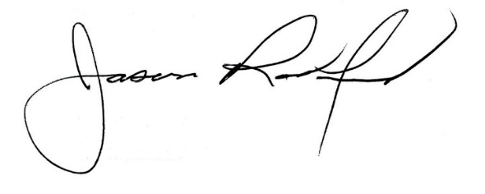
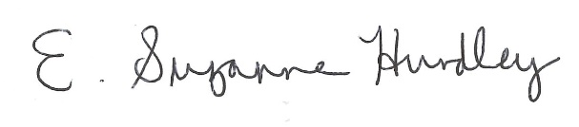

Suzanne Hundley, Board Chair Jason Radford, Superintendent/Secretary

