ACTION ITEM B
January 22, 2024
OLDHAM COUNTY BOARD OF EDUCATION
CONCERN
Consider approval of student requests for early graduation due to hardship and waiver of 8 semester requirement.
DISCUSSION
The following students are requesting early graduation due to hardship:
- C.J. is a 17-year-old senior at SOHS
- B.R. is an 18-year-old senior at BAHS
- J.R. is a 17-year-old senior at BAHS
- S.M. is a 17-year-old senior at BAHS
- B.P. is a 17-year-old senior at SOHS
Documents to support this request follow this enclosure for your review and consideration.
RECOMMENDATION
Approve the student requests for Early Graduation due to hardship.

On a motion by _______________, seconded by _______________, the Board approved the Early Graduation Due to Hardship Request for these students as presented. ( - )

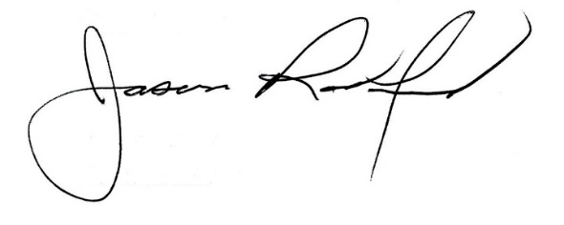
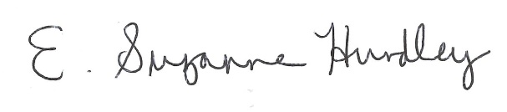

Suzanne Hundley, Board Chair Dr. Jason Radford, Superintendent/Secretary

