OCSDFC
ACTION ITEM A
MAY 20, 2024
OLDHAM COUNTY SCHOOL DISTRICT FINANCE CORPORATION
CONCERN
2024 Bond Issue
Consider a resolution authorizing the issuance of the Oldham County School District Finance Corporation School Building Revenue and Refunding Bonds, Series 2024, advertising for sale of bonds and approving all other documents in connection with the sale and issuance of the bonds to include the adoption of Continuing Disclosure Policies Procedures
DISCUSSION
A RESOLUTION OF THE BOARD OF DIRECTORS OF THE OLDHAM COUNTY SCHOOL DISTRICT FINANCE CORPORATION, PROVIDING FOR THE ISSUANCE OF $24,435,000 PRINCIPAL AMOUNT (WHICH MAY BE INCREASED BY THE AMOUNT OF $2,440,000 OR DECREASED BY AN AMOUNT DETERMINED BY THE CORPORATION TO BE IN THE BEST INTEREST OF THE CORPORATION) OF SCHOOL BUILDING REFUNDING AND IMPROVEMENT REVENUE BONDS, SERIES OF 2024, DATED THEIR DATE OF ISSUANCE (THE “BONDS”) IN ACCORDANCE WITH SECTIONS 162.120 THROUGH 162.300, 162.385 AND 58.180 OF THE KENTUCKY REVISED STATUTES, FOR THE PURPOSE OF RETIRING AT OR PRIOR TO THEIR RESPECTIVE MATURITIES ALL OF THE OUTSTANDING OLDHAM COUNTY SCHOOL DISTRICT FINANCE CORPORATION SCHOOL BUILDING REVENUE BONDS, SERIES OF 2013, DATED AUGUST 1, 2013 (THE PRIOR BONDS) AND TO PROVIDE FUNDS FOR SCHOOL BUILDING PURPOSES; PROVIDING AND DETERMINING THE DUTY OF SAID CORPORATION IN CONNECTION WITH THE OPERATION OF THE SCHOOL PROPERTY; PROVIDING FOR THE PAYMENT OF PRINCIPAL OF AND INTEREST ON ALL PRIOR BONDS BY REDEMPTION IN ADVANCE OF MATURITY, PROVIDING FOR THE CREATION OF CERTAIN FUNDS TO EFFECT THE DEFEASEMENT OF THE RIGHTS OF THE OWNERS OF ALL OF THE PRIOR BONDS AND THE TRANSFERS OF CERTAIN AMOUNTS INTO CERTAIN FUNDS; PROVIDING FOR THE PAYMENT OF SAID BONDS AND THE INTEREST THEREON; PROVIDING FOR THE RIGHTS OF THE REGISTERED OWNERS OF SAID BONDS AND THE ENFORCEMENT THEREOF; PROVIDING FOR AN ADVERTISED PUBLIC COMPETITIVE SALE OF SAID BONDS; AND AUTHORIZING THE EXECUTION OF A LEASE OF SUCH FOREGOING PROPERTY TO THE BOARD OF EDUCATION OF OLDHAM COUNTY, KENTUCKY.
RECOMMENDATION
Approve the resolution authorizing the issuance of the Oldham County School District Finance Corporation School Building Revenue and Refunding Bonds, Series 2024, advertising for sale of bonds and approving all other documents in connection with the sale and issuance of the bonds to include the adoption of Continuing Disclosure Policies Procedures.

On a motion by _______________, seconded by _______________, the OCS District Finance Corporation approved the resolution authorizing the issuance of the Oldham County School District Finance Corporation School Building Revenue and Refunding Bonds, Series 2024, advertising for sale of bonds and approving all other documents in connection with the sale and issuance of the bonds to include the adoption of Continuing Disclosure Policies Procedures. ( , ).
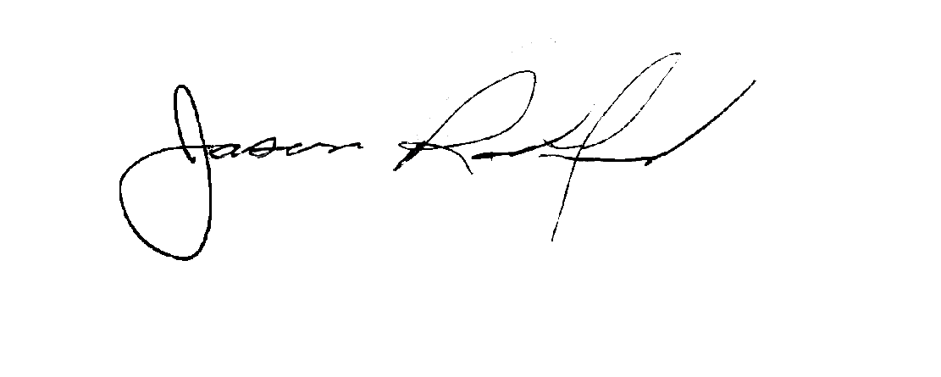
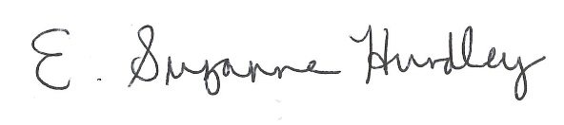

Suzanne Hundley, President Jason Radford, Superintendent / Secretary

