**Superintendent Report**

August 21, 2024

**Opening Day/Back to School Events/Start of School**

On Thursday, August 8 we held opening day activities for staff. American Fidelity provided breakfast for our staff and Mr. Hasan Davis served as our keynote speaker. He did a phenomenal job of sharing his story to demonstrate the importance of seeing the possibility in all of our students. Our roles as educators is so important and we have the power to provide hope in all of our students. Every staff member was given a copy of Mr. Davis’ book, Written Off and he also signed copies for staff. I served as Mr. Davis’ “opening act” to welcome all staff and reiterated our district’s vision, mission, and values and announced the word of the year, which is **INTENTIONAL** This word was chosen because if we are to improve our outcomes, we must be intentional in our actions, focus, words, energy, etc. Each staff member left with a token of appreciation, a Bellevue branded umbrella.

After our gathering together as a district, teams went to their respective schools to hear from their principal/supervisor. Special thank you to The Bellevue Education Foundation for providing boxed lunches from The Pretzel Place.

The Back to School Bash on the evening of August 7 was well attended and the new set up was well received. Much appreciation to our staff for making the event so welcoming for our families and to our board members who were on hand to grill. We had a small, but mighty group stick around to hear Mr. Davis speak to our community/parents. I loved his message about not counting people or places out, not writing people or places out. Together, we make things better for our community.

The first two days of school have gone very well and I credit that to the hard work of our principals and school and district staff. It is wonderful seeing our hallways filled with students once again. Special thanks to the Bellevue Police Dept. for assisting with new traffic pattern at GES. That has worked out very well. I look forward to a fantastic 2024-2025 school year. I am excited and optimistic for this new school year.

**Board Agenda Items**

* We will recognize and introduce our new staff in attendance.
* Staff Reports
  + We will have a new student liaison at the September meeting
* Consent Agenda
  + Other than the standard items you have the following:
    - Emergency certification for two teachers to teach middle school math. This allows the teachers to teach outside their content/in lieu of a teaching certificate due to not finding a certified teacher in the content area. This is for one year.
    - NKYEC membership. This helps us continue the One to One program
    - Update organizational chart – per our conversation
    - Technology Activity Report and the Data Security– This comes from Mr. Sewards and is an annual submission to the Board.
    - We left off the FRAM coordinator position on the extra duty schedule so need to approval for that revision.
* Action Items
  + Tax Rates to be approved as discussed at our work session.
  + Payment NO. 2 for Perkins Carmack.

**Construction/Facilities Update**

**GES**: Things are rolling along at Grandview. Walls are being put up for the new gymnasium. On the inside work is continuing on the 2nd floor. So far, we are co-existing well together with students in the building and construction work continuing.

720pHD

The area closest to the building is where they encountered issues with rubble and will have to dig deeper and add a flowable fill base.

Walls going up

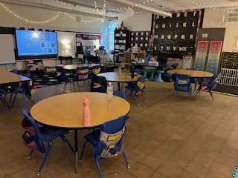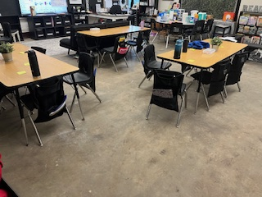

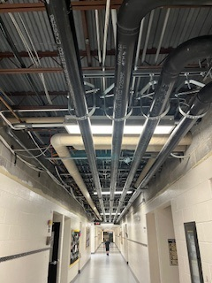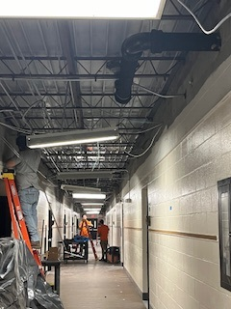

3rd grade classroom

2nd grade classroom

1st floor hallway

2nd floor hallway

**Stadium**: Plans are continuing at the stadium and the updated timeline is below.

* Bid Docs to Board September 18, 2024
* Documents to KDE September 19, 2024
* Advertise for Bids to Paper September 19, 2024
* Advertisement Published - Out for Bids September 24, 2024
* Bids Due October 15, 2024
* Board Award Project October 16, 2024
* Construction Begins November 2024
* Construction Complete Summer 2025

I have been in contact with Keith Brock from Compass Municipal Advisors and he is updating the time and events schedule for the obligation bonds with the new schedule above. He does recommend a 25-year term instead of the 20.

**BMHS**: BG#21-155 began in 2021 and has had ongoing issues. Rick and I met with KLH to get answers for the issues with the HVAC we were experiencing. After much researching and testing, they believe to have a solution and we are working with Ehmet’s office to close out on this project since we are over the 3-year period of when the bonds closed. It is a terrible situation, but we now have to yield restrict the investments. We are having a walkthrough on Tuesday and if all goes well, we will recommend adding final payment to the agenda.

**Ben Flora-HVAC**- The unit is set to ship around August 23 and they expect to work on installation the first or second week of September. They plan to have the punch list completed by 9/23. We utilized ESSER funds for this project, so they are aware of the timeline for these funds.

**District Goals**

We are being very intentional about our goals and are in the process of gathering baseline data before we can fully present the final document. We need to wait until Fall MAP testing is complete which should be the week after Labor Day, and we are also in the process of gathering baseline data for our Positive Behavior goal. These will be ready for your review at the September meeting.

**Superintendent Growth Plan**

Each of you should have received the 24-25 Supt. Growth Plan. This plan can be fluid so any recommendations you have we can discuss and make changes.

**September Work Session**

On September 4-5 I will be in Lexington at the Ky. Association of School Superintendents Fall Summit. I would like to request a change to this date.

**Upcoming Meetings/Events**

* August 17 – BEF Golf Outing
* August 21 – NKCES Superintendent Board of Directors Mtg. and BOE Meeting
* August 26 – Begin MAP Testing
* August 30 – First Home Football Game @ 7:00
* September 2 – Labor Day, No School
* September 3 – KSBA Regional Meeting @ Receptions
* September 4-5 – Kentucky Association of School Superintendents Fall Summit
* September 12 – High Attendance Day in KY

As always, please let me know if you have any questions or concerns

Respectfully submitted,

Misty Middleton

Superintendent