CONSENT ITEM I
October 14, 2024
OLDHAM COUNTY BOARD OF EDUCATION
CONCERN
Consider Approval of Additional ARC Chair
DISCUSSION
The following ARC Chairs require approval by the Board.
- Rian Heibert-SOHS
RECOMMENDATION
Approve the additional ARC Chair for FY25.

On a motion by _______________, seconded by _______________, the Board approved the additional FY25 Arc Chair.

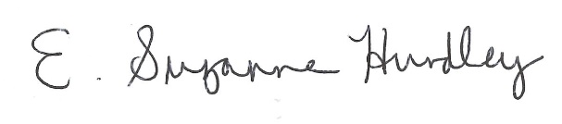
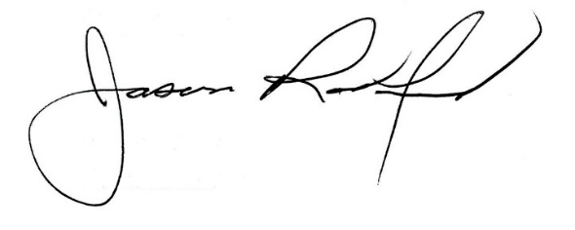

Suzanne Hundley, Board Chair Jason Radford, Superintendent/Secretary

