EXECUTIVE SESSION
January 22, 2024
OLDHAM COUNTY BOARD OF EDUCATION
CONCERN
Consider Executive Session pursuant to KRS 61.810(1)(c) to discuss litigation preparation or defense, the public disclosure of which would jeopardize the Board’s position, KRS 61.810(1)(b) deliberations on the future acquisition or sale of real property by a public agency, but only when publicity would be likely to affect the value of a specific piece of property to be acquired for public use or sold by a public agency.
DISCUSSION
Consider Executive Session pursuant to KRS 61.810(1)(c) to discuss litigation preparation or defense, the public disclosure of which would jeopardize the Board’s position, KRS 61.810(1)(b) deliberations on the future acquisition or sale of real property by a public agency, but only when publicity would be likely to affect the value of a specific piece of property to be acquired for public use or sold by a public agency.
RECOMMENDATION
Conduct Executive Session.

On a motion by _______________, seconded by _______________, the Board entered into Executive Session at ____ pm, pursuant to KRS 61.810(1)(c) to discuss litigation preparation or defense, the public disclosure of which would jeopardize the Board’s position, KRS 61.810(1)(b) deliberations on the future acquisition or sale of real property by a public agency, but only when publicity would be likely to affect the value of a specific piece of property to be acquired for public use or sold by a public agency.. ( , )

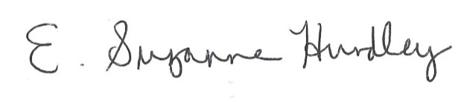
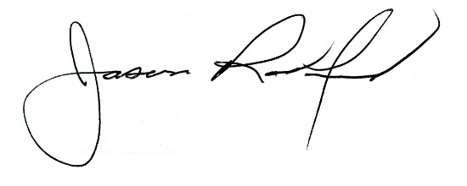

Suzanne Hundley, Board Chair Jason Radford, Superintendent/Secretary

