ACTION ITEM A
January 22, 2024
OLDHAM COUNTY BOARD OF EDUCATION
CONCERN
Consider Approval of the proposed FY25 Board Meeting Schedule.
DISCUSSION
The proposed FY25 Regular Board Meeting Schedule as follows (also attached)
Regular Session Dates:
- Monday, July 29, 2024
- Monday, August 26, 2024
- Monday, September 23, 2024
- Monday, October 14, 2024
- Monday, November 18, 2024
- Monday, December 16, 2024
- Monday, January 27, 2025
Annual OCS District Finance Corporation Meeting – 4:15pm
- Monday, February 24, 2025
- Monday, March 24, 2025
- Monday, April 28, 2025
- Monday, May 19, 2025
- Monday, June 23, 2025
Work Session Dates: Meetings shall be added as needed.
SBDM Meetings
- Thursday, January 30, 2025
- Tuesday February 4, 2025
- Thursday, February 6, 2025
- Tuesday, February 11, 2025
- Thursday, February13, 2025
RECOMMENDATION
Approve the FY25 Regular Board Meeting Schedule as presented.

On a motion by _______________, seconded by _______________, the Board approved the FY25 Regular Board Meeting Schedule as presented. ( - )
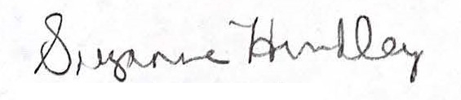
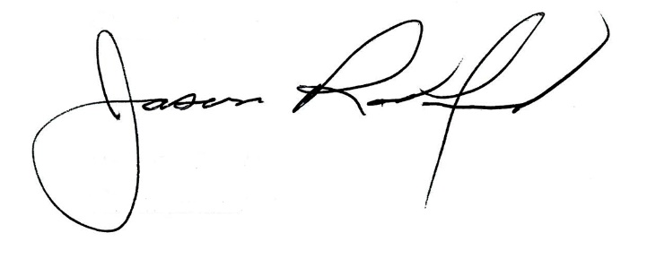

Suzanne Hundley, Board Chair Jason Radford, Superintendent/Secretary

