**Grandview Elementary**

**Board Report**

**August 24th, 2022**

**Great things happening at GES……**

* The 1st day of school was AWESOME! Students were eager to start school and excited to see their friends!

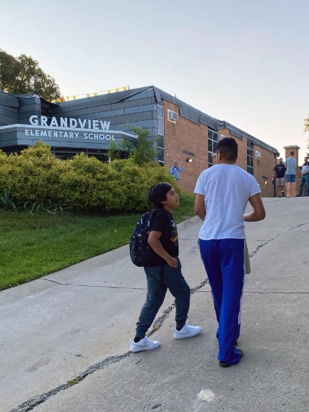 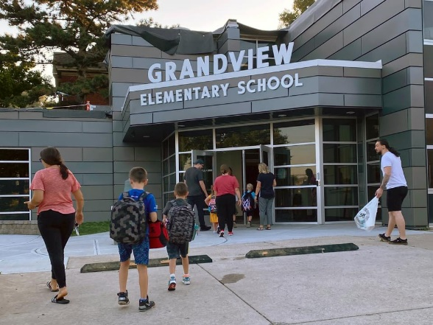

* Building construction is complete in the main office. They are still working on the courtyard fencing and roof. The office space is safe, secure and looks amazing!
* Thank you to the BEF for lunch on BISD Opening Day and all the teacher snacks for the lounge!
* Thank you to the families that repainted the U.S. map on the playground. It looks great!
* Great attendance at GES Ready Fest! Several free haircuts were given, 100 pair of free shoes were ordered and free Kona Ice was served. Families were happy to be back in the building!
* Shout Out to Rob Sanders for organizing the free backpack and supplies drive with the Sam Hubbard Foundation. Mr. Sanders also organized many of the resources at Ready Fest!

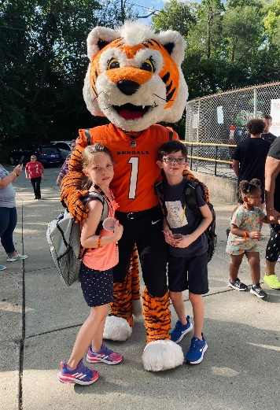 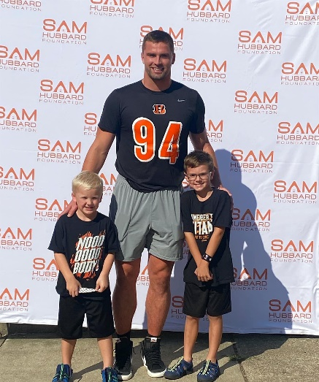

**Upcoming Dates:**

* Aug 23rd GES SBDM Meeting 3:30 @GES Library
* Sept 5th Labor Day- No School
* Sept 6th Preschool Starts
* Sept 13th      High Attendance Day- PTA will provide a special treat to students
* Sept 17th PTA Meeting @ GES 4:30-5:30pm
* Sept 27th KY Kids Day- PTA will partner with GES staff on a project

***GESLeaders Philosophy***

*Our goal is to build intentional relationships, inspire passionate learners, provide personalized learning, identify leadership in self, staff and students and challenge our team to exceed expectations.*