**Grandview Elementary**

**SBDM Board Report**

**July 19, 2023**

**Summer of learning and collaboration!!**

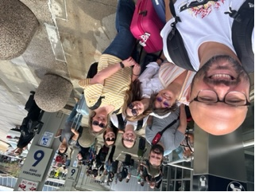 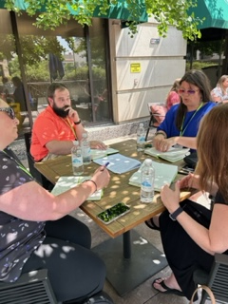

**PLC Conference**

June 25th -29th, District representatives and GES staff (Heather Rabe, Brandon Forshey and Sara Teegarden) attended the wonderful PLC Conference through Solution Tree in Minneapolis.

**GES Admin Book Study**

July 11th –25th, Allison Craig, Brandon Forshey and Heather Rabe are participating in a book study on *Lost at School*. This book gives us a collaborative problem-solving model where it teaches that challenging behaviors are a result of lagging thinking skills and unsolved problems.

**BISD Administrative Retreat**

July 9th -11th GES, BMHS and District staff participated in an Admin Retreat at the beautiful Hocking Hills. We worked on protocols and implementation for Professional Learning Communities (PLC), MTSS, District and building level goals.

**Upcoming Dates**

* July 31st -August 1st Kindergarten Jump Start
* August 2nd -Scholastic Writing professional development
* August 3rd -Scholastic Writing professional development
* August 4th -Eureka Math professional development
* August 8th -The Bellevue Classroom -BISD
* August 10th -GES Open House
* August 16th – First Day of School!!!! 😊