

**Hardin County Schools**

**Certified Evaluation Plan**

**September 2014**

**Hardin County Schools Certified Evaluation Plan Committee**

|  |  |  |
| --- | --- | --- |
| **Carla Breeding** | **Director of Evaluation and Benefits** | **Administrator** |
| **Jon Thomas** | **Director of Secondary Curriculum and Instruction** | **Administrator** |
| **Lynne Gibson** | **HS Principal** | **Administrator** |
| **Shelee Clark** | **Director of PGES** | **Administrator** |
| **Althea Hurt** | **ES Principal** | **Administrator** |
| **Eric Vowels** | **Principal Alternative Schools** | **Administrator** |
| **Emily Campbell** | **ES Principal** | **Administrator** |
| **Kelly Miller** | **Heartland Elementary** | **Teacher** |
| **Billy Staples** | **Lakewood Elementary** | **Teacher** |
| **Leslie Lewis** | **Central Hardin High** | **Teacher** |
| **Jami Reynolds** | **Bluegrass Middle** | **Teacher** |
| **Scott Squires** | **Rineyville Elementary** | **Teacher** |
| **Joe Pike** | **West Hardin Middle** | **Teacher** |
| **Erin Hubbard** | **Vine Grove Elementary** | **Teacher** |

**Table of Contents**

|  |  |
| --- | --- |
|  | **Page** |
| Assurances | **3** |
| TPGES Roles and Definitions Glossary | **4** |
| Orientation | **6** |
| The Kentucky Framework for Teaching | **7** |
| TPGES Sources of Evidence | **7** |
| Professional Growth Planning and Self-Reflection | **8** |
| Observation | **9** |
| Observer Certification and Calibration | **11** |
| Peer Observation | **12** |
| Student Voice | **13** |
| Student Growth | **14** |
| Decision Rules for Local Student Growth Goals | **16** |
| TPGES Products of Practice/Other Sources of Evidence/Letters and Memos | **17** |
| Determining the Overall Performance Category | **18** |
| Professional Growth Plan and Summative Cycle | **22** |
| Corrective Action/Improvement Plan | **22** |
| PPGES Roles and Definitions Glossary | **23** |
| PPGES Overview and Summative Model | **24** |
| Principal Performance Standards | **25** |
| PPGES Sources of Evidence | **26** |
| Professional Growth Planning and Self-Reflection | **27** |
| Site-Visits/Formative Conferences | **27** |
| Val-Ed 360 Procedures | **28** |
| Working Conditions Goal | **29** |
| PPGES Products of Practice/Other Sources of Evidence/Letters and Memos | **30** |
| Student Growth | **31** |
| Determining Overall Performance | **32** |
| Other Professional Growth and Effectiveness System | **35** |
| Responsibilities for Evaluation | **35** |
| Appeals Process | **36** |
| Appeals Panel Hearing Procedures | **37** |
| Orientation Training Sign-In Sheets | **38** |
| OPGES Appendix |  |
| Professional Growth and Evaluation Processes New and Experienced Certified Staff | **41** |
| Evaluation Cycle Timeline for Management of Professional Growth Plan and Data Collection | **42** |
| OPGES Evaluation Tracking Form | **43** |
| OPGES Individual Professional Growth Plan | **44** |
| OPGES Pre-Observation Form | **45** |
| OPGES Standards, Formative and Summative Forms |  |
| * Preschool Teachers | **46** |
| * Speech Pathologist | **64** |
| * Library Media Specialist | **75** |
| * School Counselor | **83** |
| * School Psychologists and Consultants | **94** |
| * Administrators (not assigned as building principals or assistant principals) | **103** |
| Individual Corrective Action Plan | **110** |
| Appeals Request Form | **111** |
| TPGES Forms Appendix |  |
| TPGES Timeline | **112** |
| Pre-Observation Form | **113** |
| Post-Observation Form | **114** |
| Student Growth Goal Rigor Planning Worksheet for Teachers | **115** |
| Student Growth Goal Rigor Checklist | **116** |
| TPGES Evaluation Tracking Form | **117** |
| Individual Corrective Action/Improvement Plan Form | **119** |
| Appeals Request Form | **120** |
| PPGES Forms Appendix |  |
| Reflective Practice, Student Growth, Working Conditions Goal and Professional Growth Planning Template | **121** |
| PPGES Site Visit/Formative Conference Form | **127** |
| Individual Corrective Action Plan/Improvement Plan | **129** |
| Appeals Request Form | **130** |

**ASSURANCES-- CERTIFIED EVALUATION PLAN**

The Hardin County School District hereby assures the Commissioner of Education that:

This evaluation plan was developed by an evaluation committee composed of an equal number of teachers and administrators.

The evaluation process and criteria for evaluation will be explained to and discussed with all certified personnel annually within one month of reporting for employment. This shall occur prior to the implementation of the plan. The evaluation of each certified staff member will be conducted or supervised by the immediate supervisor of the employee.

All certified employees shall develop an Individual Professional Growth Plan (PGP) that shall be aligned with the school/district improvement plan and comply with the requirements of 704 KAR3:345. The PGP will be reviewed annually.

All administrators, to include the superintendent and non-tenured teachers will be evaluated annually.

All tenured teachers will be evaluated a minimum of once every three years.

Each evaluator will be trained and approved in the use of the appropriate evaluation techniques and the use of local instruments and procedures.

Each person evaluated will have both formative and summative evaluations with the evaluator regarding his/her performance.

Each evaluatee shall be given a copy of his/her summative evaluations with the evaluator regarding his/her performance.

Each evaluatee shall be given a copy of his/her summative evaluation and the summative evaluation shall be filed with the official personnel records.

The local evaluation plan provides for the right to a hearing as to every appeal, an opportunity to review all documents presented to the evaluation appeals panel, and a right to presence of evaluatee’s chosen representative.

The evaluation plan will not discriminate on the basis of race, national origin, religion, marital status, sex, or disability.

This evaluation plan will be reviewed as needed and any substantive revisions will be submitted to the Department of Education for approval.

The local board of education approved the evaluation plan as recorded in the minutes of the meeting held on __________________________________________.

___________________________________________ _____________________________

Signature of District Superintendent Date

___________________________________________ _____________________________

Signature of Chairperson, Board of Education Date

**Professional Growth and Effectiveness System – Certified Teacher**

The vision for the Professional Growth and Effectiveness System (PGES) is to have every student taught by an effective teacher.  The goal is to create a fair and equitable system to measure teacher effectiveness and act as a catalyst for professional growth.

**Roles and Definitions**

1. **Administrator:** means an administrator who devotes the majority of employed time in the role of principal, for which administrative certification is required by the Education Professional Standards Board pursuant to 16 KAR 3:050
2. **Appeals:** a process whereby any certified employee who feels that the local school district failed to properly implement the approved evaluation system can formally disagree with his/her evaluation
3. **CIITS**: Commonwealth Instructional Improvement Technology System—state platform for recording and sharing instructional resources, assessment data, and PGES records
4. **Conference:** a meeting involving the evaluator and the certified employee evaluated for the purpose of providing feedback from the evaluator, analyzing the results of observation(s), and other information to determine accomplishments and for identifying areas for growth leading to the establishment or revision of professional growth plans and/or student growth goal plans.
5. **Educator Development Suite (EDS):**  tools located within CIITS to assist teachers and administrators with documentation related to PGES.
6. **Evaluator:** the immediate supervisor of certified personnel, who has satisfactorily completed all required evaluation training and, if evaluating teachers, observation certification training.
7. **Evaluatee:** District/School personnel that is being evaluated
8. **Evaluation:** the process of assessing or determining the effectiveness of the performance of the certified employee in a given teaching and learning or management situation, based upon pre-determined criteria, through periodic observation and other documentation such as products and performances. Evaluation shall also include the establishment and monitoring of professional growth plans and student growth goals.
9. **Evaluation Committee:** a committee consisting of local school district teachers and administrators who are responsible for developing evaluation procedures and forms for the district evaluation plan. The committee is made up of equal numbers of teachers and administrators (50-50 committee).
10. **Evaluation Plan:** a plan which includes evaluation forms and procedures. The procedures shall provide for all components of the Professional Growth and Effectiveness System including observations, professional growth planning, student growth goals, and student voice. Both the plan and procedures must be approved by the Kentucky Board of Education.
11. **Framework for Teaching:** research-based set of components of instruction that includes four domains: Planning and Preparation, Classroom Environment, Instruction, and Professional Responsibilities
12. **Full Observation:** an observation conducted by an employee’s supervisor that includes an entire class period or lesson. Observation is the process of gathering factual information in the performance of duty based upon the Framework for Teaching.
13. **Mini Observation:** an observation conducted by an employee’s supervisor or a peer that can range from 15-30 minutes of a lesson. Observation is the process of gathering factual information in the performance of duty based upon the Framework for Teaching.
14. **Peer Observer:** Observation and documentation by a trained colleague, selected as described in the district’s Professional Growth and Effectiveness System plan, who observes and documents another teacher’s professional practice and provides supportive and constructive feedback that can be used to improve professional practice**.**
15. **Professional Growth Plan:** An individualized plan that is focused on improving professional practice and leadership skills and is aligned with educator performance standards and student performance standards, is built using a variety of sources and types of student data that reflect student needs and strengths, educator data, and school/district data, is produced in consultation with the evaluator
16. **Professional Learning Community (PLC):**  a group of educators that meets regularly, shares expertise, and works collaboratively to improve teaching skills and the academic performance of students.
17. **Self-Reflection:** means the process by which certified personnel assess the effectiveness and adequacy of their knowledge and performance for the purpose of identifying areas for professional learning and growth
18. **Student Growth Goal (SGG):** a local student growth goal developed by the teacher in collaboration with the supervisor that will have a clear purpose, clear targets, sound design, effective communication and student involvement. All teachers will develop a local student growth goal.
19. **Student Growth Percentile (SGP):** the state contribution for student growth that is a rating based on each student’s rate of change compared to other students with a similar test score history. Only provided for teachers who teach reading or math in grades 4-8.
20. **Student Voice:** the state-approved student perception survey, administered each year, that provides data on specific aspects of the classroom experience and of teaching practice.
21. **Summative Evaluation**: the summary and analysis of all data, including but not limited to observations, student voice data, student growth goal data, self-reflection, and evidence collected by teacher. The summative evaluation occurs at the end of an evaluation cycle and includes a conference involving the primary evaluator and evaluatee with a printed summative evaluation report signed by both parties.
22. **Teacher:** an individual who has been assigned responsibility for student learning in a subject or course.

**Orientation**

An orientation session to acquaint certified employees with the evaluation process will be conducted by administrators within the first month of reporting for employment each school year. All employees who are newly hired during the school year will receive training within their first month of employment.

This annual review shall be an explanation of the contents of the evaluation plan handbook, including the Framework for Teaching and/or Evaluation Standards and Performance Criteria.

The immediate supervisor shall be designated as the primary evaluator. For purposes of evaluations, a principal may appoint an assistant principal to serve as primary supervisor and primary evaluator for certified staff. Additional trained administrative personnel may be used to observe and provide information to the primary evaluator.

All monitoring or observations of performance of a certified employee shall be conducted openly and with the full knowledge of the teacher or administrator.

**The Kentucky Framework for Teaching**

The Framework for Teaching is designed to support student achievement and professional practice through the domains of Planning and Preparation, Classroom Environment, Instruction, and Professional Responsibilities. The Framework also includes themes such as equity, cultural competence, high expectations, developmental appropriateness, accommodating individual needs, effective technology integration, and student assumption of responsibility. It provides structure for feedback for continuous improvement through individual goals that target student and professional growth, thus supporting overall school improvement. Evidence supporting a teacher’s professional practice will be situated within one or more of the four domains of the framework. Performance will be rated for each component according to four performance levels: Ineffective, Developing, Accomplished, and Exemplary. The summative rating will be a holistic representation of performance, combining data from multiple sources of evidence across each domain.

The use of professional judgment based on multiple sources of evidence promotes a more holistic and comprehensive analysis of practice, rather than over-reliance on one individual data point or rote calculation of practice based on predetermined formulas. Evaluators will also take into account how educators respond to or apply additional supports and resources designed to promote student learning, as well as their own professional growth and development. Finally, professional judgment gives evaluators the flexibility to account for a wide variety of factors related to individual educator performance, such as: school-specific priorities that may drive practice in one domain, an educator’s number of goals, experience level and/or leadership opportunities, and contextual variables that may impact the learning environment, such as unanticipated outside events or traumas.

Evaluators must use the following categories of evidence in determining overall ratings:

**Sources of Evidence**

* Professional Growth Planning and Self-Reflection
* Observation
* Student Voice
* Student Growth Percentiles and/or Student Growth Goals
* Other Measures of Student Learning
* Products of Practice
* Other Sources (e.g., surveys)

All components and sources of evidence related supporting an educator’s professional practice and student growth ratings will be completed and recorded in the Educator Development Suite (EDS) housed within the Continuous Instructional Improvement Technology System (CIITS).

**Professional Practice**

**Professional Growth Planning and Self-Reflection**

The Professional Growth Plan will address realistic, focused, and measurable professional goals. The plan will connect data from multiple sources including classroom observation feedback, data on student growth and achievement, and professional growth needs identified through self-assessment and reflection. In collaboration with the administrators, teachers will identify explicit goals which will drive the focus of professional growth activities, support, and on-going reflection. Professional Growth Plans will align with school/district improvement plans.

Reflective practices and professional growth planning are iterative processes. The teacher (1) reflects on his or her current growth needs based on multiple sources of data and identifies an area or areas for focus; (2) collaborates with his or her administrator to develop a professional growth plan and action steps; (3) implements the plan; (4) regularly reflects on the progress and impact of the plan on his or her professional practice; (5) modifies the plan as appropriate; (6) continues implementation and ongoing reflection; (7) and, finally, conducts a summative reflection on the degree of goal attainment and the implications for next steps.

* All teachers will participate in self-reflection and professional growth planning each year.
* All teachers will document self-reflection and professional growth planning in CIITS.
* Self-reflection process will be completed by September 1st of each year. For employees hired after the start of the school year, the self-reflection must be completed within 15 working days.
* Professional Growth Plans will be submitted to supervisor through CIITS by October 1st each year. For employees hired after the start of the school year, the professional growth plan must be completed within 30 working days.
* The professional growth plan will consist of answering the following three sentences in detail:
  + - * + What can I change about my practice that will effectively impact student learning?
        + How can I develop a plan of action to address my professional learning?
        + How will I know if I accomplished my objective?
* Evaluating supervisor will review submitted Professional Growth Plans and provide feedback and/or approve plans by October 31st each year. For employees hired after the start of the school year, the supervisor will have 10 working days to approve the professional growth plan after it is submitted by the employee.
* The professional growth plan process can be collaborative or directed. Employees on a collaborative process will submit the growth plan through CIITS. Employees on a directed professional growth plan will develop a plan under the direction of the primary evaluator. Employees needing a directed growth plan are determined using the summative rating chart on page 22 of the Certified Evaluation Plan.
* All Professional Growth Plans will be reviewed annually by April 30th. Teachers in their summative cycle may review the PGP during their summative conference.

**Observation**

The observation process is one source of evidence to determine teacher effectiveness. This will include supervisor and peer observations for each certified teacher. Both peer and supervisor observations will use the same instruments. The supervisor observation will provide *documentation* *and feedback* to measure the effectiveness of a teacher’s professional practice. Only the supervisor observation will be used to calculate a summative rating. Peer observation will only be used for formative feedback on teaching practices in a collegial atmosphere of trust and common purpose. NO summative ratings will be given by the peer observer. The rationale for each type of observation is to encourage continued professional learning in teaching and learning through critical reflection.

**Observation Model**

* Four (4) observations in the summative cycle. A minimum of 3 observations conducted by the supervisor and 1 observation conducted by the peer.
* The required peer observation must occur in the final year of the cycle.
* Final observation is conducted by the supervisor and is a full observation.
* All observations must be documented in CIITS.
* Observers will conduct three mini observations of approximately 15-30 minutes each. Because these are shorter sessions, the observer will make note of the components observed in order to identify "look fors" in the next mini observation session. One of the mini observations will be conducted by a peer observer. The final observation is a formal observation consisting of a full class or lesson observation.

**Observation Conferencing**

Observers will adhere to the following observation conferencing requirements:

* Pre-observation conferences are required for the peer observation and the full observation. Pre- observation conferences may be conducted for the other two mini observations if requested by the evaluator or evaluatee.
* Pre-observation conferences with the supervisor may be conducted in person, or submitted electronically through e-mail or other electronic platforms.
* Pre and post conferences for the peer observation must be conducted in-person or through a platform that allows visual and/or auditory discussion (i.e. phone, Lync, FaceTime, etc.). Peer observation conferences should not be completed through e-mail or other written electronic platforms.
* Pre-observation conferences will be documented using the district approved pre-observation form (See appendix).
* The observer will complete data entry into CIITS within three (3) working days of the observation.
* All observations (including peer observations) will include a post-observation conference to be conducted within five (5) working days.
* The post-observation conference will be documented using the district approved post observation form (See appendix).
* The summative evaluation conference shall be held at the end of the summative evaluation cycle. During the summative conference, the evidence from all observations will be reviewed so that an overall performance rating can be determined for domains two and three of the Framework for Teaching.
* A summative report shall be printed from CIITS at the conclusion of the summative conference and signed by both the evaluator and evaluatee. The summative report shall be included in the district teacher personnel file. (704 KAR 3:345). The evaluatee will also be provided a copy of the summative report.

**Observation Schedule**

* Observations may begin 30 days after the first day of teacher employment.
* Timeline for when observations must be completed:

First Observation Window: September 1st -October 15th

Second Observation Window: October 16th-December 1st

Third Observation Window: December 2nd-February 15th

Fourth Observation Window: February 16th-April 1st

**Observation windows may be altered by Director of Evaluation and Benefits if needed due to inclement weather days. All observations must be completed by April 1st of a school year.

**Peer observation is to be completed during second observation window for non-tenured teachers and teachers on a one-year growth plan cycle. The peer observation may occur during the first, second, or third window for tenured teachers on a three-year growth plan cycle.

* Tenured teachers on a three-year growth plan cycle will have one mini observation the first year, one mini observation the second year, and the full observation AND peer observation during the third year of their cycle.
* Non-tenured teachers and teachers on a one-year growth plan or 12-month improvement plan will have two mini observations by their supervisor, one mini observation by a peer and a full observation by their supervisor each year until they are tenured or return to a three-year growth plan cycle.
* Full observations must occur in the fourth observation window.
* Teachers hired after the start of the school year will have a pro-rated number of observations based on their hire date. The Director of Evaluation and Benefits will determine the number of observations to be completed based on the number of days of employment and the available observation windows for the district. The minimum will be one peer observation and one full observation for all new teachers hired after the start of the school year.

**Observer Certification**

To ensure consistency of observations, evaluators must complete the Teachscape Proficiency Observation Training, the current approved state platform. The system allows observers to develop a deep understanding of how the four domains of the Kentucky Framework for Teaching (FfT) are applied in observation. There are 3 sections of the proficiency system:

* Framework for Teaching Observer Training
* Framework for Teaching Scoring Practice
* Framework for Teaching Proficiency Assessment

Additionally, all new administrators shall be initially trained, tested, and certified according to state guidelines, including training by the district in the use of the local evaluation process. (704 KAR 3:345, Section 6)

The cycle for observation certification established is as follows [NOTE: This evaluation certification cycle mirrors the existing 704 KAR 3:370 related to initial and update training for certified evaluators]:

|  |  |
| --- | --- |
| Year 1 | Certification |
| Year 2 | Calibration |
| Year 3 | Calibration |
| Year 4 | Recertification |

* Only supervisors who have passed the proficiency assessment can conduct mini and full observations for the purpose of evaluation. In the event that a supervisor has yet to complete the proficiency assessment, or if the supervisor does not pass the assessment, the district will provide the following supports:

TeachScape Support System for Administrators

|  |  |  |
| --- | --- | --- |
| Initial Support | Support for Second Attempt | Support for Third Attempt |
| All new evaluators will participate in a cohort group to prepare for the proficiency exam. The cohort may provide any or all of the following supports: timeline for completion of modules and exam; reminders to complete modules and exam; study guides; group discussions | Assign mentor who has passed the proficiency test. The mentor may provide any or all of the following supports: timeline for completion of modules and exam; reminders to complete modules; study guides; discussion groups; in-person modeling.  Superintendent or his/her designee will assign an alternate observer who will conduct observations with the supervisor until the proficiency exam is passed.  Both the observer and the supervisor shall be present during observations. | Superintendent or his/her designee will assign an alternate observer who will conduct observations with the supervisor until the proficiency exam is passed.  Both the observer and the supervisor shall be present during observations.  Continue mentor supports |

**Observer Calibration**

* The district will provide access to the state approved training platform for evaluators each year for calibration purposes.
* Evaluators will be re-certified through the state approved platform every three years.

**Peer Observation**

A Peer Observer will observe, collect, share evidence, and provide feedback for formative purposes only. Peer Observers will not score a teacher’s practice, nor will peer observation data be shared with anyone other than the Observee unless permission is granted.

* All teachers will receive a peer observation in their summative year. Peer observations will be mini observations (15-30 minutes)
* All Peer Observers participating during the summative year observations will complete the state developed training once every three (3) years. Peer observation training must be completed prior to conducting any observations. Teachers completing the training should submit a copy of the completion certificate or sign a training log kept by the administrator for verification purposes.
* All required peer observations must be documented in CIITS. Peer observers are assigned in CIITS by the building administrator.
* All peer observation documentation will be accessed only the evaluatee.
* Peer observers will be selected at school level by the primary evaluator. Building administrators may choose to have all teachers participate as peer observers OR they may create a pool of observers for peer observation. Peer observers will be assigned by the evaluator.
* Teachers may request that their peer observation be conducted by a teacher trained in the teacher’s content area. The selection of the peer observer shall, if possible, be determined through mutual agreement by evaluator and evaluatee. A teacher who exercises this option shall do so in writing to the evaluator no later than October 15 of the academic year in which the peer observation occurs. If the evaluator and evaluatee have not agreed upon the selection of a peer observer within five (5) working days of the teacher’s written request, the evaluator shall select the peer observer.

**Student Voice**

The Student Voice Survey is a confidential, on-line survey that collects student feedback on specific aspects of the classroom experience and teaching practice.

* The District Student Voice Survey Point of Contact will be the Director of Assessment. Each building will also appoint a Building Student Voice Survey Point of Contact. If no contact is appointed at the school level, the principal will be the Building POC.
* No student will participate in more than THREE surveys.
* All teachers will participate in the state-approved Student Voice Survey annually with a minimum of one identified group of students. Each teacher with multiple class sections (i.e. high school, middle school, related arts, etc.) will have at least ONE identified groups of students (class sections) complete the Student Voice Survey. Self-contained teachers (i.e. elementary school teachers) will have their homeroom students complete the survey. Special education teachers may choose to have students on their caseload complete the student voice survey OR they may choose to have a class of students complete the survey who work with the teacher in a co-teaching setting. Building principals will determine the class period(s) that complete the survey. (For example, a high school principal may determine that all 2nd period classes and 4th period classes complete the survey to assure that all teachers have at least ONE class section of data. An elementary school principal may determine that classes take the survey at 8:30 AM and 1:30 PM. )
* Students will not be denied the ability to participate in the student voice survey due to disability or special need (i.e. English Language Learner, 504 plan, etc.) Students may have the same accommodations afforded to them on the student voice survey as they would have during state testing (i.e. reader, prompting, paraphrasing, etc.). The student’s accommodations will be provided by someone other than the teacher about whom the student is answering the survey.
* Results will be used to inform Professional Practice. Formative years’ data will be used to inform Professional Practice in the summative year.
* All teachers and appropriate administrative staff read, understand, and sign the district’s Student Voice Ethics Statement.
* The Student Voice Survey will be administered between the hours of 7 AM and 5 PM local time during the month of March each year. All surveys will be conducted during the state-determined window(s).
* The survey will be administered in the school.
* Survey data will only be considered when 10 or more students are respondents.
* Parents/guardians will be given the option to have their child(ren) not participate in the student voice survey. All parents/guardians who mark “NO” on the district certification statement for the item, “Periodically students may be asked to voluntarily participate in anonymous surveys to determine student programming and evaluate programs. I grant permission for my child to participate in anonymous surveys addressing school safety concerns,” will exempt their child from the Student Voice Survey. Additionally, a parent permission letter will be sent home with information regarding the student voice survey and giving parents/guardians the option of having students to not participate.

**Student Growth**

The student growth measure is comprised of two possible contributions: a state contribution and a local contribution. The state contribution pertains to teachers of the following content areas and grade levels participating in state assessments:

* 4th – 8th Grade
* Reading
* Math

The state contribution is reported using Student Growth Percentiles (SGP)*.* The local contribution uses the Student Growth Goal Setting Process and applies to all teachers in the district, including those who receive SGP. The following graphic provides a roadmap for determining which teachers receive which contributions:

YES

YES

YES

NO

NO

NO

**State Contribution – Student Growth Percentiles (SGP)**

The state contribution for student growth is a rating based on each student’s rate of change compared to other students with a similar test score history (“academic peers”) expressed as a percentile. The median SGP for a teacher’s class is compared to that of the state. The scale for determining acceptable growth will be determined by the Kentucky Board of Education and provided to the district by the Kentucky Department of Education.

**Local Contribution – Student Growth Goals (SGG)**

The local contribution for the student growth measure is a rating based on the degree to which a teacher meets the growth goal for a set of students over an identified interval of instruction (i.e. trimester, semester, year-long) as indicated in the teacher’s Student Growth Goal (SGG). All teachers, regardless of grade level and content area, will develop a SGG for inclusion in the student growth measure. All SGG will be determined by the teacher in collaboration with the principal and will be grounded in the fundamentals of assessment quality (Clear Purpose, Clear Targets, Sound Design, Effective Communication, and Student Involvement)*.*

**Student Growth Goal Criteria**

* The SGG is congruent with Kentucky Core Academic Standards and appropriate for the grade level and content area for which it was developed.
* The SGG represents or encompasses an enduring skill, process, understanding, or concept that students are expected to master by taking a particular course (or courses) in school.
* The SGG will allow high- and low-achieving students to adequately demonstrate their knowledge.
* The SGG includes both a growth component and a proficiency component.
* The SGG provides access and opportunity for all students, including students with disabilities, ELLs, and gifted/talented students.
* The data for SGGs will only be collected on students who are enrolled in a teacher’s course/class for 100 instructional days or 60% of the course term.
* **All teachers will write a student growth goal based on the criteria. Student Growth Goals will be submitted to principals in CIITS by October 1st of each school year.**

**Rigor**

* Rigor will be assessed for each student growth goal using a district-defined checklist (See Appendix). The checklist will be completed by the teacher and principal collaboratively. The checklist will include checking each student growth goal to determine if the goal is Specific, Measurable, Appropriate, Realistic, and Time-Bound. Additionally, each goal will be checked to determine if it aligns to an enduring skill, process, understanding or concept that students are expected to know and if it is appropriate for the identified group of students. Finally, each goal will be checked to determine if it includes both a growth component and a proficiency component. Goals that do not meet all required parts of the checklist will be sent back to the teacher for review before being approved in CIITS. All student growth goals will be checked for rigor by the supervisor by October 31st of the academic year.

**Comparability**

* **Administration Protocol**
  + In order for student growth goals to be comparable across schools and the district, teachers will meet in Professional Learning Communities to analyze data from district assessments and/or create common assessments for the purpose of gathering baseline and continuous data. Baseline data and continuous data can come from multiple sources including, but not limited to Measures of Academic Progress (MAP), STAR assessments, teacher-created assessments, Literacy Design Collaborative (LDC) tasks, Math Design Collaborative (MDC) tasks, End of Course assessments, and K-PREP data. Teacher-created assessments will be based upon the state and/or national standards for the teacher’s content area. Professional Learning Communities will follow the guidelines set forth in the district’s SMART goals during all meetings. When teachers do not have a school-level Professional Learning Community, the teacher may consult with other professionals in the district or state with similar content to create and/or analyze data. These consultations may take place in person or through the use of technology.
* **Scoring Process**
  + In PLCs, teachers will determine what common assessments or district assessments will be used to measure an enduring skill and develop universal protocols by jury process for comparable administration procedures and data collection.

**Sources of Evidence for Measuring Student Growth**

* Pre-Test/Post-Test
  + The teacher and principal may use pre- and post-test results to determine the growth identified in their goal. These assessments can be identical or comparable versions.
* Repeated Measures Design
* Teachers may maintain a record of results on short-term measure that allow students to act on the information obtained from each measure, repeated throughout the length of the SGG. These measures will accompany descriptive feedback rather than quantitative feedback, student involvement in the assessment process, and opportunities for students to communicate their evolving learning while the teaching is in progress. The teacher and principal will then analyze the pattern across the repeated administrations of the measure.
* Examples of other measures may include: Literacy Design Collaborative Model, Math Design Collaborative Model, Authentic Performance Tasks, Problem-Based Learning, etc.

**Determining Growth for a Single Student Growth Goal**

**Decision Rules for Local Student Growth Goals:**

* Each student growth goal has TWO components: growth and proficiency.
* For the growth component:

90%-100% of students show measurable growth as written in the student growth goal=Expected

Less than 90% of students show measurable growth as written in the student growth goal=Low

* For the proficiency component:

Interval constraints will be plus/minus 10% of the goal=Expected

Above the interval constraints=High

Below the interval constraints=Low

* Combine growth component and proficiency component using the chart below to determine student growth goal rating for that academic year.

|  |  |  |  |  |
| --- | --- | --- | --- | --- |
| Growth Component | Expected | Expected | Expected | High |
| Low | Low | Expected | Expected |
|  | Low | Expected | High |
| Proficiency Component | | | | |

**Products of Practice/Other Sources of Evidence**

Teachers may provide additional evidences to support assessment of their own professional practice. These evidences should yield information related to the teacher’s practice within the domains.

* observations conducted by certified supervisor observer(s)
* student voice survey(s)
* self-reflection and professional growth plans

Other Possible Sources of Evidence may include:

* Program Review evidence
* team-developed curriculum units
* lesson plans
* communication logs
* timely, targeted feedback from mini or informal observations
* student data records
* student work
* student formative and/or summative course evaluations/feedback
* minutes from PLCs
* teacher reflections and/or self-reflections
* teacher interviews
* teacher committee or team contributions
* parent engagement surveys
* records of student and/or teacher attendance
* video lessons
* engagement in professional organizations
* action research
* Other evidence as deemed appropriate by school or district

**Letters and Memos**

In addition to the sources of evidence listed above, letters and memos may be used to document both outstanding performance and performance which needs improvement. The correspondence should be dated and signed by both parties.

**Determining the Overall Performance Category**

Supervisors are responsible for determining an Overall Performance Category for each teacher at the conclusion of their summative evaluation year. The Overall Performance Category is informed by the educator’s ratings on professional practice and student growth. The evaluator determines the Overall Performance Category based on professional judgment informed by evidence that demonstrates the educator's performance against the Domains, district-developed rubrics (see local contribution for student growth), and decision rules that establish a common understanding of performance thresholds to which all educators are held.

**Rating Professional Practice**

The Kentucky Framework for Teaching stands as the critical rubric for providing educators and evaluators with concrete descriptions of practice associated with specific domains. Each element describes a discrete behavior or related set of behaviors that educators and evaluators can prioritize for evidence-gathering, feedback, and eventually, evaluation. Supervisors will organize and analyze evidence for each individual educator based on these concrete descriptions of practice.

Supervisors and educators will be engaged in ongoing dialogue throughout the evaluation cycle. The process concludes with the evaluator’s analysis of evidence and the final assessment of practice in relation to performance described under each Domain at the culmination of an educator’s cycle.

* Provide a summative rating for each domain based on evidence. Use the state decision rules to determine an overall rating for professional practice.

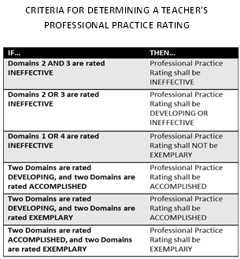

* All ratings must be recorded in CIITS.
* A summative report will be printed from CIITS and signed by both the supervisor and the employee. A copy of the signed summative report will be placed in the employee’s district personnel file. A copy of the summative report will also be given to the evaluatee.

**Rating Overall Student Growth**

The overall Student Growth Rating is a result of a combination of professional judgment and the district-developed instrumentfor summative student growth ratings. The designed instrument aids the supervisor in applying professional judgment to multiple evidences of student growth over time. The Student Growth Rating must include data from SGG and SGP (where available), and will be considered in a three year cycle (when available).

* SGG and SGP(when available) will be used to determine overall Student Growth Rating
* Three years of student growth data (when available) will be used to determine overall Student Growth Rating. When three years of data are not available, the data that is available will be used to make the final determination.
* To determine overall student growth rating, each rating for SGG and SGP(where available) from the past three years will be given a numerical weighting.

Low=1

Expected=2

High=3

* The total rankings will be averaged from the previous three years (if available) and applied to the following scale.

|  |  |
| --- | --- |
| Ranking | Average Score |
| Low | 1.0-1.49 |
| Expected | 1.5-2.49 |
| High | 2.5-3.0 |

**Determining the Overall Performance Category**

An educator’s Overall Performance Category is determined by the following steps:

1. Determine the individual domain ratings through the use of sources of evidence and professional judgment.
2. Apply State Decisions Rules for determining an educator’s Professional Practice. When state decision rules will not work using the chart below, the supervisor will make the final rating using professional judgment.



Use Local Student Growth Goal instrument to determine overall Student Growth Rating. (See directions in Rating Overall Student Growth section on page 15).

|  |  |
| --- | --- |
| Ranking | Average Score |
| Low | 1.0-1.49 |
| Expected | 1.5-2.49 |
| High | 2.5-3.0 |

1. Apply State Overall Decision Rules for determining educator’s Overall Performance Category.

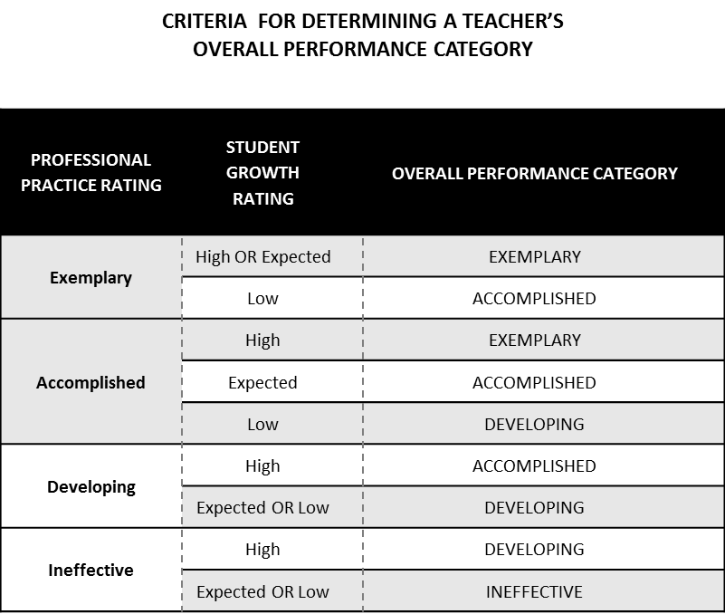

**Professional Growth Plan and Summative Cycle**

Based on the overall Professional Practice rating and Student Growth rating, supervisors will help tenured teachers determine the type of Professional Growth Plan and the length of the summative cycle.

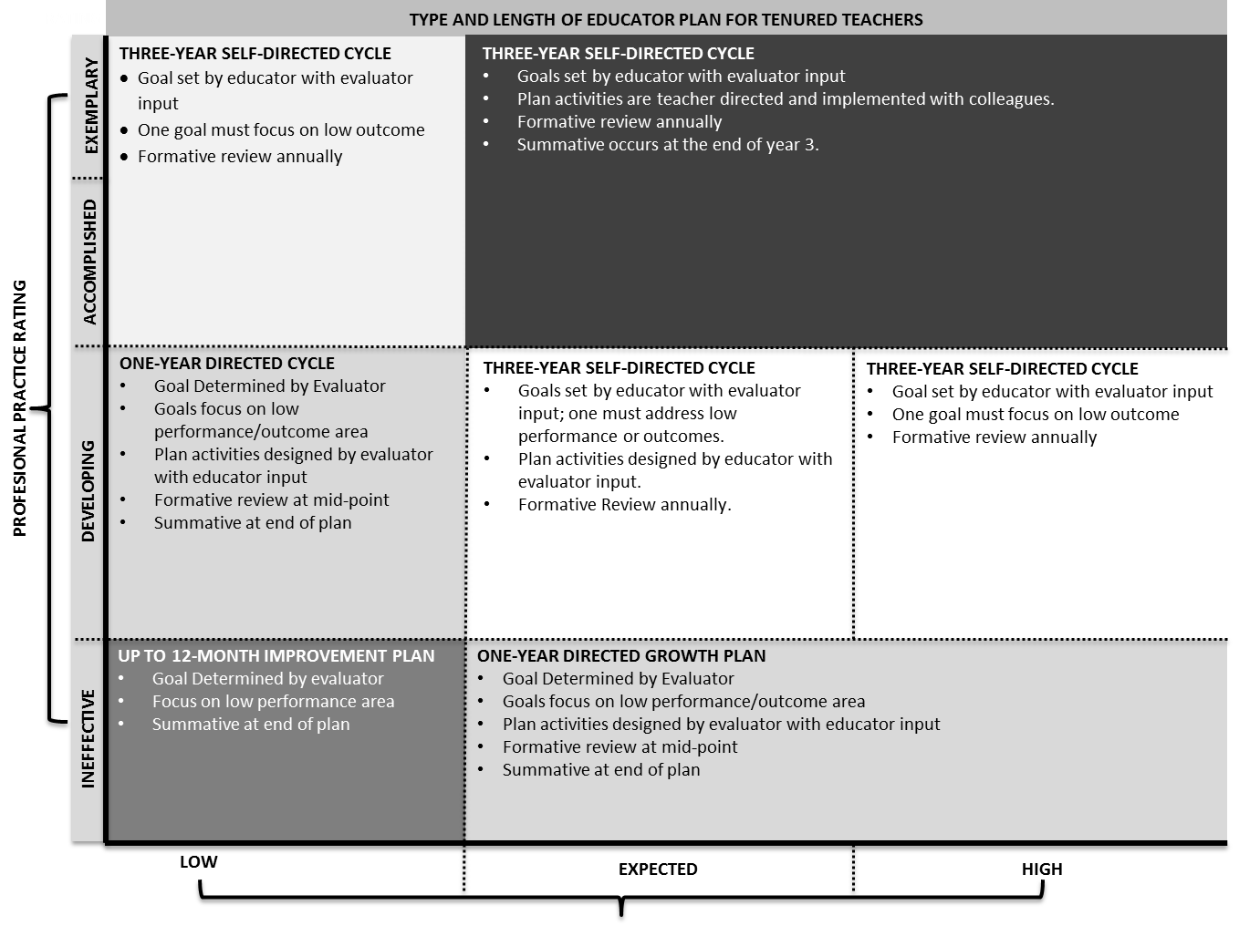

**STUDENT GROWTH**

**Improvement Plans/Corrective Action Plans**

A corrective action plan may be written at any time during the school year, but must be written when an evaluatee falls into the “Up to 12-month improvement plan” box in the chart above. No more than 3 or 4 specified areas should be denoted for improvement at any given time. When the evaluate meets specified areas, other areas may be addressed.

Corrective action plans and/or improvement plans will be reviewed continuously until performance is judged to meet the evaluation standards. Review of corrective action/improvement plans will be documented on the district approved form.

After a conference with the evaluatee, the evaluator will send a copy of the plan to the Director of Evaluation and Benefits. The Director will be responsible for informing the Superintendent of all persons on a Corrective Action/Improvement Plan.

**Professional Growth and Effectiveness System – Principal and Assistant Principal**

The vision for the Professional Growth and Effectiveness System (PGES) is to have every school led by an effective principal.  The goal is to create a fair and equitable system to measure principal effectiveness and act as a catalyst for professional growth.

**Roles and Definitions**

1. **Administrator:** means an administrator who devotes the majority of employed time in the role of principal, for which administrative certification is required by the Education Professional Standards Board pursuant to 16 KAR 3:050
2. **ASSIST:** The Adaptive System of School Improvement Support Tools (ASSIST™) is a web-based platform

designed to broaden and sharpen thinking about continuous improvement, performance and accreditation.

1. **Evaluator:** the immediate supervisor of certified personnel, who has satisfactorily completed all required evaluation training and, if evaluating teachers, observation certification training.
2. **Evaluatee:** District/School personnel that is being evaluated
3. **Professional Growth Plan:** An individualized plan that is focused on improving professional practice and leadership skills and is aligned with educator performance standards and student performance standards, is built using a variety of sources and types of student data that reflect student needs and strengths, educator data, and school/district data, is produced in consultation with the evaluator
4. **Self-Reflection:** means the process by which certified personnel assess the effectiveness and adequacy of their knowledge and performance for the purpose of identifying areas for professional learning and growth
5. **Val-Ed 360°:** An assessment that provides feedback of a principal’s learning-centered behaviors by using input from the principal, his/her supervisor, and teachers. The survey looks at core components (the what) that are listed on the slide, as well as key processes (the how).
6. **TELL Kentucky:** A working conditions survey of all school staff conducted every two years to provide feedback on specific aspects of the school’s work environment.
7. **Working Condition Goal:** a goal, set by administrators every two years, using data from the state approved working conditions survey, for the purpose of school improvement.

**Principal Professional Growth and Effectiveness System Components – Overview and Summative Model**

The following graphic outlines the summative model for the Principal Professional Growth and Effectiveness System.

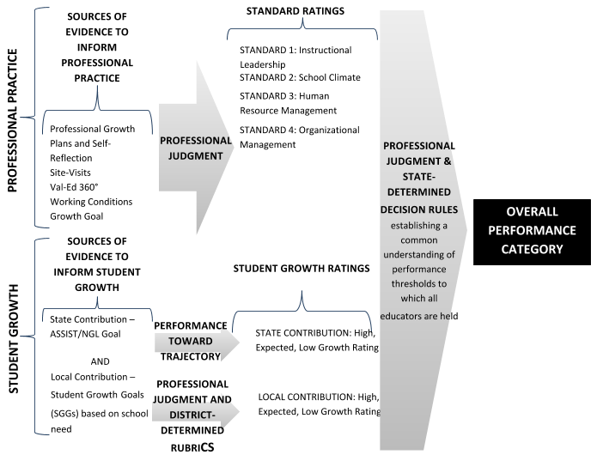

Evaluators will look for trends and patterns in practice across multiple types of evidence and apply their professional judgment based on this evidence when evaluating a principal. The role of evidence and professional judgment in the determination of ratings on standards and an overall rating is paramount in this process. However, professional judgment is grounded in a common framework: the Principal Performance Standards.

**Principal Performance Standards**

The Principal Performance Standards are designed to support student achievement and professional best-practice through the standards of Instructional Leadership; School Climate; Human Resource Management; Organizational Management; Communication & Community Relations; and Professionalism. Included in the Performance Standards are Performance Indicators that provide examples of observable, tangible behaviors that provide evidence of each standard. The Performance Standards provide the structure for feedback for continuous improvement through individual goals that target professional growth, thus supporting overall student achievement and school improvement. Evidence supporting a principal’s professional practice will be situated within one or more of the 6 standards. Performance will be rated for each standard according to the four performance levels: Ineffective, Developing, Accomplished, and Exemplary. It is important to note that the expected performance level is “Accomplished,” but a good rule of thumb is that it is expected that a principal will “live in Accomplished but occasionally visit Exemplary”. The summative rating will be a holistic representation of performance, combining data from multiple sources of evidence across each standard.

The use of professional judgment based on multiple sources of evidence promotes a more holistic and comprehensive analysis of practice, rather than over-reliance on one individual data point or rote calculation of practice based on predetermined formulas. Evaluators will also take into account how principals respond to or apply additional supports and resources designed to promote student learning, as well as their own professional growth and development. Finally, professional judgment gives evaluators the flexibility to account for a wide variety of factors related to individual principal performance. These factors may include school-specific priorities that may drive practice in one standard, an educator’s number of goals, experience level and/or leadership opportunities, and contextual variables that may impact the learning environment, such as unanticipated outside events or traumas.

**Sources of Evidence—PPGES**

Evaluators must use the following categories of evidence in determining overall ratings:

* Required Sources of Evidence
  + Professional Growth Planning and Self-Reflection
  + Site-Visits
  + Val-Ed 360°
  + Working Conditions Goal (Based on TELL KY)
  + State and Local Student Growth Goal data
* Evaluators may use the following categories of evidence in determining overall ratings:
* Other Measures of Student Learning
* Products of Practice
* Other Sources (e.g. surveys)

**Professional Practice**

The following sections provide a detailed overview of the various sources of evidence used to inform Professional Practice Ratings.

**Professional Growth Planning and Self-Reflection – completed by principals & assistant principals**

The Professional Growth Plan will address realistic, focused, and measurable professional goals. The plan will connect data from multiple sources including site-visit conferences, data on student growth and achievement, and professional growth needs identified through self-assessment and reflection. Self-reflection improves principal practice through ongoing, careful consideration of the impact of leadership practice on student growth and achievement.

* All principals will participate in self-reflection each year by September 1st. For principals hired after the start of the school year, the self-reflection must be completed within 15 working days.
* All assistant principals will participate in self-reflection each year by September 1st. For assistant principals hired after the start of the school year, the self-reflection must be completed within 15 working days.
* All professional growth plans will be submitted no later than 30 working days after state testing data becomes available. Since principals must utilize current state testing data in order to identify growth areas, the growth plan cannot be fully developed until the state data is available. For principals hired after the release of state testing data, the principal must submit a professional growth plan within 15 working days.

**Site-Visits – completed by supervisor of principal and Formative Conferences with assistant principals**

Site visits are a method by which the superintendent may gain insight into the principal’s practice in relation to the standards. During a site visit, the superintendent will discuss various aspects of the job with the principal, and will use the principal’s responses to determine issues to further explore with the faculty and staff. Additionally, the principal may explain the successes and trials the school community has experienced in relation to school improvement.

* Conducted at least twice each year. (Formal site-visits are not required for the assistant principal.)
* First site visit will be conducted before December 31st of the school year. Second site visit will be conducted prior to May 1st of the school year.
* Conferences following a site visit will occur within 5 working days of the visit.
* Each site visit will include the completion of the district approved site visit form, which includes connectivity to the Principal Performance Standards, comments, and next steps for the principal.
* Assistant principals will receive at least one formative conference each year with their principal using the district-approved Principal PGES Site visit form for the purpose of reflecting on current practice and making next step goals.

**Val-Ed 360° - completed for principals – not completed for assistant principals**

The VAL-ED 360° is an assessment that provides feedback on a principal’s learning-centered behaviors by using input from the principal, his/her supervisor, and teachers. All teachers will participate in the Val-Ed 360°. The results of the survey will be included as a source of data to inform each principal’s professional practice rating.

Conducted at least once every two years in the school year that TELL Kentucky is not administered.

Connection to the Principal Performance Standards  
Principals will refer to the crosswalk between the VAL-ED Core Components and Key Processes and the Principal Performance Standards.  This will help a principal to identify the performance standards in which he/she needs to grow and will be used as a data source in the development of the Principal Professional Growth Plan.  
  
VAL-ED ROLE GROUPS  
  
District Administrator – The Director of Evaluation and Benefits will oversee and monitor the implementation of VAL-ED 360 and coordinate the survey at all schools. The role of the district administrator is to oversee and monitor the implementation of the VAL-ED 360 process, including the distribution of teacher “letters” in hard copy to each principal and the superintendent/designee and the school teacher letters to each school. This letter will contain an anonymous code for access to the online survey. Participants will be surveyed at three levels . . . supervisor(s), principal, certified teachers.  The district administrator will establish and communicate the VAL-ED window of administration (to occur in the fall of alternating years) and individual schools will choose a teacher to organize the method for teachers to complete the survey.  Anyone absent during the survey will be required to complete the survey as soon as possible to meet the deadline.  
  
School VAL-Ed Coordinator-The school Val-Ed Coordinator serves as a liaison between district and school in administrator to train, identify how the school will organize for the teacher survey and to distribution teacher codes.  Each school will develop and publish the process for taking the VAL-ED that accommodates teacher schedules and assures all teachers participate in the survey.  
  
Superintendent -  The superintendent will receive an access code to be able to monitor the survey process and reports.  Individuals completing the survey remain anonymous through an access code process but the superintendent, as well as the District Administrator, will be able to see the response rates and reports.  The reports are not final until the survey window is closed.  For this reason, it is imperative that the superintendent wait until this time before printing/using the report data.  The individual principal data/report is personnel sensitive and should not be shared with anyone not designated as the primary supervisor.  
  
Supervisors – The district may elect to have up to three district staff complete the survey for an individual principal.  This will include the primary supervisor, who makes final decisions regarding employment and recommendations for growth.  One to two additional supervisors (district office staff who also work closely with the principal, such as assistant superintendents, instructional supervisors, Title I coordinators, special education directors, etc.) may also complete a survey for individual principals. This is a district level decision made by the primary supervisor.  
  
Principals – Each principal will also complete a survey specifically designed for principals.  The District Administrator will distribute a letter containing an access code to each principal.  The principal will also receive an email with access information to the final report.  
  
Certified Teachers – All certified teachers assigned to a specific school should complete the online survey designed specifically for teacher input.  Teacher’s surveys are anonymous and the district/principal does not have access to individual teacher responses.  This is supported by the use of individual access codes distributed in a random manner by district personnel - not the school principal.   
  
 VAL-Ed Survey results will be treated as confidential and only the principal and the immediate supervisor will receive the survey results.

**Working Conditions Goal (Goal inherited by Assistant Principal)**

Principals are responsible for setting a 2-year Working Conditions Growth Goal based on the most recent TELL Kentucky Survey. The principal’s effort to accomplish the Working Conditions Growth Goal is a powerful way to enhance professional performance and, in turn, positively impact school culture and student success.

* Developed following the completion of the TELL Kentucky Survey.
* Each principal in collaboration with the superintendent/designee will develop at least ONE working conditions goal based on the most current TELL Kentucky Survey data.
* If a principal does not have TELL data, due to lack of participation by staff, the principal will use district TELL

data to create a working conditions goal OR complete a similar survey with staff to determine an area of need.

* Once a principal identifies a working condition goal based on the TELL survey, he/she will connect the survey item to one or more of the Principal Performance Standards, write a goal and create an action plan to implement over a two-year period.
* When creating the Working Conditions Goal rubric, the principal will include the target percentage in the “Accomplished” range of the rubric. The interval constraint for the accomplished range will be +/- 5 of the target percentage. Other ranges in the rubric shall be established in collaboration with the superintendent.
* A mid-point review of the Working Conditions Goal may include one or more of the following: physical evidence to show that strategies and actions in the plan have been completed and/or started, a follow-up survey with staff members to indicate an increase in agreement with the targeted TELL statement, or conversations with the supervisor documented on the mid-year conference form.

**Products of Products of Practice/Other Sources of Evidence**

Principals/Assistant Principals may provide additional evidences to support assessment of their own professional practice. These evidences should yield information related to the principal’s/assistant principal’s practice within the domains.

* SBDM Minutes
* Faculty Meeting Agendas and Minutes
* Department/Grade Level Agendas and Minutes
* PLC Agendas and Minutes
* Leadership Team Agendas and Minutes
* Instructional Round/Walk-through documentation
* Budgets
* EILA/Professional Learning experience documentation
* Surveys
* Professional Organization memberships
* Parent/Community engagement surveys
* Parent/Community engagement events documentation
* School schedules
* Other evidence as deemed appropriate by district

**Letters and Memos**

In addition to the sources of evidence listed above, letters and memos may be used to document both outstanding performance and performance which needs improvement. The correspondence should be dated and signed by both parties.

**Student Growth**

The following sections provide a detailed overview of the various sources of evidence used to inform Student Growth Ratings. At least one (1) of the Student Growth Goals set by the Principal must address gap populations. Assistant Principals will inherit the SGG (both state and local contributions) of the Principal.

**State Contribution – ASSIST/Next Generation Learners (NGL) Goal Based on Trajectory (Goal inherited by Assistant Principal)**

Principals are responsible for setting at least one student growth goal that is tied directly to the Comprehensive School Improvement Plan located in ASSIST. The superintendent and the principal will meet to discuss the trajectory for the goal and to establish the year’s goal that will help reach the long-term trajectory target. New goals are identified each year based on the ASSIST goals. The goal should be customized for the school year with the intent of helping improve student achievement and reaching the long term goals through on-going improvement.

* Selection based on ASSIST/NGL trajectory.
* Based on Gap population unless Local goal is based on Gap population.
* Goal begins in fall and ends in fall of the following school year. Data will be lagged by a year. All Student Growth Goals must be submitted to superintendent within 30 working days after testing data is released.
* Interim trajectory goals come from ASSIST. However, they can be modified to increase the percentage goal. All goals must include a percentage in order to be measurable.
* The following rules will apply when determining high, expected or low growth for a local student growth goal:
  + Interval constraints will be plus/minus 2% of the goal=Expected
  + Above the interval constraints=High
  + Below the interval constraints=Low

**Local Contribution – Based on School Need (Goal inherited by Assistant Principal)**

The local goal for Student Growth should be based on school need. It may be developed to parallel the State Contribution or it may be developed with a different focus.

* Based on Gap population unless State goal is based on Gap population.
* Each principal shall have ONE local student growth goal.
* Goal will be developed in collaboration with the superintendent. Goal can be taken from ASSIST and address achievement, gap, growth, College/Career Readiness, or another aspect of school improvement. All local goals will include a percentage in order to be measurable.
* Goal will begin in fall and end June 1st of the calendar year. Local goals can be measured for success using formative data from the school and/or district level (since state data is not available until the following school year).
* The following rules will apply when determining high, expected or low growth for a local student growth goal:
  + Interval constraints will be plus/minus 2% of the goal=Expected
  + Above the interval constraints=High
  + Below the interval constraints=Low

**Determining the Overall Performance Category**

Superintendents are responsible for determining an Overall Performance Category for each principal at the conclusion of their summative evaluation year. The Overall Performance Category is informed by the principal’s ratings on professional practice and student growth.

**Rating Overall Professional Practice**

* Record ratings in CIITS
* Overall professional practice ratings will be assigned by June 1st of each school year.

REQUIRED

* Professional Growth Plans and Self-Reflection
* Site-Visit
* Val-Ed 360°/Working Conditions

OPTIONAL

* Other: District-Determined – Must be identified in the CEP

**PROFESSIONAL PRACTICE**

**DOMAIN RATINGS**

STANDARD 1: [I,D,A,E]

**SOURCES OF EVIDENCE TO INFORM PROFESSIONAL PRACTICE**

**PROFESSIONAL JUDGMENT**

STANDARD 2: [I,D,A,E]

STANDARD 3: [I,D,A,E]

STANDARD 4: [I,D,A,E]

STANDARD 6: [I,D,A,E]

STANDARD 5: [I,D,A,E]

A principal’s Overall Performance Category is determined by the evaluator based on the principal’s ratings on each standard, as well as student growth. Using the sources of evidence for principals/assistant principals, evaluators will use professional judgment to determine a rating for each standard. Next, the evaluator will use the following decision rules for determining the Professional Practice Category:



**Rating Overall Student Growth**

Overall Student Growth Rating results from a combination of professional judgment and the district-developed instrument. The instrument is designed to aid the evaluator in applying professional judgment to multiple evidences of student growth over time. Student growth ratings must include data from both the local and state contributions.

**Required:**

* Determine the rating using both state and local growth.
* Determine the rating using 3 years of data (when available).
* Record ratings in CIITS.
* To determine overall student growth rating, both state and local goals will be given a numerical weighting.

Low=1

Expected=2

High=3

Determination of a single yearly combined goal rating will be a simple average of the two goals. When a principal has established three years of trend data for SGG, the principal will have a ranking based on an average of the three year score. The total rankings will be averaged from the previous three years (if available) and applied to the following scale. They will be recorded in CIITS.

|  |  |
| --- | --- |
| Ranking | Average Score |
| Low | 1.0-1.49 |
| Expected | 1.5-2.49 |
| High | 2.5-3.0 |

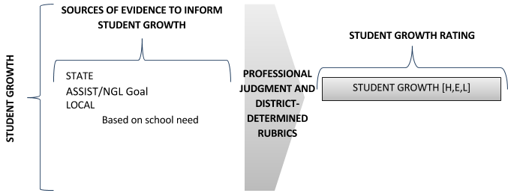

**Determining the Overall Performance Category**

A principal’s Overall Performance Category is determined by the evaluator based on the principal’s ratings on each standard, as well as student growth. Evaluators will use the following decision rules for determining the Overall Performance Category:

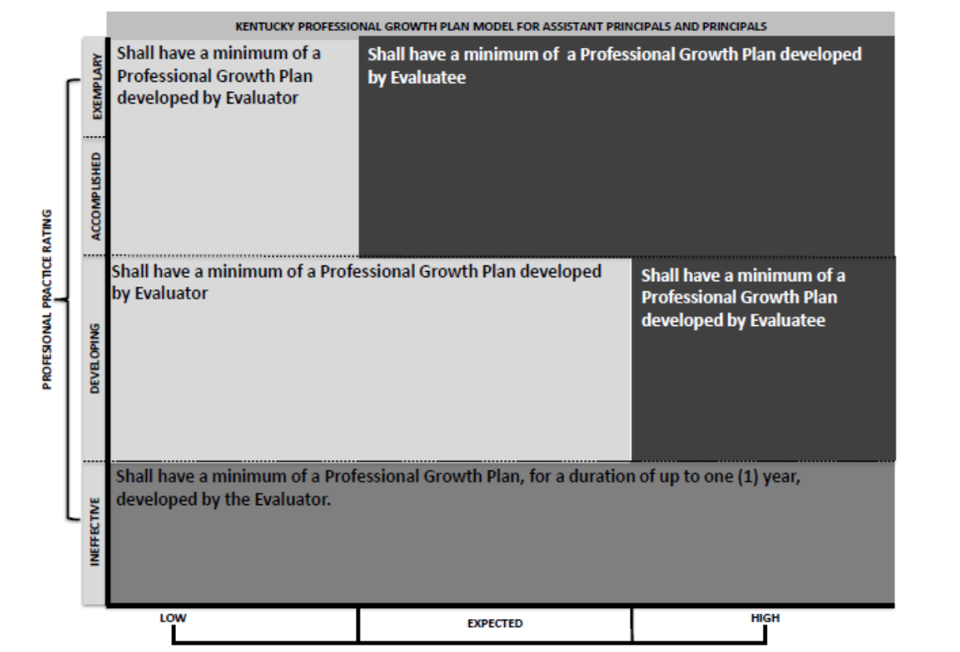

**PGES Evaluation Cycle**

All components of P-PGES will be completed over a two-year cycle. **However, all principals and assistant principals will be evaluated every year.**

**Other Professionals:**

For the 2014-15 school year, other certified employees will continue to follow the existing procedures for evaluation in Hardin County. An appendix of these forms and processes is included. The following professionals will continue to utilize the old evaluation system:

Library Media Specialists

Counselors

Occupational and Physical Therapists

School Psychologists and Consultants

Speech/Language Pathologists

Preschool Teachers

KTIP Teachers

Other Administrators who are not principals/assistant principals assigned to a school building

**Responsibilities for Evaluation**

1. The Hardin County Board of Education will evaluate the superintendent using an instrument selected by the Board of Education and approved by the Kentucky Department of Education.
2. The superintendent or his/her designee will evaluate principals, central office personnel, and head teachers.
3. The director of special education will evaluate school psychologists, consultants, and occupational and physical therapists.
4. Principals will evaluate assistant principals, guidance counselors, librarians, speech therapists, and teachers.
5. The preschool coordinator will evaluate his/her certified staff. (Not to include preschool teachers)
6. The ELL coordinator will evaluate all ELL staff.
7. The Gifted/Talented Coordinator will evaluate all GT resource teachers.
8. The Director of Evaluation and Benefits will be responsible for monitoring evaluation training and implementation of the Professional Growth and Effectiveness System and other professionals utilizing the old evaluation system.

**Appeals Process**

1. Certified employees who believe they were unfairly evaluated can only appeal following a summative evaluation and must do so in writing to the chairperson of the evaluation appeal panel within five (5) working days of receipt of the evaluation.
2. An appeal must be submitted to the chairperson on an appeals request form.
3. No member of the panel shall serve on any appeal in which he/she was the evaluator
4. No panel member shall serve on any appeal brought by the member’s immediate family.
5. The panel shall make a recommendation to the Superintendent of Schools within fifteen (15) working days from the date of filing the appeal.
6. A certified employee may appeal procedural matters to the State Board of Education after the local appeal process has been completed.

**Powers and Conditions**

1. The burden of proof rests with the employee appealing to the panel.
2. The evaluator shall be allowed an opportunity to respond to the claims of the appealing employee and to present written records which support the summative evaluation.
3. The panel shall have the power to review all documents presented to it.
4. The panel shall the authority to interview both the appealing employee and the evaluator at the hearing.
5. After sufficiently reviewing all evidence, the panel shall issue one of the following three recommendations to the superintendent.
   1. Uphold the original summative evaluation
   2. Remove the whole evaluation and any part of the summative evaluation
   3. Order a second evaluation conducted by a trained evaluator employed by the district.

(The superintendent or designee will render a decision based on the recommendation of the appeals panel within three (3) working days and notify the evaluatee.)

1. The results of actions taken by the Superintendent or designee upon the recommendation of the panel will be placed in the employee’s personnel file.

**Membership and Election Procedures for Evaluation Appeals Committee**

One member is to be appointed by the board who is a certified employee of the board. The certified employees of the district shall elect two members and one alternate to serve on the Evaluation Appeal Committee.

* 1. Each school faculty may nominate one certified employee willing to serve as a committee member.
  2. Ballots listing the candidates shall be prepared and distributed to all certified staff members.
  3. Ballots shall be collected and forwarded from each school to the Central Office where they shall be kept on file for two years.
  4. The Director of Evaluations shall total the votes and keep tally sheets on file for two years.
  5. Each election year, the candidate with the largest vote is named as a member of the appeals committee.
  6. The candidate receiving the second largest vote shall be named alternate.
  7. In years where there is no election, the alternate from the previous year continues to serve as the alternate.
  8. Members will serve 3-year terms with one member being elected or appointed each year. Members may serve more than one(1) term.
  9. In the event a member or alternate is unable to serve, the next highest eligible vote getter from the last election will serve.

**Appeals Panel Hearing Procedures**

The purpose of the Appeals Panel Hearing is to review the summative evaluation of the employee. Confidentiality and fairness shall be the primary concerns of the panel.

The purpose of the Appeals Panel is to provide a timely review of the evaluation of any certified employee who thinks he/she has not been fairly evaluated. The chairperson of the panel shall be the person appointed to the committee by the Board. The Appeals panel may require written statements or other documentation by either or both parties to be submitted prior to the proceeding. Documentation shall be provided to all parties and the panel in advance of the hearing. The evaluator and the evaluatee shall have an opportunity to adequately review in advance all documents that are to be presented to the evaluation appeals panel hearing. The evaluatee shall be given the opportunity to decide whether the hearing will be open or closed. A closed hearing will include the panel, evaluatee, evaluator, and their chosen representatives.

Upon submission of an appeal, a hearing will convene to allow the evaluatee and evaluator to present statements, documentation, witnesses, and any other information pertinent to the appeal. The chairperson will convene the hearing and establish procedures. The evaluatee shall present his/her opening statement followed by the evaluator’s opening statement. Each party will then be allowed to present his/her documentation including witnesses pertinent to the summative evaluation. Both substance and procedural issues shall be considered by the panel. A chosen representative may attend the hearing to represent the evaluator and/or evaluatee. The representative may address the panel on their client’s behalf, but shall not be given the opportunity to question witnesses. The panel will have the right to question both the evaluatee and the evaluator. The evaluatee and evaluator will leave and the panel will consider all information provided them. A decision regarding their findings shall be presented to the Superintendent within fifteen (15) working days of the filing of the appeal.

The panel’s recommendations must include one of the following:

* + 1. Uphold the original evaluation
    2. Remove the whole evaluation or any part of the summative evaluation.
    3. Order a second evaluation conducted by a trained evaluator employed by the district.

The Superintendent or designee will render a decision based upon the recommendation of the appeals panel within three (3) working days and notify the evaluatee.

Any evaluatee who feels that the procedural issues were violated may appeal the decision to the State Evaluation Appeals Panel.