**Grandview Elementary**

**SBDM Good News Report**

**January 25, 2022**

Great things are happening at GES……

**Chinese New Year Celebration**

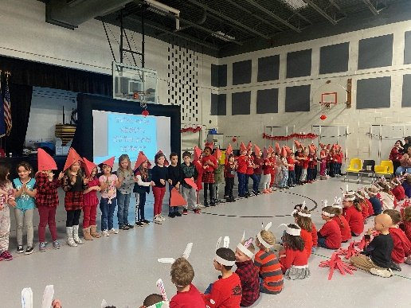 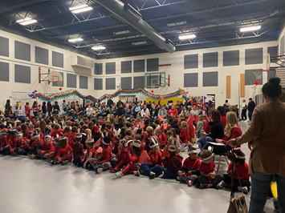  
Ms. Li, Mandarin Language Teacher, taught classes K-5th a song and/or cultural lesson. Each grade level shared what they learned with their peers and families.

**GES Students of the Month**

* Preschool- Harriet Kovatch & Adelyn Miracle
* Kindergarten-Sophie King
* 1st Grade- June Salzman
* 2nd Grade-Charlie Horn
* 3rd Grade- Maddie Boschert
* 4th Grade-Mya Cooper
* 5th Grade- Silas Gibson

**GES Teacher Commitments**

* Kentucky Standards
* The Bellevue Classroom
  + Community
  + Discourse
  + Thinking Strategies
  + Workshop Model
* Follow GES Master Schedule
* Weekly lesson plans submitted in Google drive
* Send weekly grade level newsletters in Thursday folder (display on bulletin board)
* Display student work with learning target and standard listed 2x/month
* Use Scholastic for reading and Unbound Ed for math

**Upcoming Dates:**

* Jan 24th Kids on the Block program (Schedule TBA)
* Jan 24th GES PLC meeting- Math Assessment Data
* Jan 26th PTA Winter Festival Meeting 4:30pm
* Jan 30th-31st Access Testing
* Jan 31st GES PLC Meeting- MTSS
* Feb 1st Character Education Assembly
* Feb 7th PLC meetings will be switched to Thursday Feb 9th -Writing w/Scholastic
* Feb 17th Winter Festival