May 18, 2018
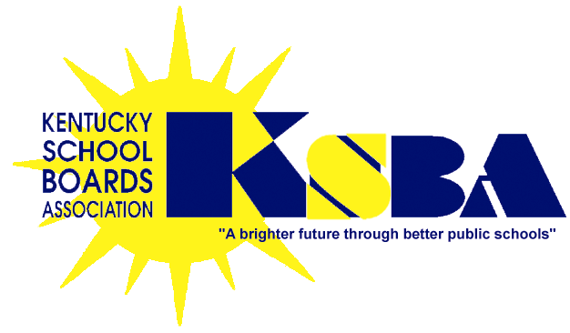
Dear Superintendent/Policy Contact:
We are enclosing your district’s customized 2018 policy update (#41) and if applicable procedure update (#22) and the related checklists. Proposed changes reflect new legal requirements, as well as “best practice” recommendations from KSBA.
Please note the following:
- KRS 160.340 requires that board policies be kept up to date by filing annual amendments thereto by August 15.
- Statutes and regulations require local boards as charter school authorizers to have policies in place regarding such regardless of whether there are any charter schools in the district. These policies are included in the update materials.
- At the top of each draft is the legal and/or recommended rationale for the proposed change. In the body of each draft, new language is underlined. Language with strike through is recommended for deletion.
Please mark any indicated changes in edit mode or contact your district’s KSBA consultant with the changes highlighted in some manner. Also, if you have been working with your consultant on a draft to revise any of the update areas, please contact him/her if you want to substitute that draft for the one enclosed with this update.
The update checklist is the only document we need returned to us, unless there are drafts to be modified. Please complete the checklist and return to the KSBA Policy Service by September 1 so that final copies can be returned to you for use during the upcoming school year.
As we do each year, we request that your District review the introductory pages in your hard copy manual for changes to be made to any vision/mission statement and/or District goals found there.
If you have questions or comments about the updating process or need your consultant to prepare additional drafts, please call us immediately at 1-800-372-2962. If this will be your first experience with a policy update, we strongly recommend you contact your District’s assigned Policy Consultant for help.
Please be aware that because your District’s policies belong to your Board of Education, the choice of language to be adopted rests solely with the Board. The KSBA Policy Service appreciates the opportunity to serve your District and stands ready to assist the Board with this important task.
Please note the approved changes go into effect as of the date of Board approval, unless otherwise noted in your Board meeting minutes.
Sincerely,
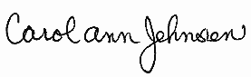
KSBA POLICY SERVICE
260 Democrat Drive
Frankfort KY 40601
Carol Ann Jehnsen, Administrative Assistant II
e-mail address: carolann.jehnsen@ksba.org
Direct Fax: (502) 783-1444
Enclosures

