We only have 3 sets of listening centers and 6 teachers who use them.  It is very difficult for them to share listening centers throughout the school year as each teacher uses them daily.  I was wondering if there were funds to purchase 3 more units and some extra headsets.

[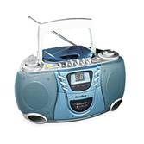](http://www.demco.com/webprd_demco/images2/products/P43/v1494388as_d.jpg)We can get three of these (no case and no headsets) for 343.12.

[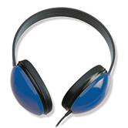](http://www.demco.com/webprd_demco/images2/products/P73/v808733a_d.jpg)  We could get these headphones for 9.55 a set (on sale right now). That would be a total of 171.98

[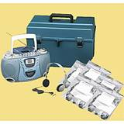](http://www.demco.com/webprd_demco/images2/products/P06/v1530662ao_d.jpg)  This is the one that comes in the case for three of these it would cost $565.86

This is the style that we currently have and it seems to be very durable and reasonably priced.  If we got the top two items (no case to keep them in) the cost would be $515.10 for 3 centers and 18 headsets.