**Board Memo**

**DATE:** 9/20/2021

**AGENDA ITEM DETAILS:**

**School/Department**

Facilities Management

**Product Vendor or Grant Issuer**

Axis Interior Systems

**Product or Grant Name**

Carpet Replacement for BOE Office & Conner Middle School

**Date/Term (Beginning and End Dates/Year)**

December 17, 2021

**APPLICABLE BOARD POLICY:**

04.32 Model Procurement Code

**DESCRIBE USE OF CONTRACT/PURCHASE/AGREEMENT**

Two vendors participated in the competitive bid for partial carpet replacement at the BOE Office and Conner Middle School. The results of the bid are shown below:



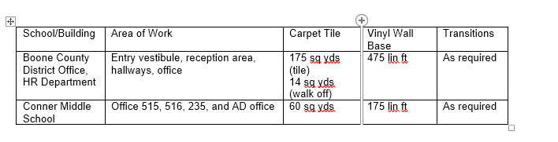

**FUNDING FOR PURCHASES AND OTHER REQUESTS:**

**Total Cost**

$11,280.00

**Funding Source**

General Fund

**\*If more than one funding source, list below along with amount or percent for each source**

N/A

**IF THIS IS A GRANT, ENTER AMOUNT TO BE AWARDED:**

N/A

**RECOMMENDATION:**

Award Bid to Axis Interior Systems based on their competitive bid, as presented.

**CONTACT PERSON: (submitter)**

Jehan M. Ghouse, Purchasing Administrator