Monthly Report

july 2020

This document outlines the activities taken place during the month on the report, including any operational activities, financial activities, and copies of receipts of all expenditures.

Confucius Institute of Western Kentucky / BG Education Management Solutions Inc.

2501 Crossings Blvd., Suite 301E

**Tel** 270-792-9330

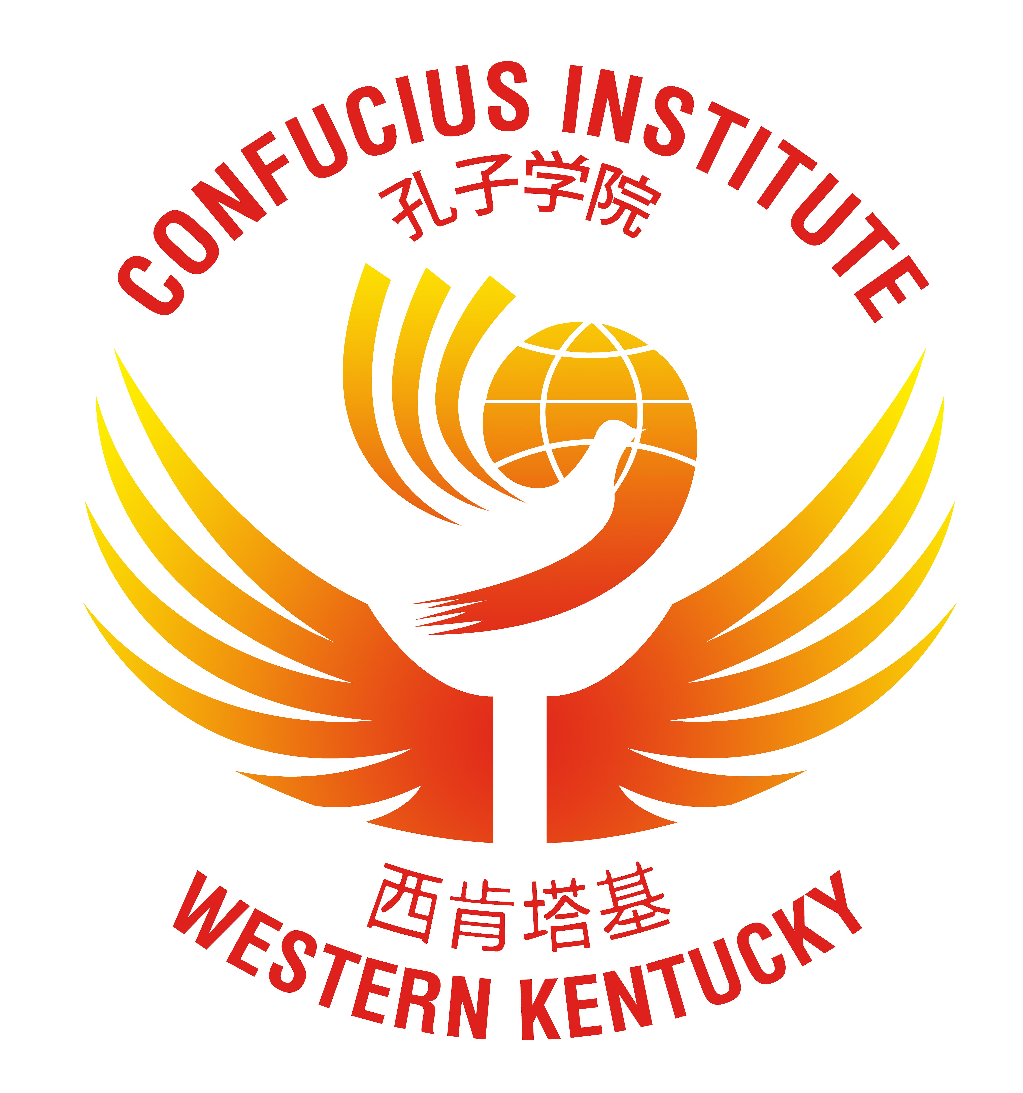

Contents

[To Simpson County Schools 1](#_Toc47721178)

[Financial Summary, 2](#_Toc47721179)

[Operational Summary 4](#_Toc47721180)

[Projects in Process 5](#_Toc47721181)

[Contact Information 6](#_Toc47721182)

[Company Information 6](#_Toc47721183)

# To Simpson County Schools

## Strategic Highlights

The Confucius Institute of Western Kentucky is in a very good spot versus were we were just one month ago. As for teachers, we will only have 27 teachers for the upcoming school year. Of the teachers, I worked with both the University of Toledo (2 teachers) and Middle Tennessee State University (2 teachers) who have provided us with a total of 4 teachers. Our training took place beginning on July 20 – July 24, 2020, which went very well. All teachers participated, and we practiced masks, social distancing, hand sanitizer, and all the teachers have settled into their districts and began training at their various schools. I have received word from the Cordell Hull that we can now recruit and bring in new teachers, of which I will request 3 teachers.

## Financial Highlights

As of June, 30st the balance in the BG Education Management Solution, Inc. account was $61,318.14. During the month of July 2020, a total of $56,807.84 was spent, with the largest expenses coming my housing, visa processing, and professional development/training.

## Operating Highlights

The CI of WKY has engaged in contracts with St. Francis School, Simpson County Schools, Cloverport Independent, Meade County, Warren County, Barren County, Butler County, Logan County, and Oldham County schools for the teachers we currently have. Conversations are taking place with school districts to discuss options if the schools end face-to-face instruction, and options for providing online instructions.

## Looking Ahead

All the Summer 2020 scheduled activities have been cancelled through summer 2020 and for the Fall 2020 for now.

Please read through the documents and advise of any questions or concerns.

Terrill D. Martin  
Director (Confucius Institute of Western Kentucky)

President & CEO (BG Education Management Solutions Inc.)

# Financial Summary,

On June 30, 2020, the balance was $61,318.14, with a total of $56,807.84 spent in the month of July 2020 leaving a balance of $4,510.30 as of, July 31, 2020. Due to the uncertainty of receiving additional funds, a frugal approach was taken. Some of the following measures were taken:

* **Center for Language Education & Cooperation (CLEC) Budget**– The CI of WKY received a total of $508,462.00 was received on 07/20/2020.
  + - **Billings for Confucius Institute Teachers 2020/2021**– Beginning next week, I will begin billing the school districts, and upon receipt, the total revenue will be $150,500.00.

Please see below for a snapshot of expenses and projected revenue for 2020. In addition, the balance sheet, and receipts of all expenditures (including receipts) are included with this report. The balance on the ledger as of July 31, 2020 are $4,510.30. The funds will not be enough to cover the operations; thus, an ACH transfer is requested in the amount of **$70,000.00.**



# Operational Summary

**Confucius Institute Summer Teacher Training Institute**

While the outbreak has taken center stage, in July, the focus for our CI shifted to preparation for the upcoming school year. The 4 new teachers started their online training with Dr. Rebecca Stobaugh, and Dr, Stephanie Kay Gandy who hosted a series of webinars. The new teachers turned in their portfolios, and conducted oral presentations, which they all passed with very good grades. Their face-to-face instruction began with all teachers on July 20 through July 24. The training took place at the CI offices, using social distancing, face masks, face shield, and plenty of antibacterial wipes, spray, and hand sanitizer.

**Confucius Institute Headquarters (Decommissioning)**

Hanban/CIH has changed its name to the Center for Chinese Language Education and Cooperation, which is a non-government owned center. This entity will consist of educational universities (with ties to CI’s abroad) and business leaders. There are two specific changes which the CI of WKY has been made aware of:

* The unit will consist of two different divisions:
  + Teacher Division – This group will continue to provide teachers for the institutes, but there are very strict budgeting guidelines, which means there will be a limit to the number of teachers which a CI can request. I am unsure of the policy at this very point.
  + Budget Division – This group will work with the Chinese University to provide budgets to external Confucius Institutes. This means that each year, the CI will submit their budget to their Chinese university partner, and the Chinese university will approve or deny budgets. The funds will be transferred from our Chinese University.

The move shows that there is a global impact to Hanban/CIH being controlled by the Chinese government. Creating this new entity does show that there is a financial impact within China, but also to try and create a new image. This means that soon, there will be more and more restrictions to the CI’s from both a budgeting standpoint and teacher placement standpoint. However, I have had several conversations with current officials who will be transferring to the new entity, that the CI of WKY will be minimally impacted by the change.

**Teacher Placements 2020/2021**

Before the outbreak, the approach was to ensure we saturated the current districts with teachers at all levels, before exploring to other districts. This approach has been re-evaluated to ensure that we have enough teachers in place to manage the current 2020/2021 teacher level before expanding at all. Please see Appendix A for a status of teachers based on the status for academic year 2020/2021.

# Projects in Process

To be determined.

# Contact Information

|  |  |  |  |  |  |
| --- | --- | --- | --- | --- | --- |
| Terrill D. Martin Director |  | ji Hui program coordinator | |  | Li Bo NCEPU Liaison |
|  |  | C:\Users\Guodong Li\AppData\Local\Microsoft\Windows\INetCache\Content.Word\Ji Hui_meitu_4.jpg | |  |  |
| **Tel** 270-792-9330  [terrill.martin@ciwky.org](mailto:terrill.martin@ciwky.org) | |  | **Tel** 270-945-0900  Ji.hui@ciwky.org |  | +86 13581709587  13581709587@163.com |

# Company Information

Confucius Institute of Western Kentucky / BG Education Management Solutions Inc.

**Tel** 270-792-9330



**Appendix A – Teacher Placement for 2020/2021 Academic Year**

