TODD COUNTY

CERTIFIED EVALUATION PLAN

INCORPORATING PGES

Todd County Board of Education

205 Airport Road

Elkton, KY 42220

(270)265-2436

(270)265-5414, Fax

Wayne Benningfield, Superintendent

Evaluation Plan Contact:

Camille Dillingham, Director of Personnel

(270)265-2436

(270)265-5414, Fax

Evaluation Plan Development Committee Members, 2015-2016:

Mishawn Greenfield Teacher

Yvonne Rundall Teacher

David Carmichael Teacher

Shannon Bailey Teacher

Contessa Orr Administrator

Doug Cotton Administrator

Kim Justice Administrator

Jennifer Pope Administrator

April 11, 2016

**The Mission of Todd County Schools is**

**Teaching, Caring and Serving**

**Teaching** all students from a rigorous and aligned curriculum.

**Caring** by building positive mentoring relationships with all students

**Serving** by using varied, research-based instructional strategies that make learning relevant to the needs of our students and the community.

**ASSURANCES**

**CERTIFIED EVALUATION PLAN**

The Todd County School District hereby assures the Kentucky Commissioner of Education as follows:

An evaluation committee composed of an equal number of teachers and administrators developed this evaluation plan.

All evaluations will be in writing on evaluation forms and in accordance with these policies and procedures which have been written in accordance with KRS 156.557, 704 KAR 3:345, and 704 KAR 3:370.

The evaluation process and criteria for evaluation will be explained to and discussed with all certified employees annually within one month of reporting for employment. This will occur prior to the implementation of the plan. The evaluation of each certified staff member will be conducted or supervised by the immediate supervisor of the employee.

All certified employees will develop an Individual Professional Growth Plan (IGP) that will be aligned with the school/district improvement plan(s) and comply with any requirements of KRS 156.557, 704 KAR 3:345, and 704 KAR 3:370. The IGP will be reviewed annually.

All administrators, to include superintendent, and non-tenured teachers will be evaluated annually.

All tenured teachers will be evaluated a minimum of once every three years.

Each evaluator will be trained and approved in the use of appropriate evaluation techniques in accordance with KRS 156.557, 704 KAR 3:345, and 704 KAR 3:370 and the use of local instruments and procedures.

Each evaluatee will have both formative and summative evaluations with the evaluator regarding his/her performance.

Each evaluatee will be given a copy of his/her summative evaluation and the summative evaluation will be filed in his/her official personnel file.

The local evaluation plan provides for the right to a hearing as to every appeal, an opportunity to review all documents presented to the District Appeals Panel, and a right to presence of evaluatee’s chosen representative.

The evaluation plan process will not discriminate on the basis of race, national origin, religion, marital status, sex, or disability.

**Table of Contents**

Certified Evaluation Plan

Rationale for Developing the Hybrid Evaluation System 1

Todd County School Certified Evaluation Process and Procedures 2-4

Schedule of Evaluation 5

*Professional Growth and Effectiveness System – Certified Classroom Teachers (TPGES)* 7

Professional Growth and Effectiveness System Overview 8-9

Professional Practice Rating 9

Kentucky Framework for Teaching……………………………………………………………………………..10-17

Student Growth 17-26

Professional Growth Plan and Summative Cycle 27-28

District Certified Personnel Evaluation…………………………………………………………………………… 29

*Professional Growth and Effectiveness System – Principal and Assistant Principal* 30

Kentucky Professional Growth & Effectiveness System Model 31

Principal Professional Growth & Effectiveness System (PPGES) Plan 32

Professional Practice Rating 32-36

Student Growth Rating 37-39

Overall Performance Category Model 40

Determining the Overall Performance Category 40-43

Principal and Assistant Principal Professional Growth Plan 44

Principal Evaluation Cycle…………………………………………………………………………………………………………………………45-46

*Todd County Appendices* 47

Appendix A – Code of Ethics 48-49

Appendix B – Student Growth Goal Rubric 50

Appendix C – Rigor Rubric- Assessments 51

Appendix E - Goal Setting Conferencing………………………………………………………………………52-53

Appendix F – Pre & Post Observation 54-57

Appendix G – Appeals Process 58-60

Appendix H - Glossary of Evaluation Terms 61-63

**Rationale for Developing the Todd County Evaluation Plan**

The reform and accountability movement in the field of education, that germinated from No Child Left Behind (NCLB) legislation and that has been further propagated by the initiative, Race to the Top (RTTT), has included and expanded the methods by which teachers are and will be evaluated. The Race to the Top initiative was competitive. For states to be eligible to be considered for RTTT funds the educational systems of those states had to meet certain criteria. One of the criteria was teacher evaluation. The RTTT initiative demands that teacher evaluations be “linked to student achievement,” according to SREB author, A. Dixon, in the article, *Focus on Teacher Reform Legislation in SREB States: Evaluation Policies*. Through studies and research, specifically, the Measures of Effective Teaching (MET) project funded by the Bill and Melinda Gates Foundation, evaluations have been examined and explored. The findings from the MET project are closely aligned and similar to the Danielson Method of measuring teacher effectiveness. Kentucky has developed a new evaluation system, Professional Growth Effectiveness System (PGES), based on the work of the MET project and Charlotte Danielson. The PGES system will be used for all certified classroom teachers, principals, assistant principals and other professionals.

**Todd County Schools’ Certified Evaluation Plan**

**PROCESS AND PROCEDURES**

Based on the premise that all individuals are capable of improvement, evaluation in the Todd County School District is a constructive, cooperative, continuous process designed for the improvement of the total educational program and staff for the benefit of all pupils. A committee made up of four administrators and four teachers developed this Certified Evaluation Plan.

This plan will be explained to and discussed with certified school personnel no later than the end of the first month of reporting for employment for each school year. Amendments approved by the Kentucky Department of Education to local systems of certified personnel evaluation that occur after the end of the certified employee’s first school month will not apply to the employee until the following school year. Each certified employee below the level of superintendent will be evaluated on the standards and performance criteria found herein by evaluators who have been trained, tested, and approved as evaluators by the Kentucky Department of Education through the initial training process. Each evaluator will complete twelve hours of additional training every two years to continue approval as an evaluator. Evaluators will use the forms (hard copy or electronic) adopted by the district and approved by the Kentucky Department of Education and available through the district office or any principal’s office. Evaluators are trained and qualified in accordance with KRS 156.557, 704 KAR 3:345, and 704 KAR 3:370.

The evaluatee’s immediate supervisor will be the primary evaluator. Additional trained administrative personnel may be used to observe and provide information to the primary evaluator. If requested by the evaluatee, observations by a peer trained in the same content area or by curriculum content specialists will be provided. The selection of this third party observer will, if possible, be determined through mutual agreement by the evaluator and the evaluatee. An evaluatee who exercises this option will do so, in writing to the evaluator, by no later than February 15th of the academic year in which the summative evaluation occurs. If the evaluator and evaluatee have not agreed upon the selection of the third party observer within five working days of the teacher’s written request, the evaluator will select the third party observer.

Monitoring and/or observations of performance will be conducted openly and with the full knowledge of the evaluatee. Evaluations below the level of superintendent will be in writing on an approved evaluation form and become a part of the evaluatee’s official personnel record. The observations will include documentation of information to be used in determining the performance of the evaluatee. The evaluation plan will provide an opportunity for a written response by the evaluatee and the response will become a part of the official personnel record. Each evaluatee will receive a copy of the evaluation.

Administrators will be evaluated annually. Certified staff holding an administrative role in the district (i.e., Director of Special Education, Instructional Supervisor, Principal,

Assistant Principal, Assistant Superintendent) and holding administrative certification issued by the Kentucky Education Professional Standards Board will be evaluated as an administrator. The Superintendent will be evaluated annually by the Todd County Board of Education. The Superintendent’s evaluation process will be developed and adopted by the Todd County Board of Education.

The evaluatee and evaluator will complete a Pre‐Observation Form prior to a classroom observation visit as a means for the evaluator and evaluatee to discuss what is to be taught. A conference between the evaluator and the person evaluated will occur within five working days following each classroom observation. Formative data collected during the Kentucky Teacher Internship Program may be utilized in the summative evaluation of the intern. Data will be transferred to district approved forms. Informal observations will also be used as a part of the evaluative process and can occur at any time the evaluator observes the evaluatee in the performance of his/her duties. Data collected by the evaluator relevant to the evaluatee may also be utilized in the evaluation process.

The summative evaluation of the evaluatee will be conducted at the end of the evaluation cycle and includes all data collected during the formative phase. A summative conference will be held to discuss the performance indicated on the summative instrument. The evaluatee will be provided an opportunity for a written response and a copy of the summative instrument. A copy of the summative evaluation and the Individual Professional Growth Plan, explained more thoroughly in the following paragraph, will be forwarded to the district office. Summative evaluations will occur yearly for each non‐tenured certified employee, every administrator, and any tenured employee whose observation results were previously unsatisfactory. Summative evaluation will occur a minimum of once every three‐year period for each tenured teacher who had previously satisfactory observation results.

All certified staff will develop an Individual Professional Growth Plan, which is aligned with the goals and missions of the school/district. The Individual Professional Growth Plan will be reviewed annually to determine if it has been achieved or needs to be revised or continued. The evaluatee has the responsibility for developing the plan with the assistance of the evaluator.

All certified staff will develop and maintain a Professional File in CIITS as an extension of the evaluation process. The Professional File will assist with the collection of specific productions and behaviors beyond the formal classroom observations such as student assessment data, extra‐curricular activities, professional development, leadership, and school‐home connections.

It is the intent of the District that all certified employees meet the District’s standards to continue their employment. In the case of non-tenured employees the evaluator should not recommend the employee for tenure unless the employee meets the District’s standards in all categories. In the case of tenured certified employees it is expected that the employee will meet the District’s standards in all categories.

A Corrective Action Plan will be developed by the evaluator to address specific concerns in employee performance. This Plan is to be completed by the evaluator (with discussion and assistance from the evaluatee) as it relates to an inadequate or “does not meet rating” on any one Standard or more from the Summative Evaluation. However, a Corrective Action Plan may be developed at any time the evaluator needs to address a specific concern in an employee’s performance. Once the corrective action plan has been implemented, there will be more frequent monitoring by the evaluator and specific assistance provided to improve performance. The employee will move back into the Individual Professional Growth Plan Cycle, when the concern has been corrected.

If there is no improvement with a corrective action plan, the evaluator may choose to implement an Assistance Team to work specifically with the evaluatee in a non-

evaluative role to provide additional help. Members of the Assistance Team will include the primary evaluator, the instructional supervisor, and a colleague who is knowledgeable of the content area of the employee requiring assistance. An employee who is assigned an Assistance Team will be informed that if the standard is not met, the district may choose to terminate the employment of the teacher or administrator.

Evaluatees have appeal rights as explained in Appendix G.

**SCHEDULE OF EVALUATION**

1. No later than the end of the first month of reporting for employment, each certified employee will be provided a copy of the form on which he or she will be evaluated and the process and criteria will be discussed.
2. Non-tenured teachers and other non-tenured professionals will be evaluated annually.
3. Non-tenured teachers and other non-tenured professionals will receive at least four formal observations (three partial and one full, following the progressive 3&1 model) annually. The first observation will be before November 1st and the last observation before April 1st.
4. Tenured personnel, other than administrators, will be evaluated every three years or at the discretion of the supervisor.
5. All administrators will be evaluated annually.
6. The Superintendent will be evaluated annually by the Todd County Board of Education.
7. All certified personnel may request an additional observation by a third party. This request must be in writing to the employee’s direct supervisor by February 15th.
8. The mid year review based on principal discretion will be completed by January 31st .
9. All Summative Evaluations will be completed and submitted to the Todd County Board of Education by May 1st.
10. In the event the first observation of a tenured employee is unsatisfactory, at least one additional observation must be completed.
11. All certified personnel will complete or review his or her previously completed growth plan annually. The individual growth plan will be aligned with the school improvement and professional development plans. The employee’s immediate supervisor will be responsible for the evaluation of the growth plan.
12. A copy of the evaluation will be provided to the evaluatee.
13. The evaluatee has 5 working days to give a written response regarding the evaluation, if so desired.
14. The superintendent may extend observation/evaluation timelines at his/her discretion.

Categories of Decisions

**CERTIFIED TEACHERS**

**Teacher Professional Growth and Effectiveness System**

**(TPGES)**

**Professional Growth and Effectiveness SYSTEM (PGES) Plan**

**I. PROFESSIONAL GROWTH AND EFFECTIVENESS SYSTEM OVERVIEW**

Effective teaching and school leadership depend on clear standards and expectations, reliable feedback, and the tools, resources and support for pro­fessional growth and continuous improvement. The Kentucky Department of Education, with the guidance and oversight of various steering committees, has designed, developed, field tested and piloted a new statewide evaluation plan referred to as the Professional Growth and Effectiveness System (PGES).

With the passage of Senate Bill 1 in 2009, Kentucky embarked on a comprehensive system of education reform integrating:

* + - relevant and rigorous standards
    - aligned and meaningful assessments
    - highly effective teaching and school leadership
    - data to inform instruction and policy decisions
    - innovation
    - school improvement

These are critical elements of student success, but it is effective teaching supported by effective leadership that will ensure all Kentucky students are successful and graduate from high school, college, and/or are career-ready.

The PGES is designed to measure teacher and leader effectiveness and serve as a catalyst for professional growth and continuous improvement and is a key requirement of Kentucky’s Elementary and Secondary Education Act (ESEA) flexibility waiver and the state’s Race to the Top grant.

The vision for the PGES is to have every student taught by an effective teacher.  The goal is to create a fair and equitable system to measure teacher effectiveness and act as a catalyst for professional growth.

7

Under PGES, evaluatees will be rated according to four performance levels: **Ineffective, Developing, Accomplished, and Exemplary**. The performance rating will be determined by compiling the evaluatee’s professional practice rating and the student growth rating, which will each be explained more thoroughly in turn.

Evaluators must use the following Required Sources of Evidence in determining overall ratings:

* + Professional Growth Planning and Self-Reflection
  + Observation
  + Student Voice
* Student Growth Percentiles and/or Student Growth Goals 2015-2016
* Other Measures of Student Learning possible examples (ACT, MAP, STAR, Brigance, etc.)
* Products of Practice
* Walk-throughs
* Other Sources (e.g., surveys)

All components and sources of evidence related to supporting an educator’s professional practice and student growth ratings will be completed and recorded in the Educator Development Suite (EDS) housed within the Continuous Instructional Improvement Technology System (CIITS).

**II. PROFESSIONAL PRACTICE RATING**

The professional practice rating is determined using the performance criteria outlined in KRS 156.557 and the Kentucky Framework for Teaching as specified in 704 KAR 3:370.

**A. KRS 156.557(4)**

**The performance criteria by which teachers and administrators shall be evaluated shall include but not limited to:**

**a. Performance of professional responsibilities related to his or her assignment, including attendance and punctuality and evaluating results;**

**b. Demonstration of effective planning of curricula, classroom instruction, and classroom management, based on research –based instructional practices, or school management skills based on validated managerial practices;**

**c. Demonstration of knowledge and understanding of subject matter content or administrative functions and effective leadership techniques;**

**d. Promotion and incorporation of instructional strategies or management techniques that are fair and respect diversity and individual differences;**

**e. Demonstration of effective interpersonal, communication, and collaboration skills among peers, students, parents, and others;**

**f. Performance of duties consistent with the goals for Kentucky students and mission of the school, the local community, laws, and administrative regulations;**

**g. Demonstration of the effective use of resources, including technology;**

**h. Demonstration of professional growth;**

**i. Adherence to the professional code of ethics; and**

**j. Attainment of the teacher standards or the administrator standards as established by the Education Professional Standards Board that are not referenced in paragraphs a to j of this subsection.**

**III. THE KENTUCKY FRAMEWORK FOR TEACHING**

The Framework for Teaching is designed to support student achievement and professional practice through the domains of:

**Framework for Teaching Specialist Frameworks for Other Professionals**

Planning and Preparation Planning and Preparation

Classroom Environment Environment

Instruction Instruction/Delivery of Service

Professional Responsibilities Professional Responsibilities

The Framework also includes themes such as equity, cultural competence, high expectations, developmental appropriateness, accommodating individual needs, effective technology integration, and student assumption of responsibility. It provides structure for feedback for continuous improvement through individual goals that target student and professional growth, thus supporting overall school improvement. Evidence supporting a teacher’s professional practice will be situated within one or more of the four domains of the framework. Performance will be rated for each component according to four performance levels: Ineffective, Developing, Accomplished, and Exemplary. The summative rating will be a holistic representation of performance, combining data from multiple sources of evidence across each domain.

The use of professional judgment based on multiple sources of evidence promotes a more holistic and comprehensive analysis of practice, rather than over-reliance on one individual data point or calculation of practice based on predetermined formulas. Evaluators will also take into account how educators respond to or apply additional supports and resources designed to promote student learning, as well as their own professional growth and development. Finally, professional judgment gives evaluators the flexibility to account for a wide variety of factors related to individual educator performance, such as: school-specific priorities that may drive practice in one domain, an educator’s number of goals, experience level and/or leadership opportunities, and contextual variables that may impact the learning environment, such as unanticipated outside events or traumas.

**A. Required Sources of Evidence to Inform Professional Practice**

1. Professional Growth Planning and Self-Reflection
2. Observation
3. Student Voice
4. Student Growth Goals and/or Median Student Growth Percentiles (4-8 - Math & ELA)

Sources of evidence/Framework for Teaching Alignment

11

|  |  |  |  |  |  |  |  |  |  |  |  |  |  |  |  |  |  |  |  |  |  |  |  |  |  |  |  |  |
| --- | --- | --- | --- | --- | --- | --- | --- | --- | --- | --- | --- | --- | --- | --- | --- | --- | --- | --- | --- | --- | --- | --- | --- | --- | --- | --- | --- | --- |
| **FRAMEWORK for TEACHING (FfT)** | **Domain** | **Planning & Preparation** | | | | | | **Classroom Environment** | | | | | **Instruction** | | | | | **Professional Responsibilities** | | | | | | | | | | |
| **Component** | **1a -Knowledge of content/pedagogy** | **1b-Demonstrate knowledge of students** | **1c- Setting Instructional Outcomes** | **1d-Demonstrates knowledge of resources** | **1e-Designing Coherent Instruction** | **1f- Designing Student Assessment** | **2a-Creating Env. of Respect & Rapport** | **2b-Establish Culture of Learning** | **2c-Maintaing Classroom Procedures** | **2d-Managing Student Behavior** | **2e-Organizing Physical Space** | **3a-Communicating with Students** | **3b-Questioning & Discussion Techniques** | **3c-Engaging Students in Learning** | **3d-Using Assessment in Learning** | **3e-Demonstrating Flexibility & Responsive** | **4a-Reflecting On Teaching** | | **4b-Maintaining Accurate Records** | **4c-Communicating With Families** | | | **4d-Participating in Profess. Learning Comm.** | | **4e-Growing & Developing Professionally** | **4f-Showing Professionalism** | |
| **SOURCES OF EVIDENCE**  **To Inform Professional Practice** | **Supervisor Observation** | **Evidence**  **(pre and post conferences)** | | | | | | **Observation** | | | | | | | | | | **Evidence**  **(pre and post conferences)** | | | | | | | | | | |
| **Student Voice** |  |  |  |  |  |  | **Kentucky Student Voice Survey** | | | | | | | | | |  |  | | |  |  | |  | | |  |
| **Professional Growth** | **Professional Growth Planning and Self Reflection** | | | | | | | | | | | | | | | | | | | | | | | | | | |
| **Self-Reflection** |
| **Peer Observation** |  |  |  |  |  |  | **Observation** | | | | | | | | | |  |  | | |  |  | |  | | |  |

**Professional Practice**

**1. Professional Growth Planning and Self-Reflection**

Each evaluatee will be required to develop his or her own Individual Professional Growth Plan, with the aid and assistance of his or her evaluator, to be used as one source of evidence in determining the professional practice rating. The Individual Professional Growth Plan must address realistic, focused, and measurable professional goals, which align with the school/district Improvement Plan. The plan will connect data from multiple sources including observation feedback, data on student growth and achievement, and professional growth needs identified through self-assessment and reflection. In collaboration with the administrators, teachers and other professionals will identify explicit goals which will drive the focus of professional growth activities, support, and on-going reflection.

Reflective practices and professional growth planning are iterative processes. The teacher (1) reflects on his or her current growth needs based on multiple sources of data and identifies an area or areas for focus; (2) collaborates with his or her administrator to develop a professional growth plan and action steps; (3) implements the plan; (4) regularly reflects on the progress and impact of the plan on his or her professional practice; (5) modifies the plan as appropriate; (6) continues implementation and ongoing reflection; (7) and, finally, conducts a summative reflection on the degree of goal attainment and the implications for next steps.

* All teachers and other professionals will participate in self-reflection and professional growth planning each year.
* All teachers and other professionals will document self-reflection and professional growth planning in CIITS.
* To monitor this process, all teachers and other professionals will submit Professional Growth Planning and Self-Reflection for approval by building principals within the first nine weeks of school.
* Late hires must complete the process within 45 days of employment.
* Mid year reviews are not required for new hires after October 15th.
* Principal will conduct and document mid year review by January 31st.
* During the last nine weeks of school, teachers will submit to administration a summative reflection on the degree of goal attainment and next steps to be implemented.

**2. Observation Model**

The observation process is one source of evidence to determine teacher effectiveness that includes supervisor and peer observation for each certified teacher. Both peer and supervisor observations will use the same instruments. The supervisor observation will provide *documentation* *and feedback* to measure the effectiveness of a teacher’s professional practice. Only the supervisor observation will be used to inform a summative rating. Peer observation will only be used for formative feedback on teaching practice in a collegial atmosphere. No ratings are given by the peer observer. The rationale for each type of observation is to encourage continued professional learning in teaching and learning through critical reflection.

**a. Observation Model For Tenured Teachers and Other Professionals**

* Four (4) observations in the three-year summative cycle. A minimum of 3 observations conducted by the supervisor and 1 observation conducted by the peer.
* The required peer observation must occur in the final year of the cycle.
* Final observation is conducted by the supervisor and is a full observation.
* Mid year review based on principal discretion and conducted by January 31st.
* For some categories for other professionals, observations may look like a workplace visit to meet the confidentiality needs of their work.
* All observations must be documented in CIITS.
* When observation results yield an ineffective determination, additional observations will be required as determined by the administrator.

**b. Observation Model For Non-tenured teachers and Other Professionals**

* One full observation by the supervisor that is the final observation consisting of a full class or lesson observation.
* Three partial observations with one being by the peer observation.
  + The partial observations will be approximately 20 to 30 minutes in duration each.
  + The observer will make a note of the components observed in the partial observation in order to identify items to look for in the next partial observation session.
* Mid year review based on principal discretion and conducted by January 31st
* Final observation is conducted by the supervisor and is a full observation.
* All observations must be documented in CIITS.

**c. Observation Conferencing**

Observers will adhere to the following observation conferencing requirements for both partial and full observations:

* Pre-conferences for supervisor observations will be conducted within five (5) instructional days prior to the observation.
* Post-observation conferences for all observations will be conducted within five (5) working days.
* The summative evaluation conference shall be held at the end of the summative evaluation cycle, and shall include all data applicable for Professional Growth and effectiveness.

Full and Partial Observation:

* The administrator may determine that the pre-conference may be conducted through electronic, written, or personal correspondence on full and partial evaluations. The post-observation conference will be done in person.

**d. Observation Schedule**

* Observations may begin after the evaluation training takes place within 30 calendar days of reporting for employment each school year.
* Late hires will follow the non-tenured observation timelines schedule dependent upon their start date.
* Teachers or other professional evaluatees who do not report to work sixty (60) or more consecutive school days shall not be observed during that respective observation window.
* Observations must be completed by April 1st.
* The deadline for completing summative evaluations for non-tenured teachers or teachers on an improvement/correction plan and submitting them to the Todd County Board of Education will be May 1st.

Non-Tenured Timeline:

* 1st Observation: Begins after the evaluation training
* 2nd Observation: Begins November 1st
* 3rd Observation: Begins December 15th
* 4th Observation (Full Observation): Begins February 15th

Tenured Timeline:

* Observation Cycle begins after the evaluation training takes place within 30 calendar days of reporting for employment and must be completed by April 1st.
* The peer partial observation and full observation will take place during the summative year.
* Two additional partial observations will take place during the 3 year cycle at the discretion of administration.
* The deadlinefor completing summative evaluations for tenured teachers and submitting them to the Todd County Board of Education will be May 1st.

**e. Observer Certification**

**All new administrators serving as a primary evaluator must complete the Initial Certified Evaluation Training prior to conducting observation for the purpose of evaluation.**

To ensure consistency of observations, evaluators must complete the approved KDE Observer Certification Training requirements (Teachscape), the current approved state platform. The system allows observers to develop a deep understanding of how the four domains of the Kentucky Framework for Teaching (FfT) are applied in observation. There are 3 sections of Teachscape:

* Framework for Teaching Observer Training
* Framework for Teaching Scoring Practice
* Framework for Teaching Proficiency Assessment

The cycle for observation certification established is as follows [NOTE: This evaluation certification cycle mirrors the existing 704 KAR 3:370 related to initial and update training for certified evaluators]:

|  |  |
| --- | --- |
| Year 1 | Certification |
| Year 2 | Calibration |
| Year 3 | Calibration |
| Year 4 | Recertification |

All administrators should be certified prior to the first instructional day of the school calendar. The Todd County Board of Education will pay for each evaluator to be certified. Evidence of successfully passing the certification requirements will be kept in each administrator’s personnel file for documentation**. Late hire supervisors should complete evaluation certification within 30 days of hire date unless extended by Superintendent.** Only supervisors who have passed the proficiency assessment can conduct partial and full observations for the purpose of evaluation.

**f. Observer Certification Support**

In the event that a supervisor has yet to complete the proficiency assessment, or if the supervisor does not pass the assessment, the district will provide the following supports:

* A scaffold approach, beginning with initial supports to ensure success during the first administration of the assessment, supports for those who do not pass after one attempt, and supports for those unable to pass the assessment after the second attempt and are subsequently locked out of the system for 90 days.
* This support will include collaboration during the initial training, additional professional learning opportunities, and assignment of a mentor.

The district will ensure teachers and other professionals have access to certified observers in cases where the supervisor is not certified through the proficiency system and therefore unable to conduct the observation.

* This observer will be assigned by the Superintendent or designee.
* This will include district-level personnel or principals from another building (certified through the proficiency system) conducting the observation with the principal (modeling the process).
* It is important to note that observation data provided by a substitute observer is considered a valid source of evidence only if the supervisor participated (passively) in the observation.

**g. Observer Calibration**

As certified observers may tend to experience “drift” in rating accuracy, the district will establish a calibration process to be completed each year where certification is not required (see chart under *Observer Certification*). This calibration process will be completed in years two (2) and three (3) after certification. Calibration ensures ongoing accuracy in scoring teaching practice; an awareness of the potential risk for rater bias; and that observers refresh their knowledge of the training and scoring practice.

* All certified observers will use Teachscape for calibration by August 1st of the designated year. The district will maintain evidence of calibration in his or her personnel file. **Recertification is required after the third year.**

**h. Peer Observation**

A peer observer will observe, collect, and share evidence and provide feedback for formative purposes only. Peer observers will not score a teacher’s practice, nor will peer observation data be shared with anyone other than the observee unless permission is granted. Peer observation data can be utilized at the teacher’s request.

* All teachers and other professionals will receive a peer observation in their summative year.
* All peer observers participating during the summative year observations will complete the state developed training once every three (3) years.
* All required peer observations must be documented in CIITS.
* Peer observers will be selected on a voluntary basis to establish a district pool, taking into consideration teacher certification and common core areas in elementary, middle, and high school levels. All peer observation documentation will be accessed only by the evaluatee.
* A district list of certified observers will be kept by the district PGES contact.
* Peer observers and observation windows will be assigned by the immediate supervisor in consultation with the teacher or other professional. An alternate observer and/or observation window may be assigned, if needed, due to extenuating circumstances.

**3. Student Voice**

The Student Voice Survey is a confidential, on-line survey that collects student feedback on specific aspects of the classroom experience and teaching practice.

* All teachers will participate in the state-approved Student Voice Survey annually with a minimum of one identified group of students.
* Student selection for participation will be consistent across the district.
* Results will be used to inform Professional Practice.
* Formative years’ data will be used to inform Professional Practice in the summative year.
* All teachers and appropriate administrative staff will read, understand, and sign the district’s “Confidentiality Agreement”.
* The Student Voice Survey will be administered between the hours of 7 AM and 5 PM local time.
* The survey will be administered in the school.
* Survey data will only be considered when 10 or more students have responded.
* District Student Voice Survey Point-of-Contact will be the Director of Personnel.
* The principal, in collaboration with the teachers, will develop a student survey administration plan that ensures all students participate in the survey. Additionally, the principal and each teacher will determine the group of students to participate in the survey, taking into consideration PGP goals, student growth goals, and accountability areas.
* The state approved Student Voice Survey will be administered during the window as established by the Kentucky Department of Education following the KDE student voice guide toolkit
* In the case that a teacher does not have a sufficient roster size to participate in the survey (minimum of 10), student voice data will not be used as a source of evidence to inform the teacher’s professional practice rating.

**IV. ADDITIONAL SOURCES OF EVIDENCE**

Teachers and other professionals may provide additional evidence to support assessment of their own professional practice. This evidence should yield information related to the teacher’s practice within the domains and may include:

* Program review evidence
* Team-developed curriculum units
* Lesson plans
* Communication logs
* Timely, targeted feedback from partial or informal observations
* Student data records
* Student work
* Student formative and/or summative course evaluations/feedback
* Minutes from PLCs
* Teacher reflections and/or self-reflections
* Teacher interviews
* Teacher committee or team contributions
* Parent engagement surveys
* Records of student and/or teacher attendance
* Video lessons
* Engagement in professional organizations
* Other Evidence as agreed upon by supervisor and evaluatee

All components and sources of evidence related to and supporting an educator’s professional practice and student growth ratings will be completed and recorded in the Educator Development Suite (EDS) housed within the Continuous Instructional Improvement Technology System (CIITS).

**V. STUDENT GROWTH**

Student Growth Goals are detailed, measurable goals for student academic growth to be achieved in a specific period of time and developed collaboratively by educators and their supervisors. Student Growth Goals are based on student learning needs identified by a review of data reflecting students’ baseline skills. Student Growth Goals provide educators with opportunities to demonstrate their students’ academic growth by setting rigorous, attainable goals for student achievement that are aligned to standards and to the instruction that teachers provide on a daily basis.

Student growth goals clearly describe specific learning targets students are expected to meet. They define which students and/or student subgroups are included in a particular goal, how their progress will be measured during the instructional time period, and why a specific level of growth has been set for students.

Student growth goals can offer a clear connection between instruction, assessment and student data. Educators employ a range of instructional strategies, skills, and techniques to affect outcomes for student academic learning, critical thinking, and behavior. The student growth goal process measures student learning and growth through various kinds of assessments.

The student growth measure is comprised of two possible contributions: a state contribution and a local contribution. The state contribution only pertains to about 20% of teachers in the following content areas and grade levels participating in state assessments:

* 4th – 8th Grade Teachers who instruct Reading
* 4th-8th Grade Teachers who instruct Math

The state contribution is reported using Student Growth Percentiles (SGP)*.* The local contribution uses the Student Growth Goal Setting Process and applies to all teachers in the district, including those who receive SGP. The following graphic provides a roadmap for determining which teachers receive which contributions:

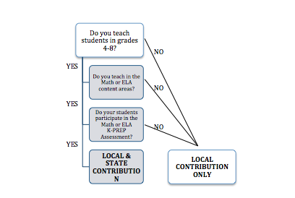

**A. State Contribution – Median Student Growth Percentiles (MSGP) – (Math/ELA, Grades 4-8)**

The state contribution for student growth is a rating based on each student’s rate of change compared to other students with a similar test score history (*academic peers*) expressed as a percentile. The scale for determining acceptable growth will be determined by the Kentucky Board of Education and provided to the district by the Kentucky Department of Education.

**B. Local Contribution – Student Growth Goals (SGG) – (All teachers and other professionals)**

The local contribution for the student growth measure is a rating based on the degree to which an educator meets the growth goal for a set of students over an identified interval of instruction (i.e. trimester, semester, year-long) as indicated in the teacher’s Student Growth Goal (SGG). All teachers and other professionals with the exception of district certified personnel, will develop a SGG for inclusion in the student growth measure.

The following categories have been identified by KDE as Other Professionals:

* Library Media Specialist
* Therapeutic Specialist/Speech
* School Guidance Counselor
* School Psychologist
* School Instructional Specialist/Coach

**Other Professionals who work with classes of students on a daily, weekly, or other re-occurring schedule must follow the protocols of the TPGES Student Growth.**

**Other Professionals who are in a role that does not work with students on a regular basis or are administrative in nature will follow the District Certified Personnel Evaluation procedures.**

**1. Student Growth Goal Criteria**

* The SGG is congruent with Kentucky Core Academic Standards and appropriate for the grade level and content area for which it was developed.
* The SGG represents or encompasses an enduring skill, process, understanding, or concept that students are expected to master by taking a particular course (or courses) in school.
* The SGG will allow high and low achieving students to adequately demonstrate their knowledge.
* The SGG provides access and opportunity for all students, including students with disabilities, ELLs, and gifted/talented students.

|  |  |
| --- | --- |
| **Growth/Proficiency Rating** | **Criteria** |
| **Low** | **Greater than 10% below the Student Growth Goal** |
| **Expected** | **Meets the Student Growth goal (+) or (–) 10%** |
| **High** | **Exceeds the Student Growth Goal by more than 10%.** |

**2. Rigor and Comparability of Student Growth Goals**

**a. Rigor**- Congruency to the Kentucky Core Academic Standards as reflected in Appendix C.

**b. Comparability**- Data collected for the student growth goal must use comparable criteria across similar classrooms (classrooms that address the same standards) to determine progress toward mastery of standards/enduring skills. Examples of similar classrooms might be 6th grade science classrooms, 3rd grade classrooms, English 1 classrooms, and band or art classes.  For similar classrooms, teachers would be expected to use common measures or rubrics to determine competency in performance at the level intended by the standards being assessed.  Although specific assessments may vary, the close alignment to the intent of the standard is comparable.

**c. See Appendix B - Rubric for Rigor and Comparability of SMART (Specific, Measurable, Appropriate, Realistic, Time-Bound) Goals**

**3. Collaborative Goal Setting Process**

Collaborative goal setting requires that both the educator and the evaluator enter into the conversation with the same purpose: to create a rigorous, yet realistic, goal that examines the educator’s impact on student learning and growth. Goals originate with the educator after their analysis of student data. The collaborative process includes guiding questions to inform revisions. Questions could include:

* How was the baseline data used to inform the growth goal?
* How are growth targets appropriate for the student population?
* Are the expectations for growth rigorous yet realistic?
* How will this goal address student needs?
* How will goal attainment help the student succeed in this class/course or future class/courses?

Developing Student Growth Goals is a collaborative process between the educator and supervisor/evaluator (including colleagues where appropriate). For example, collaborative goal setting for an educator could take three different forms with the evaluator:

* An individual teacher accountable for an intact group of students writes a classroom or subject-level goal.
* A team of teachers responsible for the same grade and/or content (e.g., 9th grade English or 4th grade team) write a team-level goal with each teacher only accountable for their individual intact group of students.
* A team of teachers who share students between classrooms (RTI, Collaborative, Resource), write a team-level goal where teachers are accountable for all students.

See Goal Setting conference– Appendix E.

**4. Steps for Setting Student Growth Goals**

**Step 1: Determine Needs**

To begin the process, educators should gather baseline data to better understand how to prepare students for the standards addressed by the class or course. This data could include end-of-year data from the previous year, baseline data from district assessments, pretests, or student work samples. Educators review data and propose goals that measure the learning and growth of all students.

To set truly meaningful goals that enhance practice and support professional growth, educators must first engage in self-reflection as part of the process in determining student needs.

The self-reflection process:

* Establishes a continuous improvement plan for every educator
* Promotes professional growth and continuous learning
* Keeps student learning at the core of all instructional, leadership, and professional practice decisions
* Builds consistency across the school and district

**Step 2: Create Specific Learning Goals based on Pre-Assessments**

Student Growth Goals for students align with state or national standards, district priorities, and/or course objectives. When writing a student growth goal, both proficiency and growth must be addressed. The goal can be tiered for specific students to allow all students to demonstrate growth. See Appendix B for Rigor and Comparability of Student Growth Goal.

Educators are encouraged to collaborate to establish student growth goals (e.g. grade level, departments, curricular or administrative teams). Educators discuss proposed goals with their supervisor/evaluator and collaborate to establish final student growth goals. The educator and the evaluator ensure that quality goal setting occurs through a discussion of the rigor and rationale of each goal, appropriate evidence-based strategies, quality of evidence and standards addressed. The SMART (Specific; Measureable; Appropriate; Realistic and Time-bound) goal process is used in the development of the student growth goals. The educator will receive two ratings for their student growth goal to address how closely proficiency and growth were met.

Educators will identify strategies and measures that will be used to determine goal attainment and specify what evidence will be provided to document progress on each goal. Examples may include, but not limited to:

* MAP
* Common Assessments
* Diagnostic Classroom Assessments
* Performance Portfolios
* Work Samples
* Pre and Post Assessments

**Types of Measures for Student Learning and Growth**

**Step 3 and 4: Create and Implement Teaching and Learning Strategies and Monitor Student Progress through ongoing Formative Assessment**

These two steps are a continuous cycle throughout the life of the goal. Over the course of the school year, each educator will implement the instructional strategies that are appropriate for students to meet their targets as stated in the student growth goals.

The educator will be responsible for collecting and organizing student data and monitoring student progress through ongoing formative assessments. See Appendix C for Rigor and Comparability of Assessments.

Educators and evaluators will conduct a mid-course/class check on student progress toward goals and, consequently, on educator progress toward meeting their student growth goals. The educator and their evaluator may determine that an adjustment in instructional strategies is warranted, or that there are immediate support/resources available to help the educator with a particular struggle (e.g., observing another educator or collaborating with a mentor).

See Goal Setting Conference – Appendix E.

**Step 5: Determine Whether Students Achieved the Goal**

At the end of the course or school year, each educator and their supervisor meet for a final review of educator progress on student growth goals. They will reflect on student learning results and student learning outcomes and how future professional development might support continued learning and growth. They will examine the end-of-year data, discuss what worked and what did not, and identify available resources. The scoring process can be facilitated by creating a scoring rubric or worksheet where the educator can enter for each student their baseline score, growth target, and final score; whether each student exceeded, met, or did not meet the target; and the percentage of students in each category.

**5. Determining Growth for a Student Growth Goal**

Evaluators and educators should utilize the following chart to determine the level at which they have met proficiency and growth in their Student Growth Goal:

Once a determination is made as to the Growth and Proficiency Rating, the two should be applied to the chart below to get an overall Local Student Growth Rating:

|  |  |  |  |  |
| --- | --- | --- | --- | --- |
| Local Student Growth Goal/Proficiency Rating | | | | |
| Growth Rating | **High** | High | High | Expected |
| **Expected** | High | Expected | Expected |
| **Low** | Expected | Expected | Low |
|  | **High** | **Expected** | **Low** |
| Proficiency Rating | | | | |

In cases where there is both a Local Student Growth Goal rating and a State Student Growth Percentile (grades 4-8) the following table should be utilized to get an overall Student Growth Trend Rating:

|  |  |  |  |  |
| --- | --- | --- | --- | --- |
| Overall Student Growth Rating | | | | |
| Local Goal  Rating | **High** | High | High | Expected |
| **Expected** | High | Expected | Expected |
| **Low** | Expected | Expected | Low |
|  | **High** | **Expected** | **Low** |
| State Goal Rating | | | | |

The MSGP will be determined by KDE and will be reported as High, Expected or Low. Teachers who receive an MSGP in more than one content area should only consider the SGP that corresponds to the area that the local SGG was written to address. For example, if a teacher receives an MSGP in reading and math and their Student Growth Goal was written to address reading, the MSGP that pertains to reading is what should be utilized to determine overall Student Growth.

Tenured teachers who have three years of student growth ratings will apply the averages of the three years to the following decision rules:

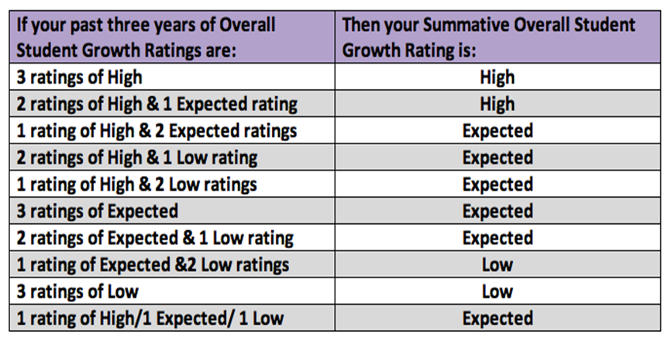

**V. DETERMINING THE OVERALL PERFORMANCE CATEGORY**

Supervisors are responsible for determining an Overall Performance Category for each teacher at the conclusion of the summative evaluation year. The Overall Performance Category is informed by the educator’s ratings on professional practice and student growth. The evaluator determines the Overall Performance Category based on professional judgment informed by evidence that demonstrates the educator's performance against the Domains, district-developed rubrics (see local contribution for student growth), and decision rules that establish a common understanding of performance thresholds to which all educators are held.

**A. Rating Professional Practice**

The Kentucky Framework for Teaching stands as the critical rubric for providing educators and evaluators with concrete descriptions of practice associated with specific domains. Each element describes a discrete behavior or related set of behaviors that educators and evaluators can prioritize for evidence-gathering, feedback, and eventually, evaluation. Supervisors will organize and analyze evidence for each individual educator based on these concrete descriptions of practice.

Supervisors and educators will be engaged in ongoing dialogue throughout the evaluation cycle. The process concludes with the evaluator’s analysis of evidence and the final assessment of practice in relation to performance described under each Domain at the culmination of an educator’s cycle.

* Provide a summative rating for each domain based on evidence.
* All ratings must be recorded in CIITS.

**B. Rating Overall Student Growth**

The overall Student Growth Rating is a result of a combination of professional judgment and the district-developed instrumentfor summative student growth ratings. The designed instrument aids the supervisor in applying professional judgment to multiple evidences of student growth over time. The Student Growth Rating must include data from SGG and SGP (where available) and will be considered in a three-year cycle (when available).

* SGG and SGP (when available) will be used to determine overall Student Growth Rating
* Up to Three years of student growth data (when available) will be used to determine overall Student Growth Rating for teachers.

**C. Determining the Overall Performance Category**

An educator’s Overall Performance Category is determined using the following steps:

* Determine the individual domain ratings through the use of sources of evidence and professional judgment.
* Apply State Decisions Rules for determining an educator’s Professional Practice rating.
* Apply State Overall Decision Rules for determining educator’s Overall Performance Category. For State Decision Rules for Other Professionals see Appendix D.
* All summative ratings must be recorded in the department approved technology

platform-CIITS.

STATE

* SGPs
* State Predefined Cut Scores

LOCAL

* SGG
* Maintain current process
* Rate on H/E/L

**STUDENT GROWTH**

**STUDENT GROWTH RATING**

STUDENT GROWTH [H,E,L]

**SOURCES OF EVIDENCE TO INFORM STUDENT GROWTH**

**PROFESSIONAL JUDGMENT AND DISTRICT-DETERMINED RUBRICS**

**CRITERIA FOR DETERMINING A TEACHER’S PROFESSIONAL PRACTICE RATING**

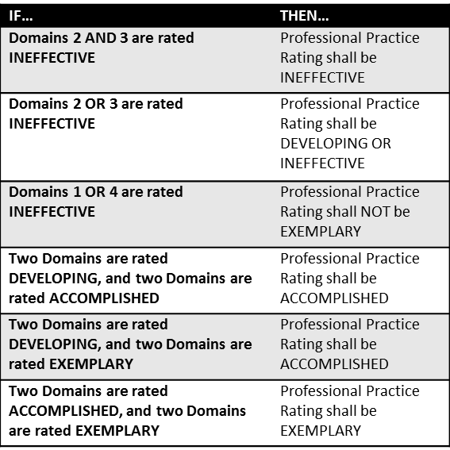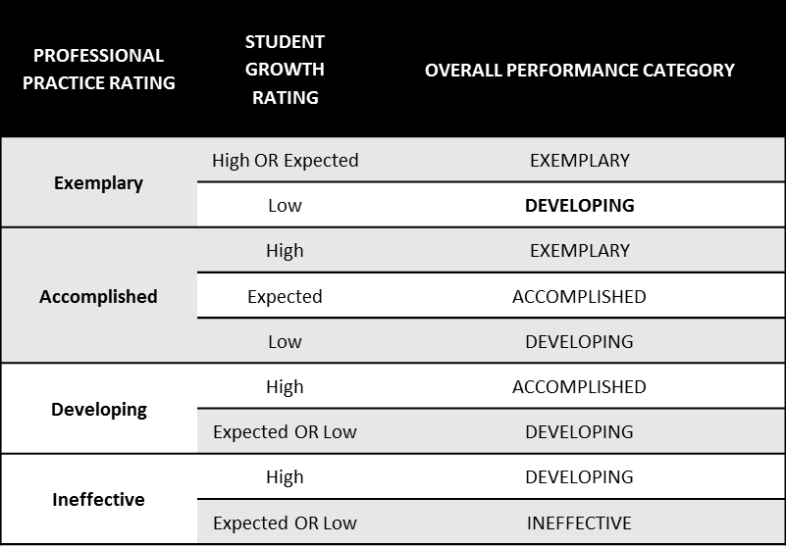

**CRITERIA FOR DETERMINING A TEACHER’S OR OTHER PROFESSIONAL’S**

**OVERALL PERFORMANCE CATEGORY**

**VI. PROFESSIONAL GROWTH PLAN AND SUMMATIVE CYCLE**

Based on the overall Professional Practice rating and Student Growth rating, the type of Professional Growth Plan and the length of the summative cycle will be determined using the next chart and 704 KAR 3:370, Section 9 also outlined below:

KAR 3:370 Section 9. Professional Growth Plan and Cycle for Tenured Teachers. A teacher shall be placed on an appropriate plan and summative evaluation cycle based on the professional practice rating and the overall student growth rating, as illustrated by the Kentucky Professional Growth Plan and Cycle Model for Tenured Teachers.

(1) A teacher whose professional practice rating is exemplary or accomplished and who has an expected or high overall student growth rating shall have a professional growth plan that includes: goals set by the teacher, with evaluator input; activities that are teacher-directed and implemented with colleagues; a formative review annually; and a summative evaluation that occurs at the end of year three (3) of the evaluation cycle.

(2) A teacher whose professional practice rating is accomplished or exemplary, with a low overall student growth rating, or developing, with a high overall student growth rating, shall have a professional growth plan that includes: goals set by the teacher with evaluator input; if there is a low student growth rating, one (1) goal shall focus on low student growth outcome; an annual formative review; and a summative evaluation that occurs at the end of year three (3) of the evaluation cycle.

(3) A teacher whose professional practice rating is developing, with an expected overall student growth rating, shall have a professional growth plan that includes: goals set by the teacher with evaluator input; one (1) goal that addresses professional practice or student growth; activities that are teacher-directed and implemented with colleagues; an annual formative review; and a summative evaluation that occurs at the end of year three (3) of the evaluation cycle.

(4) A teacher whose professional practice rating is developing, with a low overall student growth rating, or whose professional practice rating is ineffective, with an expected or high overall student growth rating, shall have a professional growth plan that includes goals determined by the evaluator: goals shall focus on professional practice and student growth, include an annual formative review, and include a summative evaluation that occurs at the end of one (1) year.

(5) A teacher whose professional practice rating is ineffective, with a low overall student growth rating, shall have an improvement plan with goals determined by the evaluator: the goals shall focus on low performance areas and a summative evaluation shall occur at the end of the plan, whose duration is determined by the evaluator and may last up to one (1) year.

*The implementation of the Overall Performance Category process will be utilized for each of these ratings to determine educator effectiveness.

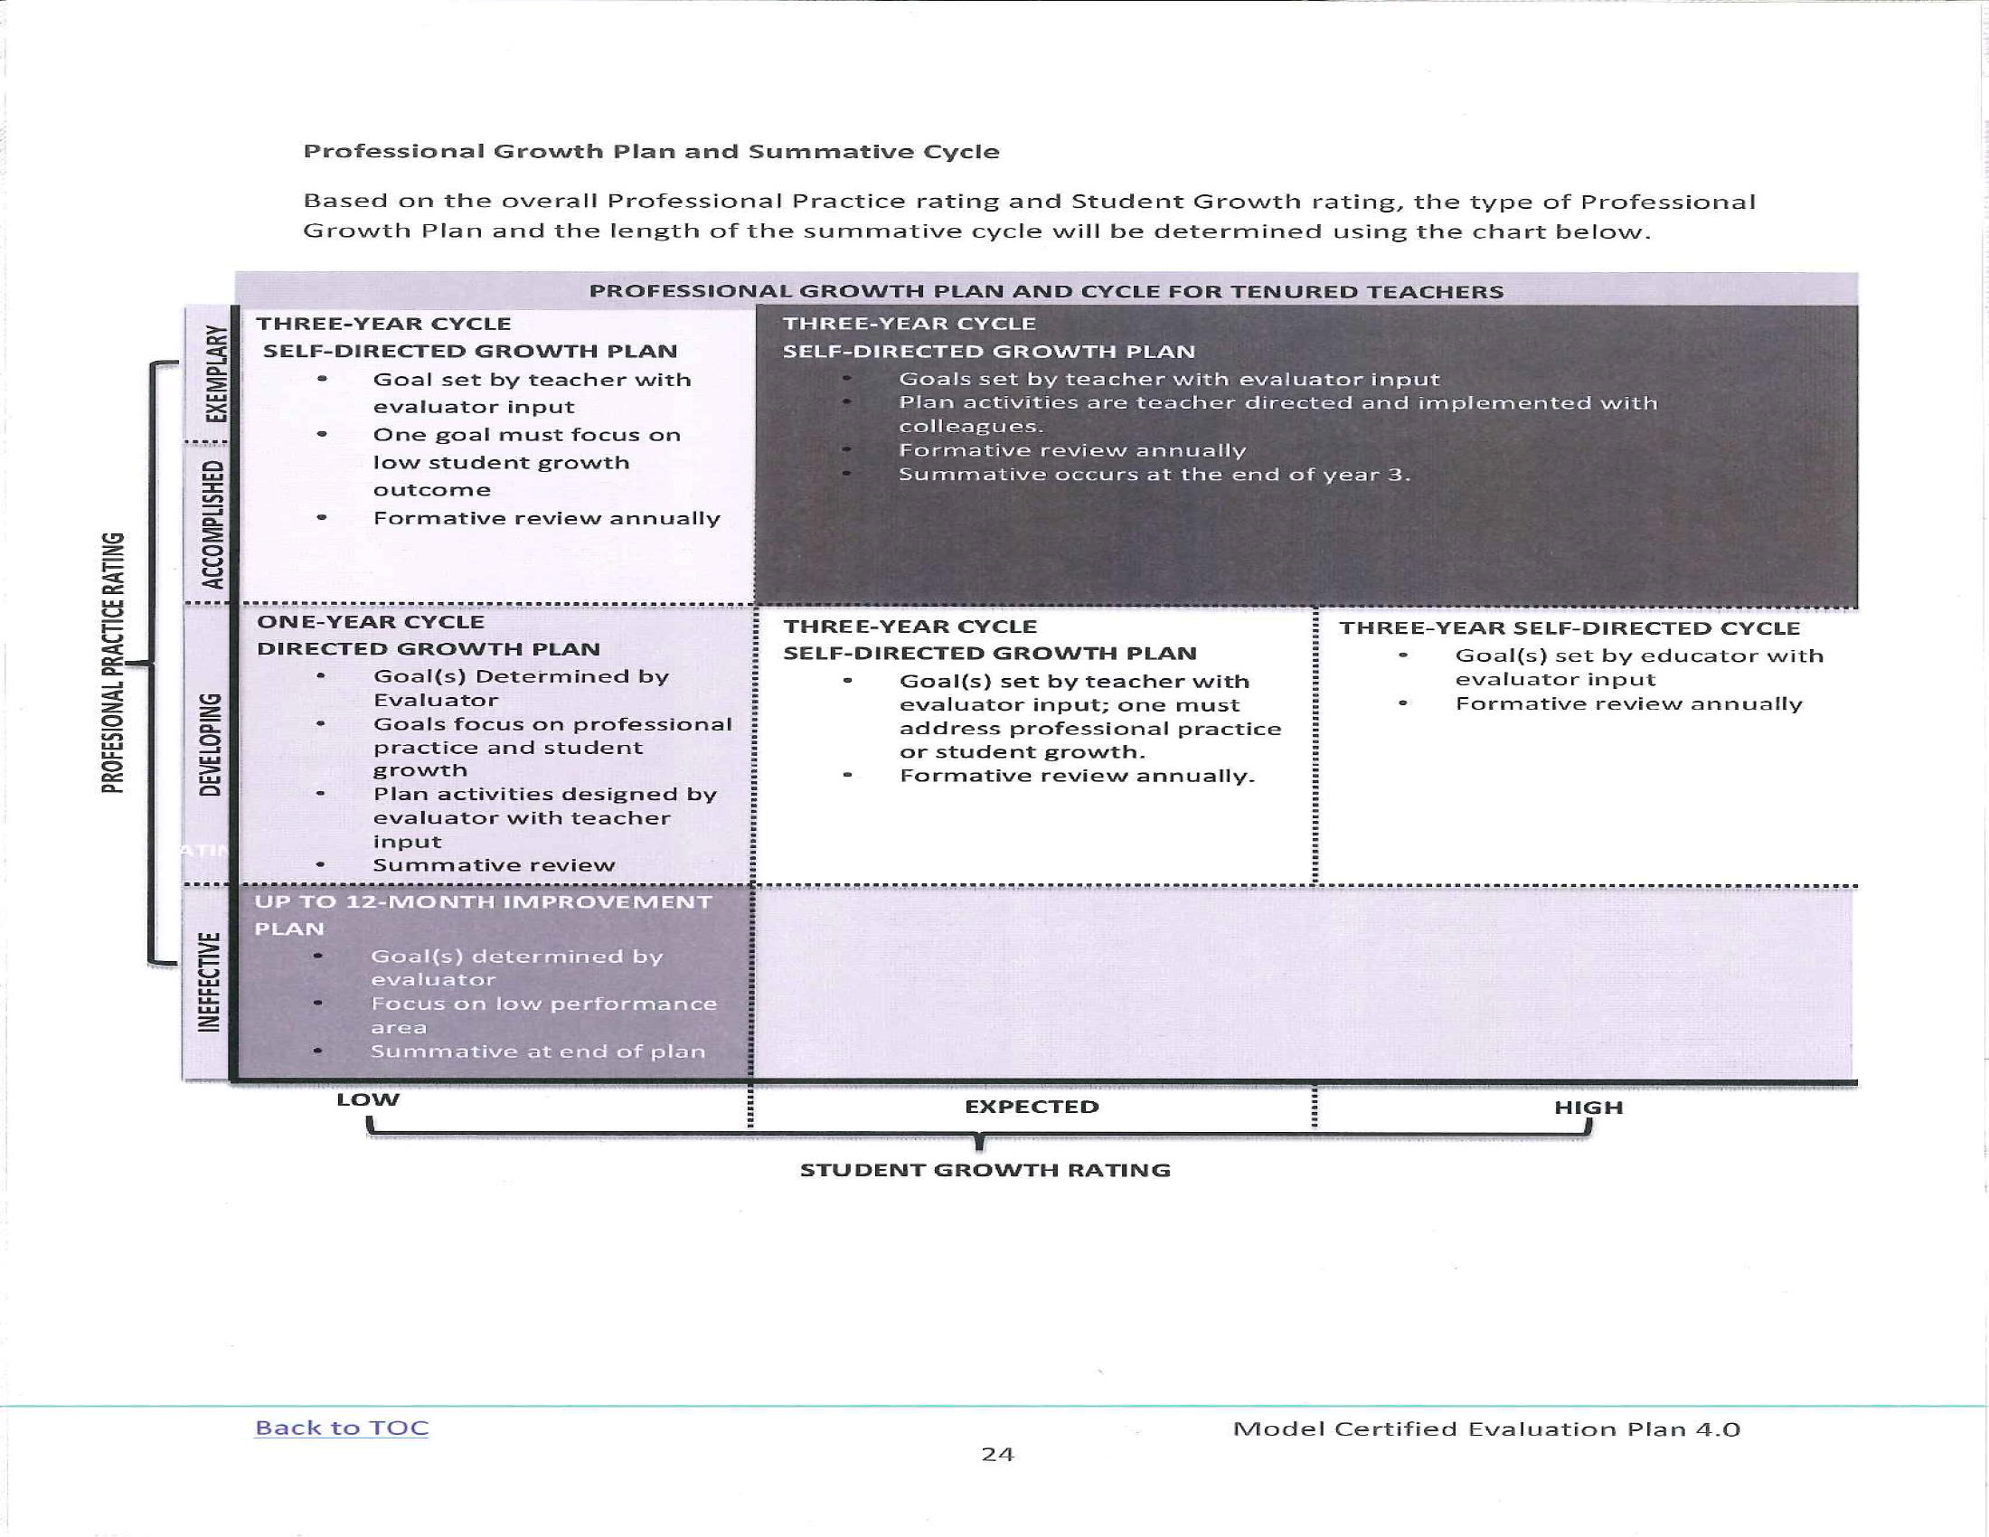

**Professional Practice Rating**

**DISTRICT CERTIFIED PERSONNEL EVALUATION**

**District Certified Personnel will be evaluated on previously approved documents and plan.**

**PRINCIPAL AND ASSISTANT PRINCIPAL Professional Growth and Effectiveness**

**(PPGES)**



**Professional Growth and Effectiveness SYSTEM (PGES) Plan**

**I. PROFESSIONAL GROWTH AND EFFECTIVENESS SYSTEM**

Under PGES, evaluatees will be rated according to four performance levels: **Ineffective, Developing, Accomplished, and Exemplary**. The performance rating will be determined based on the professional practice rating and the student growth rating, which will each be explained more thoroughly in turn.

**II. PROFESSIONAL PRACTICE RATING**

The professional practice rating is determined using the performance criteria outlined in KRS 156.557 and criteria specified in 704 KAR 3:370.

**A. KRS 156.557(4)**

**The performance criteria by which teachers and administrators shall be evaluated shall include but not limited to:**

**a. Performance of professional responsibilities related to his or her assignment, including attendance and punctuality and evaluating results;**

**b. Demonstration of effective planning of curricula, classroom instruction, and classroom management, based on research –based instructional practices, or school management skills based on validated managerial practices;**

**c. Demonstration of knowledge and understanding of subject matter content or administrative functions and effective leadership techniques;**

**d. Promotion and incorporation of instructional strategies or management techniques that are fair and respect diversity and individual differences;**

**e. Demonstration of effective interpersonal, communication, and collaboration skills among peers, students, parents, and others;**

**f. Performance of duties consistent with the goals for Kentucky students and mission of the school, the local community, laws, and administrative regulations;**

**g. Demonstration of the effective use of resources, including technology;**

**h. Demonstration of professional growth;**

**i. Adherence to the professional code of ethics; and**

**j. Attainment of the teacher standards or the administrator standards as established by the Education Professional Standards Board that are not referenced in paragraphs a through j of this subsection.**

**B. 704 KAR 3:370 Section 10 (1)**

**(a). Instructional Leadership Performance Standard. The evaluatee fosters the success of all students by facilitating the development, communication, implementation, and evaluation of a shared vision of teaching and learning that leads to student academic growth and school improvement.**

**(b). School Climate Performance Standard. The evaluatee fosters the success of all students by developing, advocating, and sustaining an academically rigorous, positive, and safe school climate.**

**(c). Human Resources Management Performance Standard. The evaluatee fosters effective human resources management by assisting with selection and induction and by supporting, evaluating, and retaining quality instructional and support personnel.**

**(d). Organizational Management Performance Standard. The evaluatee fosters the success of all students by supporting, managing, and overseeing the school’s organization, operation, and use of resources.**

**(e). Communication and Community Relations Performance Standard. The evaluatee fosters the success of all students by communicating and collaborating effectively with stakeholders.**

**(f). Professionalism Performance Standard. The evaluatee fosters the success of all students by demonstrating professional standards and ethics, engaging in continuous professional learning, and contributing to the profession.**

**C. Sources of Evidence**

The following sections provide a detailed overview of the various sources of evidence used to inform Professional Practice Ratings.

**1. Professional Growth Planning and Self-Reflection – completed by principal & assistant principal**

The Professional Growth Plan (PGP) will address realistic, focused, and measurable professional goals. The plan will connect data from multiple sources including site-visit conferences, data on student growth and achievement, and professional growth needs identified through self-assessment and reflection. Self-reflection improves principal practice through ongoing, careful consideration of the impact of leadership practice on student growth and achievement.

* Principals and assistant principals will submit their Professional Growth Planning and Self-Reflection for approval within the first nine weeks of school.
* For late hires, the superintendent/principal, principals/assistant principals will select key components of assessment data and the school improvement plan to develop a professional growth plan. This PGP is to be completed and submitted to the immediate supervisor within 45 days of hire date

**2. Site-Visits – completed by supervisor of principal – formal site visits shall not be used for assistant principal evaluations**

Site  visits  are  a  method  by  which  the  superintendent  may  gain  insight  into  the  principal’s  practice  in  relation  to  the standards. During a site visit, the superintendent will discuss various aspects of the job with the principal and   will   use   the   principal’s   responses   to   determine   issues   to   further   explore   with   the   faculty   and   staff.    Additionally, the principal may explain the successes and trials the school community has experienced in relation to school improvement.

* Site-visits will occur once per semester for the principal (mid-year and end of year).
* Conference expectations will include evaluation of various data points (survey results, growth goals, improvement plans, professional growth plans, Val-Ed or TELL results, etc.) around the Principal Performance Standards. Principals and assistant principals will look at the evidence and establish a rating to be used as a component in establishing the overall professional practice rating with guidance from their primary evaluator mid-year and at the end of the year.
* Conferences will take place within 5 school days of a site visit.
* For late hires, two site visits will still be required, with the first site visit taking place within 30 days of the hire date.
* Site visits will be documented in CIITS.

**3. Val-Ed 360° - completed for principals – shall not be completed for assistant principal**

The VAL-ED  360°  is  an  assessment   that  provides   feedback   on  a  principal’s  learning-centered behaviors by using input from the principal, his/her supervisor, and teachers. All teachers will participate in the Val-Ed 360°.

* The superintendent and instructional supervisor will oversee and administer Val-Ed 360°.
* Val-Ed 360° administration will occur every other year, once in the fall and/or once in the spring, during a year when the TELL Kentucky Survey is not administered.
* Val-Ed 360° results will be used as a data point in the evaluation of the principal and in establishing the professional practice rating.
* The superintendent, instructional supervisor, and principals will have access to Val-Ed 360°.
* For late hires, the Val-Ed survey will be completed a year after the hire date during the next regular cycle.

**4. Working Conditions Goal - Principal’s Goal is Inherited by Assistant Principal**

Principals are responsible for setting a 2-year Working Conditions Growth Goal based on the most recent TELL Kentucky Survey, Val-Ed survey or other culture assessments.   The  principal’s  effort  to  accomplish  the  Working  Conditions  Growth  Goal   is a powerful way to enhance professional performance and, in turn, positively impact school culture and student success.

* One Working Conditions Goals will be required each 2-year cycle and developed following the TELL survey.
* At the end of year 1, the mid-point review will be conducted by discussing progress made toward the Working Conditions Goals and plans will be discussed to make additional progress toward goals.
* Any additional surveys or evidence available and approved by the superintendent may be used to inform the Working Conditions Goal(s).
* Documentation pertaining to the working conditions goal will be kept by the administrator in a Professional Portfolio and reviewed by the superintendent.

**Working Conditions Growth Goal Rubric:**

The  rubric is  established  when  setting  the  Working Conditions Growth Goal in  collaboration  with the Superintendent.  A “Met” result is the expected outcome from the goal.  .

|  |  |
| --- | --- |
| Not Met | Met |
| * lack of evidence * evidence provided does not show adequate progress of Working Conditions Goal | * sufficient evidence provided * evidence shows adequate progress of Working Conditions Goal |

**5. Other Sources of Evidence**

Principal/Assistant Principal may provide additional evidence to support assessment of his or her own professional practice, which should yield information related to the principal’s / assistant principal’s practice within the domains. Such evidence may include, but is not limited to, the following:

* SBDM Minutes
* Faculty Meeting Agendas and Minutes
* Department/Grade Level Agendas and Minutes
* PLC Agendas and Minutes
* Leadership Team Agendas and Minutes
* Instructional Round/Walk-Through Documentation
* Budgets
* EILA/Professional Learning Experience Documentation
* Surveys
* Professional Organization Memberships
* Parent/Community Engagement Surveys
* Parent/Community Engagement Events Documentation
* School Schedules



**III. STUDENT GROWTH RATING**

The following provided a detailed overview of the various sources of evidence used to inform Student Growth Ratings, including the mandates of 704 KAR 3:370 section 10(8). Assistant Principal will inherit the SGG (both state and local contributions) of the Principal.

**704 KAR 3:370 Section 10 (8)**

**The overall student growth rating for principals and assistant principals shall be determined as established in this subsection.**

**(a)The student growth measure for principals and assistant principals shall consist of a state contribution and a local contribution.**

**(b) The state contribution for principals and assistant principals shall be based on the degree to which the evaluatee meets the next generation learners’ goal. A principal’s next generation learners’ goal shall be the assistant principal’s next generation learners goal as well.**

**(c) The local contribution for the student growth measure for principals and assistant principals shall be a rating based on the degree to which the principal or assistant principal meets student growth goals. Assistant principals shall share the principal’s student growth goals.**

**(d) All principals and assistant principals shall develop and implement a minimum of two (2) student growth goals each year, one (1) of which shall focus on school gap population data.**

**(e) One (1) goal shall address the needs outlined in the school’s comprehensive school improvement plan.**

**(f) One (1) goal shall be based on local student growth data.**

**(g) The district shall ensure that student growth goals are rigorous and comparable across schools in the local district.**

**(h) The scale for low, expected, and high student growth goal ratings shall be determined by the local school district. In determining the scale, local school districts shall consider the schools goals and measures of success in the comprehensive school improvement plan required in 703 KAR 5:225, Section 9.**

**(i) The district shall develop a process for using professional judgment and evidence from the following sources of evidence to determine the overall student growth rating:**

**1. Growth trends over the three (3) most recent years of next generation learners student growth data, calculated pursuant to 703 KAR 5:200; and**

**2. Growth trends over the three (3) most recent years of student growth goal data.**

**A. State Contribution –Goal Based on Trajectory found on School Report Card (Goal inherited by Assistant** **Principal)**

The superintendent and the principal will meet to discuss the trajectory for the State Contribution goal and to establish the year’s goal/interim goal that will help reach the long-term trajectory target. Both the trajectory and the interim goal are easily visible in the school report card. The goal should be customize for the school year with the intent of helping improve student achievement and reaching the long-term goals through on-going improvement. This goal may focus on Gap population unless the Local Contribution will do so. Goals should be reviewed at the beginning of the year, mid-year, and the end of the year to determine progress.

Possible Goals:

* Proficiency (Combined Reading and Math)
* College and Career Ready
* Graduation Rate
* Gap Population

2017 Trajectories are the long-term goals for these goals. Interim goals for each school year are set and visible in School Report Cards. These interim goals may serve as the goal for the principal. Districts mays also set high goals if the interim goals have previously been achieved.

*Sample State Contribution Student Growth Goal: By September 2015 ABC Elementary will increase the average combined reading and math K-Prep scores from 60% to 68%.*

|  |  |
| --- | --- |
| Growth | Criteria |
| Low | Greater than 10% below the criteria stated in the goal. |
| Expected | Meets the criteria set in the goal (+) or (-) 10% |
| High | Exceeds the criteria set in the goal by 10% or more |

**B. Local Contribution – Based on School Need (Goal inherited by Assistant Principal)**

The local goal for Student Growth should be based on school need. It may be developed to parallel the State Contribution or it may be developed with a different focus.

* The principal will develop at least two student growth goals each year, one of which must focus on school gap population data.
* One goal must address the needs outlined in the schools ‘comprehensive school improvement plan.
* One goal must be based on local student growth data.
* All goals must be rigorous and comparable across schools in the district. Therefore, goals must be developed in collaboration with the superintendent and may include collaboration with other central office staff or school administrators. The principal, in collaboration with the supervisor, will review the baseline data in order to determine what would constitute low, expected and high results based upon that data.

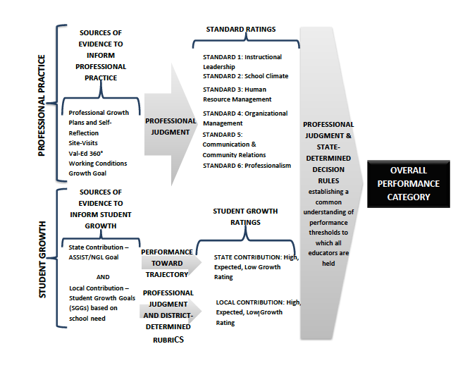

**IV. DETERMINING THE OVERALL PERFORMANCE CATEGORY**

**A. Rating Overall Professional Practice**

Overall professional practice must be rated by May 1 and recorded in CIITS or other required state system.

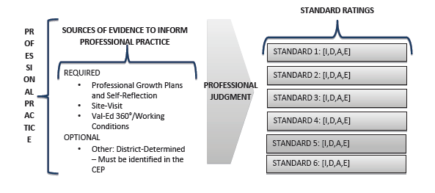

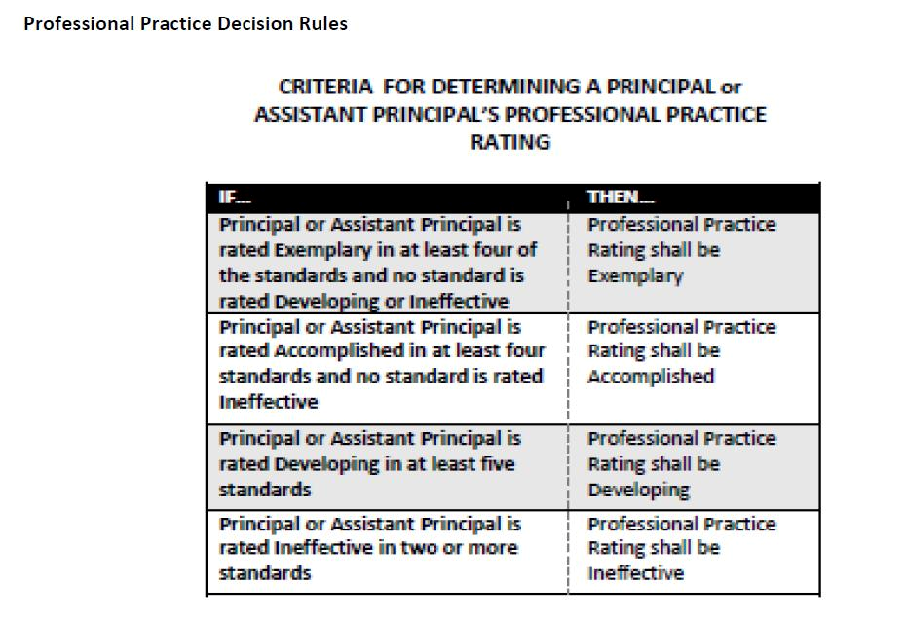

* **Apply the State Decision Rules for determining an Overall Professional Practice Rating.**

**B. Rating Overall Student Growth**

Overall Student Growth Rating results from a combination of professional judgment and the district

developed instrument. The instrument is designed to aid the evaluator in applying professional

judgment to multiple evidence of student growth over time. Student growth ratings must include data

from both the local and state contributions.

* This determination is made in collaboration with the principal/assistant principal.

Three years of data, when available, will be considered to identify possible trends.

Student growth will be based on 25% state and 75% local contribution. All information for

Student growth will be recorded in CIITS or other state system.

**Local Student Growth for multiple years of data and Student Growth Percentiles** (when applicable) will be calculated using the following formula:

If SGP apply (Local – 75%SGP – 25%) If SGP do not apply (Local – 100%)

* + LOW = 1
  + EXPECTED = 2
  + HIGH = 3

The total rankings will be averaged from the previous three years (if available) and applied to the following scale.

|  |  |
| --- | --- |
| **RANKING** | **AVERAGE SCORE** |
| Low | 1.0-1.49 |
| Expected | 1.50-2.49 |
| High | 2.50--3 |

**Example of finding average score for:**

**Local student growth goal is as follows:**

Year 1- A teacher’s student growth average is 3

Year 2- A teacher’s student growth average is 2

Year 3- A teacher’s student growth is 1

**3 + 2 + 1 = 6 ÷ 3 = 2**

**State student growth percentiles**

Year 1- A teacher’s student growth average is 3

Year 2- A teacher’s student growth average is 2

Year 3- A teacher’s student growth is 2

**1 + 2 + 2 = 1.67**

**Overall Growth for 3 years (75% - Local + 25% - State)**

**Local - 2 x .75 = 1.5**

**State - 1.67 x .25 = .42**

**Overall - 1.6 + .33 = 1.92**

**1.92 = Expected overall growth**

**C.** **Determining the Overall Performance Category**

A   principal’s   Overall   Performance   Category   is   determined   by   the   evaluator   based   on   the

principal’s   professional practice and student growth.

Superintendents are responsible for determining an Overall Performance Category for each

principal at the conclusion of the annual evaluation. All summative ratings must be

recorded on the department approved technology platform (CIITS).

The Overall Performance Category is informed by the principal’s ratings on professional practice and

student growth.

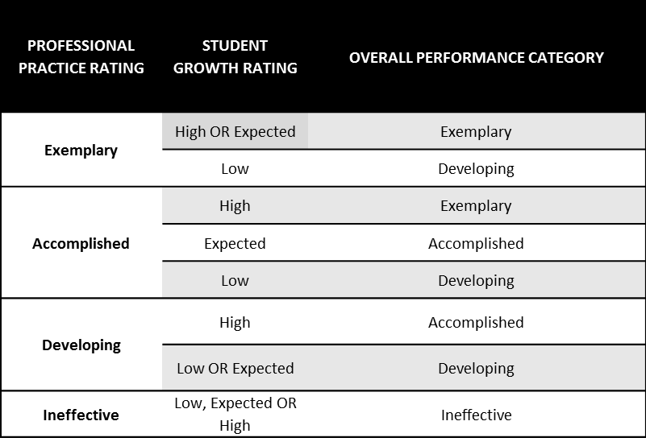

**CRITERIA FOR DETERMINING A PRINCIPAL’S OVERALL PERFORMANCE CATEGORY**

**V. PRINCIPAL AND ASSISTANT PRINCIPAL PROFESSIONAL GROWTH PLAN**

The Professional Growth Plan will be established according to 704 KAR 3:370, Section 12

and as explained by the chart that follows the regulation.

**704 KAR 3:370, Section 12. Professional Growth Plan for Principals and Assistant**

**Principals. The evaluator shall place an assistant principal or principal evaluate**

**on an appropriate professional growth plan based on the professional practice**

**rating and the overall student growth rating, as illustrated by the Kentucky**

**Professional Growth Plan Model for Assistant Principals and Principals.**

**(a) An evaluatee whose professional practice rating is exemplary, with**

**an expected to high overall student growth rating, shall have, at a minimum, a**

**professional growth plan with goals set by the evaluatee with evaluator input**

**and a summative evaluation that occurs at the end of each school year.**

**(b) An evaluatee whose professional practice rating is accomplished,**

**with an expected to high student overall student growth rating, shall have,**

**at a minimum, a professional growth plan with goals set by the evaluatee with**

**evaluator input and a summative evaluation that occurs at the end of each school year.**

**(c) An evaluatee whose professional practice rating is developing, with a high**

**overall student growth rating, shall have, at a minimum, a professional growth**

**plan with goals set by the evaluatee with evaluator input and a summative**

**evaluation that occurs at the end of each school year.**

**(d) An evaluatee whose professional practice rating is developing, with a low**

**to expected overall student growth rating, shall have, at a minimum, a professional growth plan with goals determined by the evaluator and a summative evaluation at the end of each school year.**

**(e) An evaluatee whose professional practice rating is ineffective shall have, at a minimum, a professional growth plan with the goals determined by the evaluator and a summative evaluation at the end of the plan, as determined by the evaluator, not to exceed one (1) year in duration.**

***Professional Growth Plan and Summative Cycle***

Based on the overall Professional Practice rating and Student Growth rating, supervisors will determine the type of Professional Growth Plan required of the principal.



**PRINCIPAL PGES CYCLE**

The following chart shows the required components for principals and assistant principals

over the two year process.  **All principals** **and** **assistant** **principals** **will** **be** **evaluated**

**every** **year.**

**Two-Year Cycle of the PPGES**

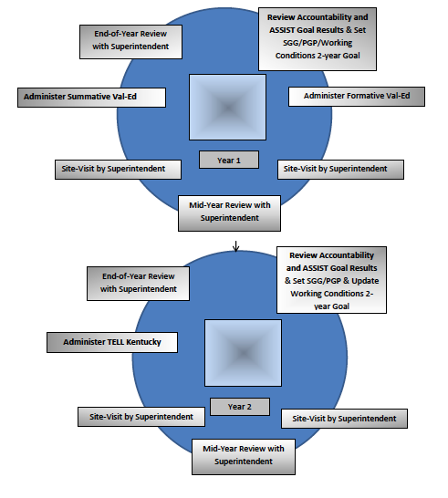

**Todd County PGES**

**Appendices**

**Appendix A**

**CODE OF ETHICS**

**704 KAR 20:680**

NECESSITY, FUNCTION, AND CONFORMITY: KRS 161:028 requires that the Education Professional Standards Board develop a professional code of ethics. This administrative regulation establishes the code of ethics for Kentucky school certified personnel and establishes that violation of the code of ethics may be grounds for revocation or suspension of Kentucky certification for professional school personnel by the Education.

**Section 1. Certified personnel in the Commonwealth:**

1. Shall strive toward excellence, recognize the importance of the pursuit of truth, nurture democratic citizenship, and safeguard the freedom to learn and to teach;

2. Shall believe in the worth and dignity of each human being and in educational opportunities for all;

3. Shall strive to uphold the responsibilities of the education profession, including the following obligations to students, to parents, and to the education profession:

**To Students**

1. Shall provide students with professional education services in a nondiscriminatory manner and in consonance with accepted best practice known to the educator;

2. Shall respect the constitutional rights of all students;

3. Shall take reasonable measures to protect the health, safety, and emotional well‐being of students;

4. Shall not use professional relationships or authority with students for personal advantage;

5. Shall keep in confidence information about students which has been obtained in the course of professional service, unless disclosure serves professional purposes or is required by law;

6. Shall not knowingly make false or malicious statements about students or colleagues;

7. Shall refrain from subjecting students to embarrassment or disparagement; and

8. Shall not engage in any sexually related behavior with a student with or without consent, but shall maintain a professional approach with students. Sexually related behavior shall include such behaviors as sexual jokes; sexual remarks; sexual kidding or teasing; sexual innuendo; pressure for dates or sexual favors; inappropriate physical touching, kissing, or grabbing; rape; threats of physical harm; and sexual assault.

**To Parents**

1. Shall make reasonable effort to communicate to parents information which should be revealed in the interest of the student;

2. Shall endeavor to understand community cultures and diverse home environments of students;

3. Shall not knowingly distort or misrepresent facts concerning educational issues;

4. Shall distinguish between personal views and the views of the employing educational agency;

5. Shall not interfere in the exercise of political and citizenship rights and responsibilities of others;

6. Shall not use institutional privileges for private gain, for the promotion of political candidates, or for partisan political activities; and

7. Shall not accept gratuities, gifts, or favors that might impair or appear to impair professional judgment, and shall not offer any of these to obtain special advantage.

**To the Education Profession**

1. Shall exemplify behaviors which maintain the dignity and integrity of the profession;

2. Shall accord just and equitable treatment to all members of the profession in the exercise of their professional rights and responsibilities;

3. Shall keep in confidence information acquired about colleagues in the course of employment, unless disclosure serves professional purposes or is required by law;

4. Shall not use coercive means or give special treatment in order to influence professional decisions;

5. Shall apply for, accept, offer, or assign a position or responsibility only on the basis of professional preparation and legal qualifications; and

6. Shall not knowingly falsify or misrepresent records of facts relating to the educator’s own qualifications or those of other professionals.

**Section 2.**

Violation of this administrative regulation may result in cause to initiate proceedings for revocation or suspension of Kentucky certification as provided in KRS 161.120 and 704 KAR 20:585. (21 Ky.R. 2344; eff. 5‐4‐95.) Attainment of other established EPSB standards not included in the plan. [704 KAR 3:345 7(2)]

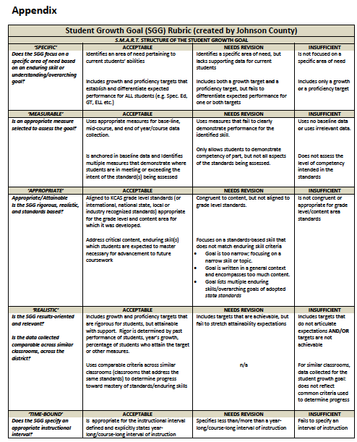

**Appendix B**

**Appendix C**

Rigor Rubric—Assessments

|  |  |  |
| --- | --- | --- |
| ***Accomplished*** | ***Developing*** | ***Needs Revision*** |
| **Aligns all assessment items** (performances, tasks, questions) to the content standards identified in the SGG. | Aligns most assessment items (performances, tasks, questions,) to the content standards identified in the SGG. Other items are “loosely aligned” or are not congruent to the specified content standards. | There is little to no evidence of congruency of assessment items to the content standards identified in the SGG. |
| All of the SGG grade-level learning content is assess using multiple items to determine if/when standards have been “met.” | Most of the SGG grade-level learning content is assessed using multiple items to determine if/when standards have been “met”. | Some of the SGG grade-level learning content is assessed using multiple items to determine if/when standards have been “met”. |
| Provides for **all** students the opportunity to demonstrate learning of the content, including rubrics, scoring guides, and /or answer keys for all items, all of which are accurate, clear, and thorough. | Provides for all students the opportunity to demonstrate learning of the content, including rubrics, scoring guides, and /or answer keys for all items, most of which are accurate and clear. | Provides for all students the opportunity to demonstrate learning of the content, including rubrics, scoring guides, and /or answer keys for all items, some of which are accurate and clear. |

Comparability of Data

|  |  |  |
| --- | --- | --- |
| ***Accomplished*** | ***Developing*** | ***Needs Revision*** |
| For similar classrooms, data collected for the student growth goal: Reflects use of common measures/rubrics to determine competency in performance at the level intended by the standard(s) being assessed. | For similar classrooms, data collected for the student growth goal: Does not reflect common criteria used to determine progress. | N/A |

**Appendix E**

|  |  |
| --- | --- |
| Goal-Setting Conference | |
| Content/Standard Student Growth Goal | A clear statement of relevant (e.g., grade-level) content, skills, and national or state standards for students. |
| Context | Description of the demographics and learning needs of all students in the class or course. |
| Baseline Data | Baseline and trend data include:   1. Student information including past assessment data and/or pre-assessment results. 2. Student strengths and challenges 3. Clear explanation for expected growth 4. Data must be attached |
| Student Growth Goal Statement | Describes growth targets for students. SMART criteria are used to formulate the goals. Together, both goals should be ambitious but attainable, address all students, and represent the most important learning during a class or course. |
| Types of Measures/Evidence for SGG | Measures that will be used to monitor student progress toward attainment of the goal. The SGG may include formative and/or summative assessments to monitor student progress. There are three categories of assessments from which to select measures: (1) state or national standardized tests, (2) common national, regional, or district-developed measures; and (3) classroom-based or school-wide measures. |
| Strategies | In order to support meeting the needs for student growth, educators incorporate in the SGG the instructional strategies relevant to learning specific content and skills. These strategies can be adjusted throughout the year based on data about student progress. Include a description on how you will collaborate with your evaluator and other educators. |
| Professional Learning and Support | Describe the professional learning and support that is needed as an educator to meet the student learning and growth goals. |

|  |  |
| --- | --- |
| Mid-Year Review | |
| Collaborative Mid-Year Goal Review | Review available data/evidence toward goal attainment and make necessary adjustments (e.g. training needs, resources, strategies for attaining goals). |
| Strategy Modification | Strategies for attaining goals may be adjusted, the goals should remain constant and you should update/review professional growth goals or direct improvement plans if necessary. |

|  |  |
| --- | --- |
| Year-End Goal Conference | |
| End-of-Year Data | Review post-assessment data to determine the percentage of students who exceeded the goal, who met the goal, and who did not meet the goal. Attach supporting data. |
| Reflection on Results | Describe how the goal setting process impacted your professional practice and student learning. Describe what worked, what did not work, and what you would do differently. |

**PRE-OBSERVATION DOCUMENT**

**Appendix F**

|  |  |
| --- | --- |
| **Teacher** |  |
| **School** |  |
| **Grade Level/Subject(s)** |  |
| **Observer** |  |
| **Date of Conference** |  |

**Preconference (Planning Conference)**

|  |  |
| --- | --- |
| **Questions for Discussion:** | **Notes:** |
| What is your identified student learning target(s)? |  |
| To which part of the standard does this lesson relate? |  |
| How does this learning fit in the sequence of learning for this class? |  |
| Briefly describe the students in this class, including those with special needs. |  |
| How will you engage the students in the learning? What will you do? What will the students do? Will the students work in groups, or individually, or as a large group? Provide any materials that the students will be using. |  |
| How will you differentiate instruction for individuals or groups of students? |  |
| How and when will you know whether the students have achieved the learning target(s)? |  |
| Is there anything that you would like me to specifically observe during the lesson? |  |

**POST-OBSERVATION DOCUMENT**

|  |  |
| --- | --- |
| **Teacher** |  |
| **School** |  |
| **Grade Level/Subject(s)** |  |
| **Observer** |  |
| **Date of Conference** |  |

|  |  |
| --- | --- |
| In general, how successful was the lesson? Did the students achieve the learning targets? How do you know, and what will you do for those students who did not? |  |
| In addition to the student work witnessed by the observer, what other student work samples, evidence or artifacts assisted you in making your determination for question one? |  |
| To what extent did classroom procedures, student conduct, and physical space contribute to or hinder student learning? |  |
| Did you depart from your plan? If so, how and why? |  |
| If you had an opportunity to teach this lesson again to the same group of students, what would you do differently, and why? |  |
| What do you see as the next step(s) in your professional growth for addressing the needs you have identified through personal reflection? |  |

*For each of the following standards, reflect on the lesson that was observed using the following guiding questions to focus your reflections:*

*Evaluator’s Formative Observation Rating:*

|  |  |  |  |  |  |  |  |  |  |  |
| --- | --- | --- | --- | --- | --- | --- | --- | --- | --- | --- |
| **Domain 2: The Classroom Environment** | **Rating:** | | | | **Domain 3: Instruction** | **Rating:** | | | | |
| A: Creating an Environment of Respect and Rapport | **I** | **D** | **A** | **E** | A: Communicating with Students | **I** | **D** | **A** | **E** |
| B: Establishing a Culture for Learning | **I** | **D** | **A** | **E** | B: Using Questioning and Discussion Techniques | **I** | **D** | **A** | **E** |
| C: Managing Classroom Procedures | **I** | **D** | **A** | **E** | C: Engaging Students in Learning | **I** | **D** | **A** | **E** |
| D: Managing Student Behavior | **I** | **D** | **A** | **E** | D: Using Assessment in Instruction | **I** | **D** | **A** | **E** |
| E: Organizing Physical Space | **I** | **D** | **A** | **E** | E: Demonstrating Flexibility | **I** | **D** | **A** | **E** |

|  |  |  |  |  |  |  |
| --- | --- | --- | --- | --- | --- | --- |
|  |  |  |  |  |  |  |
| Teacher’s Signature* |  | Date |  | Observer’s/Evaluator’s Signature |  | Date |
| *Denotes sharing of results, not necessarily agreement with the formative rating | | | | | | |

**Appendix G**

**APPEALS**

**APPEALS TO THE DISTRICT APPEALS PANEL**

**RELEVANT PROVISIONS:**

**KRS 156.557**

**(9) The local board of education shall establish an evaluation appeals panel for certified school personnel that shall consist of two (2) members elected by the certified employees of the local district and one (1) member appointed by the board of education who is a certified employee of the local board of education. Certified school personnel who think they were not fairly evaluated may submit an appeal to the panel for a timely review of their evaluation.**

**704 KAR 3:345**

**Section 7: For an appeal to the local evaluation appeals panel, each local evaluation plan shall provide for the following:**

**1. Right to a hearing as to every appeal;**

**2. Opportunity reasonably in advance of the hearing for the evaluator and evaluatee to adequately review all documents that are to be presented to the evaluation appeals panel; and**

**3. Right to presence of evaluatee’s chosen representative.**

**704 KAR 3:370**

**Section 18: Local Evaluation Appeals Panel. The district shall provide in its System Plan, for an appeal to the local evaluation appeals panel, the following:**

**1. A right to a hearing as to every appeal;**

**2. An opportunity, five (5) days in advance of the hearing, for the evaluator and evaluatee to adequately review all documents that are to be presented to the local evaluation appeals panel; and**

**3. A right to presence of evaluatee’s chosen representative.**

An evaluatee who feels he or she has not been evaluated fairly has a right to an appeal to the District Appeals Panel. The purpose of the District Appeals Panel is to review the summative evaluation. The Panel is comprised of individuals appointed by the Todd County Board of Education in accordance with KRS 156.557. Confidentiality and fairness shall be the primary concerns of the Panel. Any certified employee may, within five working days of the summative evaluation conference, file an appeal with the District Appeals Panel utilizing the request form available at the district office and also available from each principal. The request form shall be provided to the panel via the Superintendent. Within five (5) working days of receiving written notification of the appeal from the Superintendent, the Chairperson of the Panel shall notify other members of the Panel and schedule a preliminary hearing. The final hearing shall occur within twenty (20) working days of receipt of the request form by the Panel Chairperson. Additionally, the Chairperson will request documentation from the evaluator to support his/her evaluation decisions and receive those documents prior to the preliminary hearing.

Upon receiving the request form, the Panel will schedule a preliminary hearing to provide documentation to all parties and the Panel. Copies of all documents to be considered in the appeal shall be made available at this time. One copy for each of the Panel Members and one copy each for the evaluator and evaluatee shall be provided. The evaluatee must receive these documents at least three days prior to the final hearing. Otherwise, these documents shall be kept at a secure location at the district office. The chairperson shall convene the preliminary hearing and explain the procedures for the process. After the evaluatee and evaluator leave the preliminary hearing, the Panel shall remain and review all documents and formulate questions for the hearing.

The evaluatee and evaluator may be represented by legal counsel or their chosen representatives at this preliminary hearing, the final hearing, and any other proceeding. The Board of Education shall provide legal counsel to the panel if requested. The evaluatee has the right to determine whether the preliminary hearing, final hearing, and any other proceeding are open or closed. A closed hearing will include the panel, evaluatee, evaluator, and their chose representatives.

At the final hearing, witnesses may be called by either party, but witnesses will not be allowed to observe the hearing process other than during their own testimony. Each party may have an opportunity to cross-examine the other party’s witnesses. Only documents provided during the preliminary hearing shall be introduced at the hearing. At the conclusion of the final hearing, the Panel shall render a timely written decision.

**APPEALS TO THE STATE EVALUATION APPEALS PANEL**

**RELEVANT PROVISIONS:**

**704 KAR 3:345**

**Section 9:**

**1. A certified employee who feels that the local district is not properly implementing the evaluation plan according to the way it was approved by the Kentucky Department of Education shall have the opportunity to appeal to the Kentucky Board of Education.**

**2. The appeal procedures shall be as follows:**

**a. The Kentucky Board of Education shall appoint a committee of three (3) state board members to serve on the State Evaluation Appeals Panel. Its jurisdiction shall be limited to procedural matters already addressed by the local appeals panel required by KRS 156.557(5). The panel shall not have jurisdiction relative to a complaint involving the professional judgmental conclusion of an evaluation, and the panel’s review shall be limited to the record of proceedings at the local district level.**

**b. No later than thirty (30) days after the final action or decision at the local district level, the certified employee may submit a written request to the chief state school officer for a review before the State Evaluation Appeals Panel. An appeal not filed in a timely manner shall not be considered. A specific description of the complaint and grounds for appeal shall be submitted with this request.**

**c. A brief, written statement, and other document which a party wants considered by the State Evaluation Appeals Panel shall be filed with the panel and served on the opposing party at least twenty (20) days prior to the scheduled review.**

**d. A decision of the appeals panel shall be rendered within fifteen (15) working days after the review.**

**e. A determination of noncompliance shall render the evaluation void, and the employee shall have the right to be reevaluated.**

**704 KAR 3:370**

**Section 19:**

**1. A certified school personnel who believes that the local district is not properly implementing the evaluation plan as approved by the department shall have the opportunity to appeal to the Kentucky Board of Education.**

**2. The appeal procedures shall be as follows:**

**a. The Kentucky Board of Education shall appoint a committee of three (3) state board members to serve on the State Evaluation Appeals Panel (SEAP). The SEAP’s jurisdiction shall be limited to procedural matters already addressed by the local appeals panel or the district’s failure to implement an evaluation plan as approved by the department. The SEAP shall not have jurisdiction of a complaint involving the professional judgment conclusion of an evaluation, and the SEAP’s review shall be limited to the record of proceedings and documents therein, or lack thereof, at the local district level and any documents submitted pursuant to paragraph (c) of this subsection.**

**b. No later than thirty (30) calendar days after the final action or decision at the local district level, a certified school personnel may submit a written request to the chief state school officer for a review before the SEAP. An appeal not filed in a timely manner shall not be considered. A specific description of the complaint and grounds for appeal shall be submitted with the request.**

**c. a brief, written statement, or other document that a party wishes to submit for consideration by the SEAP shall be filed with the panel and served on the opposing party at least twenty (20) days prior to the scheduled review.**

**d. A decision of the SEAP shall be rendered within fifteen (15) working days after the review.**

**e. A determination of district noncompliance with the local evaluation plan or absence of a district local evaluation plan shall render the evaluation void, and the certified employee shall have the right to be reevaluated.**

Evaluatees have a right to an appeal to the State Evaluation Appeals Panel as outlined in KRS 156.557 and the relevant regulations. Any appeal to the State Evaluation Appeals Panel is limited to the record of proceedings at the local level and limited to the procedures used at the local level and cannot be based on the professional judgment of the evaluator.

**Appendix H**

**GLOSSARY OF EVALUATION TERMS AND DEFINITIONS**

**(As applied to Kentucky’s professional growth and certified personnel evaluation process)**

Evaluation terms and definitions listed below include those presented in **KRS 156.557, 704 KAR 3:345, and KRS 160.345 (2) ( c ).**

**administrator:** is any person who devotes the majority of his/her employed time to service in a position for which administration certification is required by the Education Professional Standards Board in 704 KAR Chapter 20.

**appeals:** a process whereby any certified personnel employee who feels that the local school district failed to properly implement the approved evaluation system can formally disagree with his/her evaluation.

**baseline data:** The data collected prior to interventions being implemented and signifies the student’s present level of performance on a targeted skill/concept.

**conference:** a meeting involving the evaluator and the certified employee evaluated for the purpose of providing feedback from the evaluator, analyzing the results of observation(s) and other information to determine accomplishments and for identifying areas for growth leading to establishment or revision of a professional growth plan.

**corrective action plan:** a plan developed by the evaluator and evaluatee as a result of an unsuccessful standard rating(s) on the summative evaluation or when the evaluator needs to address a specific problem in the employee’s performance. Specific assistance and activities are identified and progress monitored.

**employee assistance team:** a team established to assist the employee in meeting the district standards.

**enduring skills:** the ability to use one's knowledge effectively and readily in execution and performance, ensuring content is used beyond a single test date, is a value in other disciplines, provides relevance beyond the classroom and is worthy of embedded, course-long focus.

**evaluatee:** one whose behaviors and performances are being observed, examined, appraised, or critiqued.

**evaluation:** the process of assessing or determining the effectiveness of the performance of the certified employee in a given teaching and learning or leadership and management situation, based upon predetermined criteria, through periodic observation and other documentation such as portfolios, peer reviews, products, or performances. Evaluation shall also include the establishment and monitoring of individual professional growth plans.

**evaluation committee:** consists of local school district teachers and administrators who are responsible for developing evaluation procedures and forms for the district evaluation plan. The committee is made up of equal numbers of teachers and administrators.

**evaluation plan:** includes evaluation forms and procedures. The procedures shall provide for both formative evaluation and summative evaluation components. The Kentucky Department of Education must approve both the plan and the procedures.

**evaluation procedures:** as well as the evaluation forms, must be designed to foster professional growth and to support individual personnel decisions.

**evaluator:** one who appraises or carefully examines behaviors and performances to determine a value. Evaluators must be trained, tested, and certified.

**formative evaluation:** a continuous cycle of collecting evaluation information and interacting, and providing feedback with suggestions regarding the certified employee’s professional growth and performance.

**indicators:** are measurable or observable behaviors and outcomes that demonstrate performance criteria.

**job category:** a group or class of positions with closely related functions such as: principal, coordinator, or director.

**M:** Met

Mid-year review

**monitoring:** to supervise; to check systematically or to scrutinize for the purpose of collecting specified categories of data. (For example: principals monitor teacher’s lesson plans, units of study, interactions with students, parents, and each other.)

**NI:** Needs Improvement

**NM:** Not Met

**observation (formal):** process of gathering information in the performance of duty based on predetermined criteria in the district evaluation plan within five (5) working days.

**observation (informal):** an observation whereby the evaluator enters the classroom unannounced to observed performance. Informal observations can take place at any time the employee is in the performance of his/her duties. These observations may be made as frequently as deemed necessary.

**openly:** with full knowledge of evaluatee.

**other support staff:** any certified staff other than teacher or administrator.

**peer observer:** Observation and documentation by a trained certified school personnel.

**performance criteria:** performance areas, skills, or outcomes on which the certified employee shall be evaluated based upon position and the district evaluation plan.

**position:** a professional role in the school district such as teacher, principal, and supervisor of instruction.

**primary evaluator:** the evaluator who is the employee’s immediate supervisor (principal, associate principal, head teacher, etc.)

**professional growth plan:** a plan whereby the person being evaluated establishes goals for enrichment and development with the assistance of the evaluator. The individualized plan includes objectives, a plan for achieving the objectives, and a method for evaluating success. The individual professional growth plan shall be aligned with specific goals and objectives of the school improvement plan or district improvement plan. Reviewed annually, this plan is attached to the summative evaluation and placed in the individual’s personnel file at the district office.

**post-conference:** a meeting between the evaluator and the certified employee to provide feedback from the evaluator. The evaluator and the certified employee analyze the results of observation(s) and other information to determine accomplishments and areas of growth leading to the establishment or revision of an individual professional growth plan. The post conference shall be conducted within five (5) working days after an observation.

**pre-conference:** a meeting between the evaluator and the certified personnel to discuss and plan the schedule, date, content, time, etc. of the formal observation(s).

**self-reflection:** means the process by which certified personnel assesses the effectiveness and adequacy of their knowledge and performance for the purpose of identifying areas for professional learning and growth.

**standards of performance:** acceptable qualitative or quantitative levels of specific job performances expected of effective certified personnel employees.

**student voice:** the state-approved student perception survey, administered each year, that, provides data on specific aspects of the classroom experience and of teaching practice.

**summative evaluation:** the summary of, and conclusions from, all data, including but not limited to the formative evaluation data. The summative evaluation occurs at the end of an evaluation cycle. Summative evaluation includes a conference involving the evaluator and the evaluated certified employee, and a written evaluation report.

**teacher:** any certified staff person who directly instructs students

**For additional definitions and roles, please see 704 KAR 3:370 Professional Growth and Effectiveness System**