**Grandview Elementary**

**SBDM Board Report**

**October 25, 2023**

**Social-Emotional and Behavior**

Character Strong’s trait for October is Responsibility.   Every classroom is continuing to use the Character Strong platform to help implement Responsibility lessons/discourse into their daily morning meeting. It provides several activities, discussion starters, or suggestions of things to try as a family related to Responsibility.

Data from the Universal Screener have been analyzed and students will start to receive Tier 2 or Tier 3 interventions.  The topics of these groups are Relationship & Social Skills, Externalizing Emotions & Regulations, Internalizing Emotions & Coping, and Executive Functioning/Self-Management.

**District Wide Walkthroughs**

* + Glow: High number of observed *Clarity* and *Responsiveness*
  + Grow: Need for increased planning in inquiry

**Math Assessments**

* K-5 EasyCBM Math assessments have been administered-teachers have additional knowledge to help drive individualized math instruction
  + Teachers have spent time analyzing these results during PLCs in order to help them better understand their students.

**All K students have been assessed using Brigance**

* + 35% of K students are considered Ready with Interventions
  + 53% of K students are considered Ready
  + 13% of K students are considered Ready with Enrichments

**Professional Development**

* + Sara Teegarden and Nic Staggs attended Instructional Coach conference
  + K-2 teachers attended 3 hours of training on Scholastic’s Ready 4 Reading Phonics portion and are beginning to implement it in the classroom
  + 3rd-5th grade teachers had their first round of Scholastic writing coaching for the year. Each class was observed and met to debrief the lesson. Each teacher chose a focus area for growth and set a goal to work toward as the focus of their next round of coaching
  + Fall round of Internal Lab Observations have been scheduled
  + 4 teachers who have participated in TSI (Thinking Strategies Institute with PEBC have opened their classrooms as learning platforms for their colleagues
    - October 23
    - October 24
    - October 30
    - November 2
  + Every teacher will have the opportunity to participate in a pre-brief, observation and debrief.

**PLCs**

* + Share ideas for Tier 1 support and differentiation
  + Data collection and assessment analysis using protocol
  + Analyze EasyCBM data using [Data Analysis Protocol](https://docs.google.com/document/d/1EbsVUZkChOT8Z7jeOz0Y50kBbLajXY2E/edit)

**District Wide TBC (The Bellevue Classroom)**

* + Planning- How: The Elements of Planning
    - Purpose
    - People
    - Process

**Student Engagement**

* KY Kids Day
* One 2 One Reading Program
* High School Student Partnership Reading Program

**Upcoming Dates**

* Oct 16th-20th         Parent Teacher Conferences (No PLCs)
* Oct 16th -20th        Book Fair during scheduled library time
* Oct 18th Each classroom turns in Distinguished **Math** student work for bulletin board
* Oct 19th                 Book Fair Family Night 3-6pm
* Oct 21st                 Trunk or Treat @ Tiger Lane 5-7pm Set up is 4-4:45pm (see Katrina’s email)
* Oct 27th                 Heather out of the building @ i3Leaders Louisville
* Oct 28th                  Fall Festival 12-4pm
* Oct 30th                Staff pumpkin decorating contest -Completed pumpkins due (see Andi’s email)
* Oct 31st                  Halloween Parade PreK-5th: 10-10:30am

Grandview down Foote, left on Center, left on Washington and back to Grandview

* Nov 1st                     Extended ERD @ Campbell County Library 3:15-4:30pm
* Nov 1st -3rd            Heather @ Innovative Schools Conference Chicago
* Nov 6th                    No School
* Nov 7th                    Election Day: No School for students-

PD Eureka Training Day #2 for Certified staff 8am-3pm

* Nov 10th                  District-wide Veteran’s Day Assembly @ Ben Flora
* Nov 13th                  Each classroom turns in Distinguished **ELA** student work for bulletin board
* Dec 6th                    Each classroom turns in Distinguished **Science** work for bulletin board
* Jan 3rd                     No School for students- PD Eureka Training Day #3 for Certified staff 8am-3pm

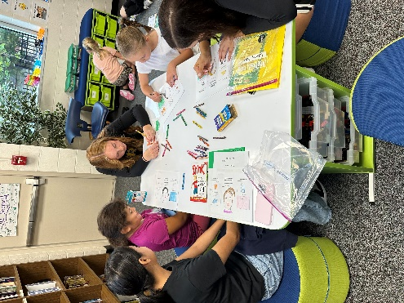 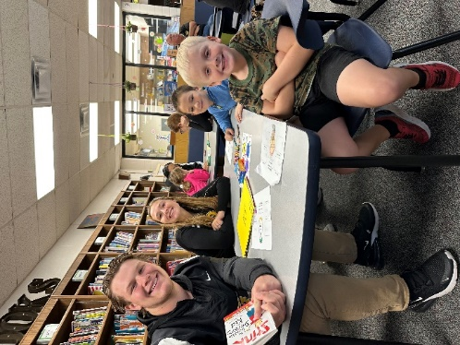

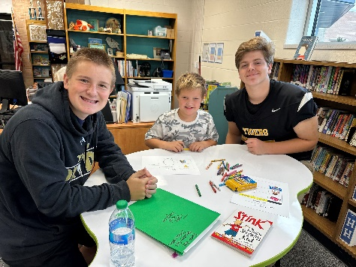

***Engage ~ Equip ~ Empower***