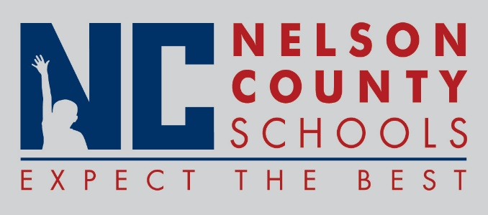

Decision Paper
To: | Nelson County Board of Education
From: | Bob Morris, Executive Director of Student Support
cc: | Tom Brown, Superintendent
Date: | February 20, 2018
Re: | Policy Update 09.2241 Student Medication

RECOMMENDATION: I recommend the Nelson County Board of Education approve policy update second reading.

RECOMMENDED MOTION: I move that the Nelson County Board of Education approve policy update second reading

