**GES Monthly Board Report**

September 2024 - Susan Short

THANK YOU, BOE MEMBERS, FOR ALL YOU DO FOR BISD!

Personnel:

* Current Vacancies
  + Math Coach (grant position)

Construction:

* Brun park is open! Students are enjoying walking to, and playing on, the beautiful new playground.
* Floor for the new gym has been poured!

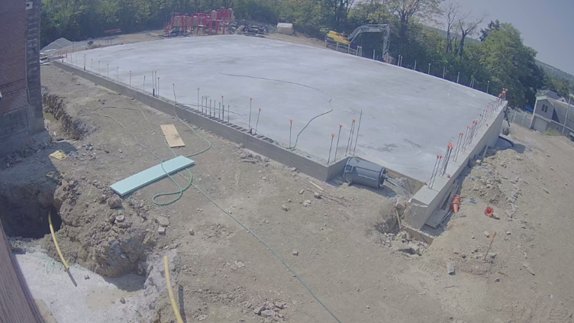

Instruction/ Curriculum:

* GES teachers meet weekly in PLC with our literacy coach, Allison Roth, to ensure implementation of Wonders, our high quality instructional resource for ELA.
* Teachers are being trained in the implementation of iReady Reading and Math on Wednesday during their planning and ERD time. This training includes how to administer the diagnostic assessment to students as well as utilizing individual learning paths to help meet students’ unique needs.
* MAP testing is complete for all grades, and K will complete the Brigance Assessment by Sept. 26th.
* PBIS Tier 1 team and the PBIS Tier 2/3 team are meeting this week:
  + The Tier 1 team meets at least monthly to refine school-wide practices and evaluate their effectiveness. The team reviews discipline data, school culture/ climate data, state tests, and other data sources related to improving school-wide outcomes.
  + The Tier 2/3 team meets regularly to design and refine Tier 2 & Tier 3 interventions within the building to meet the needs of qualifying students. The team is responsible for the student referral process related to interventions. This Team includes someone to coordinate each Tier 2 intervention, a school administrator, a behavior specialist/ special education teacher, and classroom teachers.

UPCOMING DATES FOR GES:

* Sept 12th: high attendance day and picture day!
* Sept 21st: Fall Fest