**GES Monthly Board Report**

October 2024 - Susan Short

THANK YOU, BOE MEMBERS, FOR ALL YOU DO FOR BISD!

Personnel:

* Current Vacancies
  + Math Coach (grant position)
  + Our Intervention Teacher, Ms. Regina Welscher, is retiring at the end of October. We are so sad to see her leave, but wish her all the best!

Construction:

* Work on the upper floors is continuing each day. Currently, the goal is still to move grades 4 and 5 to the upper floor in February so work can begin on the main floor.
* The gym is coming together! It has been amazing to see the progress

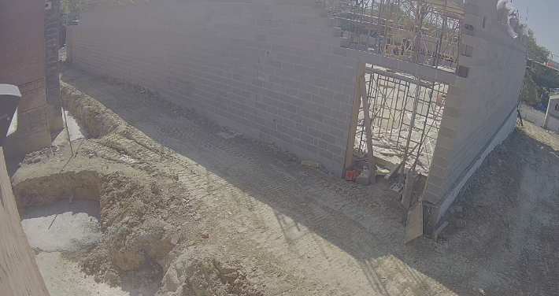

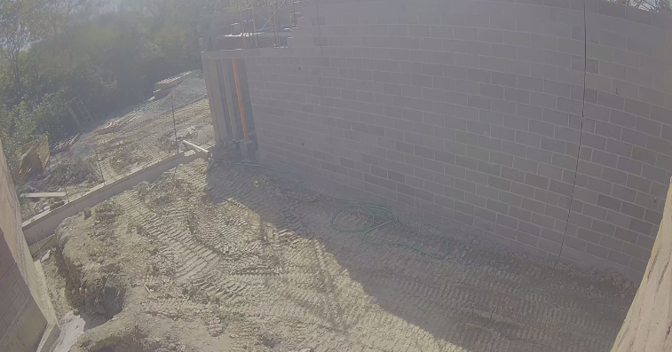

Instruction/ Curriculum:

* GES teachers met during ERD on Oct 2nd to analyze released school data from last year’s state test. Staff celebrated the state color rating change from orange to high yellow, but also discussed what created that growth for our students and what next steps we need to take in order to keep the momentum going.
* Staff worked together in grade level meetings the week of Oct 10th to complete MTSS (multi-tiered system of supports) meetings, discussing student assessment data, classroom performance, attendance, behavior, and social emotional skills in order to develop instructional plans that will meet individual student needs and help students grow.
* GES is a happening place this month! We have hosted the following events:
  + One to One orientation breakfast and meet and greet for our volunteer reading coaches, teachers, and students. One to One coaches visit with their students once a week to provide extra reading support as well as a positive, caring role model for our kids.
  + Adopt-a-Class recruitment/ orientation meeting for our corporate business partners who are interested in adopting a class.
    - These companies create teams of 4-5 adults who visit their class for one hour once a month. These visits provide students with a team of positive role models who are interested in our students and their future.
    - They focus on career and life skills and provide exposure to a variety of career paths, helping our students to see all of the amazing possibilities that their future holds!
  + Lunch with Grandparents- Grandparents were invited to come and eat lunch with their kids at GES. We had approximately 90 grandparents attend the event. A huge thank you to our cafeteria staff and custodial staff for making this event a huge success!

UPCOMING DATES FOR GES:

* Oct 18th: End of the first quarter.
* Oct 24th: Report cards go home
* Oct 22nd and Oct 24th: Family/ Teacher conferences
* Oct 25th: Schoolwide PBIS reward