**M E M O R A N D U M**

**TO: Dr. Randy Poe, Superintendent**

**Board Members**

**DATE: April 29, 2019**

**RE: Energy Management Report**

**Following for your review is an energy management update, which includes data through March of the current school year. Highlights of the report include:**

* + - **Premium Credit of $5,000.00 from participation in the Duke Power Share program for the upcoming year.**
* **To date, we have used 1,282,284 kWh less than last year.**
* **With the new Duke Energy rate structure for Burlington Elementary, we saved $1,513.97 for the month of March. Additionally, with the new Duke Energy rate structure for Florence Elementary, we saved $1,521.43 for the month of March.**
* **BOONE COUNTY SCHOOLS was recognized at the 2019 NEED Youth Awards in Lexington KY for Exemplary Leadership in Energy Education!! Twenty-one schools though-out the state submitted projects to the NEED Youth Awards and Boone County Schools had a record number of 10 schools participate!! See attached flyer.**

**Eric McArtor**

**Chief Operating Officer/Deputy Superintendent**

**Boone County Schools Energy Management Update**

**Total Cost and Use:**





**Credits/Rebates/Incentives:**



**Action Items:**

|  |  |
| --- | --- |
| Reviewing proposals for Guaranteed Energy Savings Contract RFP |  |
| Working with Duke Energy to understand recent rate increase and change two school's rates | |
| Continue to keep utility data current and apply for EPA Energy Star eligible schools |  |

**ATTACHMENT**



**Cooling degree days (CDD) are a measure of how much (in degrees), and for how long (in days), the outside air temperature was *above* a certain level (i.e., 65°F). Conversely, heating degree days (HDD) are a measure of how much (in degrees) and for how long (in days) that the outside air temperature was *lower* than 65°F. As the above table shows, the number of HDD days in March 2019 were about the same as those in March 2018. We had 3 CDD this year versus last year.**

**GREAT NEWS**

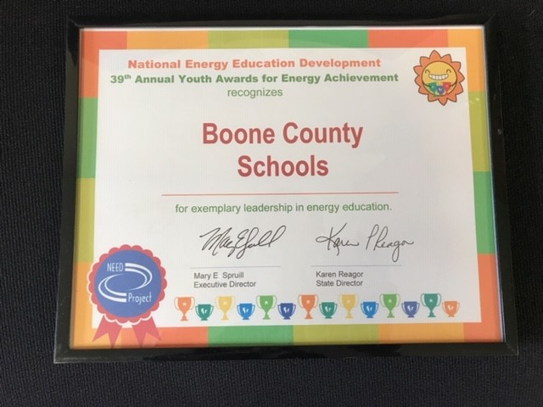

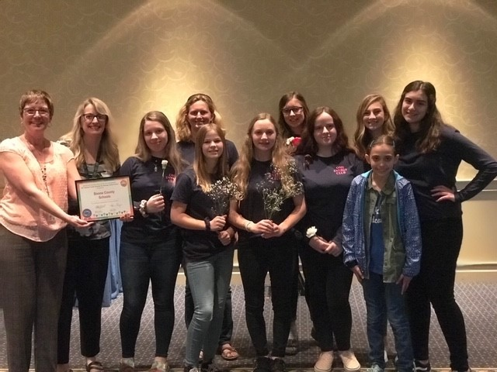 BOONE COUNTY SCHOOLS was recognized at the **2019 NEED Youth Awards** in Lexington KY for Exemplary Leadership in Energy Education!! Twenty-one schools though-out the state submitted projects to the NEED Youth Awards and Boone County Schools had a record number of **10** schools participate!! Thanks to Duke Energy Foundation Grant funds that gave us the opportunity to do such wonderful projects with our Energy/Green Teams and STEM clubs.